

**Commonwealth Environmental Water Office Monitoring, Evaluation and Research Project:**

Lower Murray

2019-20 Technical Report

A draft report prepared for the Commonwealth Environmental Water Office by the South Australian Research and Development Institute, Aquatic Sciences

*Insert photo*

December 2020

**Ye, Q.1, Giatas, G.1, Bice, C.1, Brookes, J.2, Furst, D. 2, Gibbs, M.2,3, Nicol, J.1,Oliver, R.2, Shiel, R.2,4, Zampatti, B.5, Bucater, L.1, Busch, B.6, Hipsey, M.6, Lorenz, Z.2, Maas, R.7, and Woodhead, J.7 (2020). Commonwealth Environmental Water Office Monitoring, Evaluation and Research Project: Lower Murray 2019-20 Technical Report. A draft report prepared for the Commonwealth Environmental Water Office by the South Australian Research and Development Institute, Aquatic Sciences.**

1 South Australian Research and Development Institute (Aquatic Sciences)

2 The University of Adelaide

3 Department for Environment and Water

4 Wetland Research and Management

5 CSIRO

6 The University of Western Australia

7 University of Melbourne







This monitoring project was commissioned and funded by Commonwealth Environmental Water Office (CEWO) with additional in-kind support from the South Australian Research and Development Institute (SARDI) and South Australian Department for Environment and Water (DEW). The authors of this report as well as the CEWO respectfully acknowledge the traditional owners of Country in the Murray–Darling Basin, their Elders past and present, their Nations, and their cultural, social, environmental, spiritual and economic connection to their lands and waters. In particular, the Ngarrindjeri Nation and the First Peoples of the River Murray and Mallee as traditional owners of the land and water on which this publication is focused.

**Disclaimer**

The views and opinions expressed in this publication are those of the authors and do not necessarily reflect those of the Australian Government or the Minister for the Environment. While reasonable efforts have been made to ensure that the contents of this publication are factually correct, the Commonwealth does not accept responsibility for the accuracy or completeness of the contents, and shall not be liable for any loss or damage that may be occasioned directly or indirectly through the use of, or reliance on, the contents of this publication.

**© Copyright Commonwealth of Australia, 2020**

‘Commonwealth Environmental Water Office Monitoring, Evaluation and Research Project: Lower Murray 2019-20 Technical Report’ – this report is licensed by the Commonwealth of Australia for use under a Creative Commons By Attribution 3.0 Australia licence with the exception of the Coat of Arms of the Commonwealth of Australia, the logo of the agency responsible for publishing the report, content supplied by third parties, and any images depicting people. For licence conditions see: http://creativecommons.org/licenses/by/3.0/au/

Table of contents

Table of contents i

List of figures ii

List of tables vii

Acknowledgements ix

Executive summary 1

1 Introduction 2

1.1 Flow regimes and riverine ecology 2

1.2 CEWO Monitoring, Evaluation and Research Project 2

1.3 Expected outcomes in the Lower Murray 4

1.4 Environmental water delivery 6

1.5 Purpose of the CEWO MER report for 2019-20 11

2 Indicators 12

2.1 Hydraulic Regime 12

2.2 Stream Metabolism and Water Quality 26

2.3 Matter Transport and Coorong Habitat 45

2.4 Littoral Vegetation Diversity and Productivity 61

*2.5* Microinvertebrate Assemblage 62

2.6 Fish Spawning and Recruitment 86

2.7 Murray Cod Recruitment 103

2.8 Fish Assemblage 106

3 Contingency Monitoring 118

3.1 Background 118

3.2 Lamprey migration in 2019-20: key findings and evaluation 118

4 Synthesis and Evaluation 119

5 General Management Recommendations 122

6 References 123

7 Appendices 134

Appendix A: Expected outcomes of Commonwealth environmental water in the LMR, Lower Lakes and Coorong 134

Appendix B: Overview of other watering and management activities during 2019-20 135

Appendix C: DEW evaluation questions 138

Appendix D: Supplementary information for indicators 147

Acronyms 155

Glossary 156

List of figures

Figure 1. Map of the Lower Murray Selected Area showing the LMR floodplain (blue), gorge (green) and swamplands (orange) geomorphic zones, and the Lower Lakes, Coorong and Murray Mouth (yellow). Sampling sites are indicated by coloured circles. Fish Spawning and Recruitment sites represent larval sampling only. 4

Figure 2. The various flow types of the LMR as described by the Murray–Darling Basin Plan and Gawne *et al.* (2013). 5

Figure 3. Cause and effect diagram of flow for the main channel of the Lower Murray with respect to the proposed indicators. Magnitude, timing and duration are factors of flow (in black). Yellow indicators followed standard protocols to support quantitative Basin-wide and Selected Area evaluation, where applicable. Purple indicators were developed to address objectives and test a series of Selected Area-specific hypotheses with respect to biological/ecological response to environmental flows. 6

Figure 4. Daily flow (ML/d) in the LMR at the South Australian border (blue solid line) from January 1996 to July 2020, compared to modelled flow under natural conditions (grey dashed line). Approximate bankfull flow in the main channel of the LMR is shown (black dashed line). 7

Figure 5. Flow to South Australia from July 2014 to July 2020 showing the contribution of environmental water. CEW = Commonwealth environmental water. Other eWater = The Living Murray, Victorian Environmental Water Holder, New South Wales Department of Planning, Industry and Environment and water delivered as part of River Murray Increased Flows. The ‘no eWater’ component includes South Australian entitlement held by the Commonwealth Environmental Water Holder and by TLM. Approximate bankfull flow (red dotted line) is 45,000 ML/d in the LMR. Modelled flows under natural conditions (dotted black line) peaked at 163,230 ML/d in 2016-17. 9

Figure 6. Flow to South Australia from July 2019 to July 2020 showing the (a) contribution of environmental water and (b) source of all (environmental and consumptive) water (MDBA). CEW = Commonwealth environmental water. Modelled flow under natural conditions is shown by the dotted black line. Bigmod salinity routines used as a proxy for transport of biological matter, to estimate the proportion of the flow that originated at different upstream tributaries.Refer to Figure X for location of rivers and tributaries, relative to the LMR. 10

Figure 7. Discharge (Flow to South Australia), inundated area and length of river with faster flowing velocities (v>0.2 m/s and v>0.3 m/s) for the LMR between Locks 1 & 6 (excluding anabranches). Total length of river assessed in the LMR = 345 km. 15

Figure 8. Median modelled velocity in each weir pool (line), with the range in velocities within the weir pool (the shaded area), defined by the 10th and 90th percentiles, in the LMR. 16

Figure 9. Modelled water level at the downstream end (i.e. at the lock and weir) of each weir pool in the Lower Murray Selected Area. 17

Figure 10. Modelled water level at the upstream end of each weir pool in the LMR. 18

Figure 11. Area inundated (hectares) in each weir pool for changes in discharge and weir pool level in the LMR. Weir Pool 3 is shown on a different colour scale due to the larger areas in this weir pool. 24

Figure 12. Proportion of the weir pool with velocities exceeding 0.3 m/s for changes in discharge and weir pool level in the LMR. 25

Figure 13. Rates of GPP (), ER () and NEP () at (left) Lock 6 and (right) Lock 1 over the five monitoring periods from 2014–2019. 30

Figure 14. The response of GPP per unit phytoplankton biomass in carbon units, to the mean irradiance of the water column over the daylight period for Lock 6 (orange circles) and Lock 1 (blue circles) when water velocities were greater than 0.22 m/s. Regression, y = 0.0164x - 0.0024, r2= 0.78. 31

Figure 15. (A) Environmental water contributions to discharge at Lock 6, (B) Fractional change in volumetric GPP(b), (C) Fractional change in cross-sectional GPP(b), due to flow including all environmental water () or only CEW (). 32

Figure 16. Flow induced changes at Lock 6 (top) and Hattah (bottom) in (left) cumulative volumetric GPP over each monitoring period, (right) cumulative cross-sectional production over each monitoring period, due to the addition of CEW (blue bars) and all environmental water (grey) from no environmental water. Fractions above each bar represent proportional changes in GPP due to environmental flows compared with no environmental flows (e.g. 1.02 indicates GPP increased by 2% over no environmental water). 33

Figure 17. Comparison of the vertical attenuation coefficient kd measured in the field and calculated from the dissolved organic carbon concentration and the turbidity. 34

Figure 18. The vertical attenuation coefficient for Photosynthetically Active Radiation () and the contributions due to DOC () and NTU () at Lock 6 for each monitoring period. 35

Figure 19. Respiration rates and net production for phytoplankton (), bacteria () and both combined (). 36

Figure 20. (A) The gas exchange coefficient at different water velocities and (B) the water velocities with () and without () environmental water at Lock 6. 38

Figure 21. Overview of model domain applied in the Matter Transport study of LTIM using TUFLOW-FV. Grid provided courtesy of DEW. Coloured grids in maps on the right-hand side represent depths, i.e. increasing depth from shallow (blue) to deep (red). 48

Figure 22. Overview of the three flow scenarios assessed by the model simulations. Scenarios include flow with all water, flow without Commonwealth environmental water (no CEW) and flow without any environmental water (no eWater). Flows were applied to the matter transport model at the upstream boundary, which is at Lock 1. 49

Figure 23. Modelled cells (circled) used for calculating the modelled concentration of nutrients or salt at the Wellington, Lake Alexandrina Middle and Murray Mouth sites. 51

Figure 24. Modelled daily salinity concentrations (left) and six monthly cumulative salt exports (net, right) with and without environmental water delivery for 2013–2019. Scenarios include with all water, without Commonwealth environmental water (no CEW) and without any environmental water (no eWater). 53

Figure 25. Mean microinvertebrate density collected in the LMR at below Lock 6 in the floodplain geomorphic zone, demonstrating community assemblage characteristics in a) 2014-15, (b) 2015-16, (c) 2016-17 and (d) 2017-18, plotted against flow discharge (blue line) and temperature at SA Border (red line). 71

Figure 26. Mean microinvertebrate density collected in the LMR at below Lock 1 in the floodplain geomorphic zone, demonstrating community assemblage characteristics in a) 2014-15, (b) 2015-16, (c) 2016-17 and (d) 2017-18, plotted against flow discharge (blue line) and temperature at SA Border (red line). 72

Figure 27. Mean (±S.E.) species richness of microinvertebrates collected in the LMR at sites below Lock 6 (black bars) and Lock 1 (grey bars). 73

Figure 28. MDS ordination of microinvertebrate assemblage data (square-root transformed) at Lock 6 and Lock 1 during 2014–2018. Samples are labelled by sampling trip. Species density correlations are overlaid with blue vectors and water temperature (Water temp) and discharge into South Australia (QSA) correlations are overlain with red vectors. Species have been labelled by their family and preferred habitat (FamilyHabitat). Rotifer labels are blue and microcrustacean (cladocerans and copepods) labels are in black. Correlation value set to 0.5. 74

Figure 29. Abundance (number, *n*) of prey identified in the guts of post-flexion Murray cod (*n* = 15; TL = 7.8–12.0 mm) and golden perch (*n* = 13; TL = 6.5–20 mm) from 2014–2018. Prey taxa are presented as copepods (black), cladocerans (blue), rotifers (red), malacostracans (green), insects (grey) and oligochaetes (purple). * indicates littoral microcrustaceans. 78

Figure 30. Abundance (number, *n*) of prey identified in the guts of post-flexion freshwater catfish (*n* = 20; TL = 13.0–20.7 mm) from 2014–2018. Prey taxa are presented as copepods (black), cladocerans (blue), ostracods (orange), malacostracans (green) and insects (grey). * indicates littoral microcrustaceans. 79

Figure 31. Map showing the location of the Murray–Darling Basin and the major rivers that comprise the southern Murray–Darling Basin, the numbered Locks (L) and Weirs (up to Lock 26, Torrumbarry), the Darling, Lachlan, Murrumbidgee, Edward–Wakool, Campaspe and Goulburn rivers and Lake Victoria, an off-stream storage used to regulate flows in the Murray River. 87

Figure 32. (a) Mean 87Sr/86Sr (with minimum and maximum values as error bars) in water samples collected from spring–summer in the mid-Murray (Barmah, Torrumbarry and Lock 11), lower River Murray (Lock 9, 6 and 1) and Darling rivers from 2011–2019, and (b) annual discharge (GL) in the Murray River at the South Australian border (QSA) and the proportion of discharge from the Darling River at Burtundy that contributed to QSA. 91

Figure 33. Mean catch-per-unit-effort (CPUE, individuals per trip) ± standard error of (a) golden perch larvae and (b) fish eggs collected below Lock 6 and Lock 1, in the LMR, from 2010-11 to 2018-19 during larval tow sampling. From 2014-15 onwards, natal origins of larvae (expressed in text as proportions) are inferred through a subsample of otolith core 87Sr/86Sr from larval and golden perch of that spawn year. LRM = Murray River, below the Darling confluence. Perch (i.e. silver or golden perch) eggs were not differentiated from other eggs prior to 2015-16. Daily flow to South Australia (SA) (solid blue line), modelled flow under non-regulated (natural) conditions (dotted grey line) and approximate bankfull flow (dotted black line) are shown. 93

Figure 34. Back-calculated spawn dates (frequency) for larval golden perch captured at Lock 6 (blue bars) and Lock 1 (red bars) in the LMR during spring/summer 2014–2019. Spawn dates are plotted against discharge (ML/d) at the South Australian border (solid blue line) and downstream of Lock 1 (solid red line), and water temperature (°C) (dotted black line). 94

Figure 35. Mean catch-per-unit-effort (CPUE) ± standard error of golden perch captured during Category 1 Fish Assemblage electrofishing (individuals per 90 second shot) in the gorge geomorphic zone (10 sites) of the LMR in autumn from 2015–2019. CPUE data from five sites are presented for 2017 as other sites were sampled during winter 2017. 95

Figure 36. Age frequency distribution of golden perch from the LMR from 2015–2019 showing the natal origins of dominant cohorts inferred from otolith core signatures of the sampled fish in comparison to the water sample reference collection (Figure 32). LRM = Murray River, below the Darling confluence. Percentage of origin for each cohort are based on the subsampled population. Age cohorts with grey bars were not assessed for natal origin. 97

Figure 37. An individual life history profile based on transect analysis of 87Sr/86Sr from the core to edge of an otolith from a (a) 2016-17 year class (age 1+) golden perch from Lowbank, (b) 2010-11 year class (age 8+) golden perch from Cobdogla, (c) 2005-06 year class (age 11+) golden perch from Rilli Island and (d) 1996-97 year class (age 21+) golden perch from Swan Reach. Green dashed line indicates the temporally stable water 87Sr/86Sr of the lower Darling River (i.e. ~0.7075) and the blue dashed lines represent the range of water 87Sr/86Sr in the lower River Murray (i.e. ~0.7080–0.7160). Red dashed lines represent the range of water 87Sr/86Sr in the mid-Murray River (Lock 11–Torrumbarry, ~0.7160–0.7190) (Figure 32). 98

Figure 38. Target species for the LMR: (a) Murray cod and (b) freshwater catfish (equilibrium life history); (c) golden perch and (d) silver perch (periodic life history); and (e) carp gudgeon, (f) Murray rainbowfish and (g) bony herring (opportunistic life history). 106

Figure 39. Mean catch-per-unit-effort (CPUE) ± standard error of (a) large-bodied fish species captured using electrofishing (individuals per 90 second shot) and (b) small-bodied fish species captured using fine-mesh fyke nets (individuals per net per hour) in the gorge geomorphic zone (10 sites) of the LMR in autumn from 2015–2019. Electrofishing CPUE data from five sites are presented for 2017 as other sites were sampled during winter 2017. 108

Figure 40. Non-metric multi-dimensional scaling (MDS) plot of (a) large-bodied fish assemblages sampled by electrofishing and (b) small-bodied fish assemblages sampled by fyke netting in the gorge geomorphic zone of the LMR from 2015–2018. Sites (*n* = 5) sampled in winter 2017 were removed from the ordination. 110

Figure 41. Length frequency distributions and age structures of golden perch collected from the gorge geomorphic zone of the LMR from 2015–2019. 111

Figure 42. Length frequency distributions and age structures of silver perch collected from the gorge geomorphic zone of the LMR from 2015–2019. 112

Figure 43. Length frequency distributions and age structures of freshwater catfish collected from the gorge geomorphic zone of the LMR from 2015–2019. 113

Figure 44. Length frequency distributions and age structures of Murray cod collected from the gorge geomorphic zone of the LMR from 2015–2019. 114

Figure 45. Length frequency distributions and age structures of bony herring collected from the gorge geomorphic zone of the LMR from 2016–2019. 115

List of tables

Table 1. Total annual volumes (gigalitres) of environmental water (eWater), including Commonwealth environmental water (CEW), delivered to the LMR (excludes wetland watering) and the proportion contribution towards total flow to the LMR (QSA). Volumes are provided by the CEWO and include the environmental components of the South Australian entitlement. TLM = The Living Murray, VEWH = Victorian Environmental Water Holder, RMIF = River Murray Increased Flows, NSW DPIE = New South Wales Department of Planning, Industry and Environment. 7

Table 2. Annual flow over the Murray barrages (total volume, GL) from 2014–2020, showing contribution by Commonwealth environmental water (CEW). CEW and total flow volumes are based on SA barrage dashboard accounting data. Matter transport results in Section 2.3 are based on different modelled data, and may not necessarily reflect the accounted data presented here. 7

Table 4. Hydrological Regime evaluation questions and answers. CEW = Commonwealth environmental water, eWater = environmental water. 19

Table 5. Number of days in each monitoring period meeting the velocity criteria (0.18 m/s) without environmental water (eWater) contributions, with Commonwealth environmental water (CEW), or with all environmental water. 38

Table 6. Stream Metabolism evaluation questions and answers relating to Commonwealth environmental water (CEW) and environmental water (eWater). The Lock 6 site has been used to answer the evaluation questions. 39

Table 7. Water quality sampling sites within each water-body. 46

Table 8. Five year record of modelled salt export (tonnes) over the barrages to the Coorong estuary and through the Murray Mouth into the Southern Ocean. 52

Table 9. Five year record of modelled phytoplankton export (as carbon, tonnes) over the barrages to the Coorong estuary. 54

Table 10. Matter Transport evaluation questions and answers. CEW = Commonwealth environmental water. 55

Table 11. Littoral Vegetation Diversity and Productivity evaluation questions and answers. CEW = Commonwealth environmental water, eWater = environmental water. 61

Table 11. Microinvertebrate sampling dates from 2014–2018 in the LMR. 63

Table 12. Details of microinvertebrate sampling sites downstream (DS) of Lock 1 and Lock 6 in the LMR. 64

Table 13. Sample sizes of large-bodied fish larvae analysed for gut contents from 2014–2018, indicating the number of fish with contents in their stomachs. Total lengths (TL) are for all fish sampled. 65

Table 14. PERMANOVA table of results for pairwise comparisons on density data between years, where 2014 = 2014-15, 2015 = 2015-16, 2016 = 2016-17 and 2017 = 2017-18, and sites where Lk1 = Lock 1 and Lk 6 = Lock 6. *P*-values presented in bold are significant comparisons. 66

Table 15*.* PERMANOVA table of results for pairwise comparisons on species richness data between years, where 2014 = 2014-15, 2015 = 2015-16, 2016 = 2016-17 and 2017 = 2017-18, and sites where Lk1 = Lock 1 and Lk 6 = Lock 6. *P*-values presented in bold are significant comparisons. 67

Table 16*.* PERMANOVA table of results for pairwise comparisons on community assemblage data between years, where 2014 = 2014-15, 2015 = 2015-16, 2016 = 2016-17 and 2017 = 2017-18, and sites where Lk1 = Lock 1 and Lk 6 = Lock 6. *P*-values presented in bold are significant comparisons. 67

Table 17. Table summarising the timing and origin of environmental water delivered to the LMR in 2014-15, 2015-16 and 2017-18 and the species indicated by SIMPER analysis driving major differences in the microinvertebrate community due to higher densities at the time of delivery and likey community origin. The sampling period 2016-17 is not included due to the very low propotion of environmental water delivered during that period. 75

Table 18. Microinvertebrate Assemblage evaluation questions and answers. CEW = Commonwealth environmental water, eWater = environmental water. 80

Table 19. Locations of water sample collection for 87Sr/86Sr analysis from 2014–2019. 87

Table 20. Larval fish sampling details from 2014–2019. 88

Table 21. PERMANOVA pairwise comparison test results for golden perch electrofishing abundance (individuals per 90 second shot) in the gorge geomorphic zone (10 sites) of the LMR in autumn from 2015–2019. *P*-values presented in bold are significant comparisons, using Bonferroni corrected α = 0.0050 (Narum 2006) for comparisons between years (ten comparisons). 95

Table 22. Fish spawning and recruitment evaluation questions and answers. CEW = Commonwealth environmental water, YOY = young-of-year. 99

Table 11. Murray Cod Recruitment evaluation questions and answers. CEW = Commonwealth environmental water, eWater = environmental water. 105

Table 23. PERMANOVA pairwise comparison test results for large- and small-bodied fish assemblages in the gorge geomorphic zone of the LMR from autumn 2015–2019. *P*-values presented in bold are significant comparisons, using Bonferroni corrected α = 0.0050 (Narum 2006) for comparisons between years (ten comparisons). 109

Table 24. CEWO evaluation questions by indicators for the Lower Murray, which includes the Lower Murray River (LMR) and the Coorong, Lower Lakes and Murray Mouth (CLLMM). Evaluation questions are sourced or adapted from Gawne *et al.* (2014). Evaluation of CEW for hydraulic and matter transport questions is based on modelled data. CEW = Commonwealth environmental water. Refer to the evaluation in respective indicator sections (Section 2) for more detail. 120

# Acknowledgements

This study was funded by the Commonwealth Environmental Water Office (CEWO) from 2019–2022 with in-kind contributions from the South Australian Research and Development Institute (SARDI) and South Australian Department for Environment and Water (DEW). SARDI provided project leadership, undertook the fish and vegetation components of this project and sub-contracted other components to the University of Adelaide (UoA), CSIRO, The University of Western Australia and Australian Limnological Services (ALS) (Wetland Research and Management, WRM). SA Water and DEW provided water quality data for the Matter Transport and Coorong Habitat task and for Stream Metabolism and Water Quality.

Thanks to numerous SARDI staff for providing technical assistance in the field or laboratory. SA Water, Goulburn–Murray Water and Water NSW staff assisted with collecting water samples for 87Sr/86Sr analysis. Thanks also to staff from The Arthur Rylah Institute for Environmental Research and NSW Department of Primary Industries for collecting additional water samples in the Murray, Goulburn, Murrumbidgee and Edward-Wakool river systems. Dr Daniel McCullough and Mahdi Montazeri (DEW) provided hydraulic model outputs that support the analysis undertaken for the hydrological regime indicator.

Thanks to Anthony Moore, and Michelle Campbell (CEWO) for providing project management and support to the Lower Murray Selected Area. Shane Brooks (LitePC Technologies), Karen Stuart-Williams (CEWO), Julia Mynott (LaTrobe University) and Sam Roseby (MDBA, formerly CEWO) provided Monitoring Data Management System (MDMS) data upload support. Jim Foreman and Aftab Ahmad (MDBA) provided detailed flow and environmental flow data. The Lower Murray Selected Area Working Group provided a forum for the exchange of information and intelligence that supported the CEWO MER Project, through effective coordination of environmental watering, and monitoring and evaluation. Anthony Moore, Michelle Campbell, Lucy Carlile, Bill Mathews (CEWO) and other members of the Lower Murray Selected Area Working Group including Gill Whiting, Damian Green (MDBA), Tracey Steggles, Jane Whittle and Nathan Creeper (DEW) provided comments on a draft version of this report. The authors also thank Anthony Moore, Lucy Carlile, Bill Mathews, Michelle Campbell (CEWO), and XX XX (SARDI) for reviewing this report and providing most welcome and constructive feedback.

# Executive summary

To be updated

# Introduction

## Flow regimes and riverine ecology

River regulation and flow modification have severely impacted riverine ecosystems throughout the world, including the Murray–Darling Basin (MDB) (Maheshwari *et al.* 1995; Kingsford 2000). The southern MDB is highly regulated, where natural flow regimes have been substantially altered, leading to decreased hydrological (e.g. discharge) and hydraulic (e.g. water level and velocity) variability, and reduced floodplain inundation (Maheshwari *et al.* 1995; Bice *et al.* 2017). The Murray River downstream of the Darling River junction (herein, the lower River Murray) is modified by a series of low-level (<3 m) weirs (Figure 1), changing a connected flowing river to a series of weir pools (Walker 2006). The flow regime has been further exacerbated by upstream diversions and increased extraction. These have had profound impacts on riverine processes and ecosystems (Walker 1985; Walker and Thoms 1993; Wallace *et al.* 2014).

Natural flow regimes play a critical role in maintaining the distribution and abundance of native aquatic biota, and the ecological integrity of floodplain rivers (Junk *et al.* 1989; Poff *et al.* 1997; Bunn and Arthington 2002). Lotic (flowing water) habitats are important for ecological and life history processes for many native biota that are adapted to flowing riverine environments. For example, they provide stimuli for spawning of flow-cued species (e.g. golden perch *Macquaria ambigua*) (King *et al.* 2016), facilitate downstream drift and transportation of plankton, macroinvertebrates and fish larvae, and provide diverse hydraulic habitats that are suitable for a range of species (e.g. Murray cod, *Maccullochella peelii* and Murray crayfish, *Euastacus armatus*) (Mallen-Cooper and Zampatti 2018). Increased variability in water levels improve lateral connectivity and increase transport of material from off-channel habitats to enhance productivity and support food webs (Baldwin *et al.* 2016), benefit fringing and floodplain vegetation (e.g. Cooling *et al.* 2010), and assist in the regular “re-setting” of biofilms (Steinman and McIntire 1990), which are key components of riverine food webs.

Environmental flows have been used to re-establish key features of the natural flow regime for ecological restoration of the MDB (MDBA 2012; Koehn *et al.* 2014; Webb *et al.* 2017). The main channel of the Murray River, which includes the South Australian section (herein, Lower Murray River, LMR), represents a significant ecological asset to be targeted for environmental watering (MDBC 2006; DEWNR 2015). To achieve the greatest ecological benefits from available environmental water, it is important to understand biological and ecological responses to flow regimes. This provides critical knowledge to underpin environmental flow management in the LMR.

## CEWO Monitoring, Evaluation and Research Project

From 2014-15–2018-19, the five-year Commonwealth Environmental Water Office (CEWO) Long-Term Intervention Monitoring (LTIM) Project was conducted to monitor and evaluate ecological outcomes of Commonwealth environmental water delivery in the MDB. The project was implemented across seven Selected Areas throughout the MDB, including the Lower Murray, to assess and evaluate both Basin-scale and Selected Area (local) responses to environmental flows. The overall aim of this project was to demonstrate the ecological outcomes of Commonwealth environmental water delivery and support adaptive management. The current CEWO Monitoring, Evaluation and Research (MER) Project extends the LTIM Project activities to June 2022.

In the Lower Murray, the CEWO MER Project (2019-20–2021-22) focuses on the main river channel between the South Australian border and Wellington (LMR), with one targeted investigation (i.e. Matter Transport and Coorong Habitat) extending to the Lower Lakes and Coorong (Figure 1). The riverine monitoring sites (for indicators) covered three geomorphic zones (floodplain, gorge and swamplands) (Figure 1).

A total of nine indicators were established to assess ecological responses to environmental water delivery in the Lower Murray. Three indicators (***Hydrology (channel)[1]***, ***Stream Metabolism and Water Quality*** and ***Fish (channel)***) followed standard protocols to support quantitative Basin-wide and Selected Area evaluation, where applicable (Hale *et al.* 2014). Six indicators (***Hydraulic Regime***, ***Matter Transport and Coorong Habitat***, ***Littoral Vegetation Diversity and Productivity, Microinvertebrate Assemblage,*** ***Murray Cod Recruitment*** and ***Fish Spawning and Recruitment***) were developed to address Selected Area-specific objectives and test a series of hypotheses with respect to biological/ecological response to environmental flows. Under the MER Project, an integrated research project explores the links between key indicators and improve our understanding of how flow influences the ecological processes that drive recruitment of key fish species (Murray cod). Contingency monitoring activities are also undertaken to support current monitoring and/or to inform environmental water use planning and management.



Figure 1. Map of the Lower Murray Selected Area showing the LMR floodplain (blue), gorge (green) and swamplands (orange) geomorphic zones, and the Lower Lakes, Coorong and Murray Mouth (yellow). Sampling sites are indicated by coloured circles. Fish Spawning and Recruitment sites represent larval sampling only.

## Expected outcomes in the Lower Murray

For the period of the MER Project (2019-20 to 2021-22), it is expected that the majority of the Commonwealth environmental water deliveries to the Lower Murray will continue to be used to contribute to baseflows and freshes in the LMR channel (Figure 2), and maintain river flows to the Lower Lakes and Coorong. These particular flows aim to achieve a variety of environmental outcomes including those relating to fish, vegetation, birds, water quality and river function, Lower Lakes water levels, salt export and connectivity between freshwater, estuarine and marine environment (Appendix A), although only some of these are monitored through this project.



Figure 2. The various flow types of the LMR as described by the Murray–Darling Basin Plan and Gawne *et al.* (2013).

In the Lower Murray, it is anticipated that environmental water delivery (contributing to baseflows and freshes) would: increase stream velocity, mixing and dilution; increase variability in water levels; increase the inundated area of littoral zone of channels, low-lying wetlands and floodplains; and improve connectivity between freshwater, estuarine and marine environments. These changes to hydrological/hydraulic conditions in the LMR are expected to lead to:

* Maintained dissolved oxygen and water quality due to increased mixing and discharge
* Increased productivity due to lateral transport of organic material
* Increased transport of dissolved and particulate matter (salt and nutrients) downstream due to mobilisation and increased discharge
* Increased littoral understorey vegetation diversity, productivity and community resilience due to increased water levels.
* Increased diversity and abundance of microinvertebrates and their egg-bank due to higher water residence times in littoral and off-channel habitats from increased water levels and discharge.
* Increased larval abundance of flow-dependent fish species (golden perch) due to the provision of flow-cues for spawning and increased larval drift and dispersion.
* Increased recruitment of flow-dependent fish species due to increased spawning and larval drift, and enhanced survival rate due to increased productivity.
* Improved recruitment and population resilience of main channel specialist fish species (Murray cod) due to increase in lotic habitat and productivity.
* Increased salt export out of the MDB; and reduced salinities and improved fish habitats in the Coorong, and *Ruppia tuberosa* habitats in the Coorong, at higher flow discharges.

Over the long-term (decades), environmental water delivery is expected to make a significant contribution to achieving ecosystem outcomes in the Lower Murray, through restoring ecological processes and improving habitat for biota in the main channel and floodplain/wetlands. A consolidated view of the expected outcomes driven by flow for the Lower Murray is presented in Figure 3 below, which includes core monitoring indicators of the MER Project. The conceptual diagram demonstrates the inter-relationships between the changes of hydrological/hydraulic regime and riverine productivity (stream metabolism, vegetation, microinvertebrates) and matter transport, and how these may influence fish spawning and recruitment and the overall fish assemblage in the Lower Murray.



Figure 3. Cause and effect diagram of flow for the main channel of the Lower Murray with respect to the proposed indicators. Magnitude, timing and duration are factors of flow (in black). Yellow indicators followed standard protocols to support quantitative Basin-wide and Selected Area evaluation, where applicable. Purple indicators were developed to address objectives and test a series of Selected Area-specific hypotheses with respect to biological/ecological response to environmental flows.

## Environmental water delivery

Since 2011-12, environmental water has been delivered to the Lower Murray to facilitate ecosystem recovery post ten years (2001−2010) of drought (Figure 4) and restore ecological health ([www.environment.gov.au/water/cewo](http://www.environment.gov.au/water/cewo)). During the LTIM and MER projects (2014-15 to 2019-20), a total of ~X GL of Commonwealth environmental water has been delivered to the LMR channel, in conjunction with other environmental flows (i.e. The Living Murray (TLM) Initiative, Victorian Environmental Water Holder, River Murray Increased Flows, and New South Wales Department of Planning, Industry and Environment) (

Figure 4. Daily flow (ML/d) in the LMR at the South Australian border (blue solid line) from January 1996 to July 2020, compared to modelled flow under natural conditions (grey dashed line). Approximate bankfull flow in the main channel of the LMR is shown (black dashed line).

Table 1; Figure 5; Ye *et al.* 2020), with ~X GL of Commonwealth environmental water flowing over the barrages into the Coorong during this period (Table 2). Deliveries to the LMR largely occurred as return flows through coordinated watering events across the southern connected Basin to achieve multi-site environmental outcomes. Direct orders of environmental water to the South Australian border also occurred for specific purposes, often during summer−autumn, to provide flow for the Lakes and Coorong.



Figure 4. Daily flow (ML/d) in the LMR at the South Australian border (blue solid line) from January 1996 to July 2020, compared to modelled flow under natural conditions (grey dashed line). Approximate bankfull flow in the main channel of the LMR is shown (black dashed line).

Table 1. Total annual volumes (gigalitres) of environmental water (eWater), including Commonwealth environmental water (CEW), delivered to the LMR (excludes wetland watering) and the proportion contribution towards total flow to the LMR (QSA). Volumes are provided by the CEWO and include the environmental components of the South Australian entitlement. TLM = The Living Murray, VEWH = Victorian Environmental Water Holder, RMIF = River Murray Increased Flows, NSW DPIE = New South Wales Department of Planning, Industry and Environment.

|  |  |  |  |  |  |  |
| --- | --- | --- | --- | --- | --- | --- |
| Water year | 2014-15 | 2015-16 | 2016-17 | 2017-18 | 2018-19 | 2019-20 |
| CEW | 581 | 798 | 618 | 894 | 549 | X |
| TLM | 107 | 101 | 234 | 176 | 51 | X |
| VEWH | 26 | 15 | 43 | 30 | 35 | X |
| RMIF |  |  | 100 | 53 | 111 |  |
| NSW DPIE |  |  |  | 9 |  |  |
| Total eWater | 714 (25%) | 914 (37%) | 995 (11%) | 1162 (43%) | 747 (31%) | X (X%) |

Table 2. Annual flow over the Murray barrages (total volume, GL) from 2014–2020, showing contribution by Commonwealth environmental water (CEW). CEW and total flow volumes are based on SA barrage dashboard accounting data. Matter transport results in Section 2.3 are based on different modelled data, and may not necessarily reflect the accounted data presented here.

|  |  |  |  |  |  |  |
| --- | --- | --- | --- | --- | --- | --- |
| Water year | 2014-15 | 2015-16 | 2016-17 | 2017-18 | 2018-19 | 2019-20 |
| Total | 987.1 | 561.0 | 6483.9 | 854.0 | 377.2 |  |
| CEW | 453.8 | 561.0 | 802.3 | 757.1 | 377.2 |  |

In 2019-20, flow remained in-channel and was similar to four of the previous five years, which were hydrologically dry (i.e. flow <18,000 ML/d at the South Australian border, Figure 4). During this year, ~X GL of environmental water, including ~X GL of Commonwealth environmental water, was delivered to the LMR (Table 1).

Environmental water delivered to the LMR from mid-July to mid-August 2019, consisting of return flows from the Goulburn and Murrumbidgee rivers (?), contributed to a winter flow pulse in the LMR (11,000 ML/d, Figure 6). Similarly, environmental water delivered between early October and early November 2019, supported by flow pulses from the Goulburn River, and return flows from Barmah–Millewa Forest (?), promoted an in-channel flow pulse during mid-October 2019 (15,600 ML/d, Figure 6).

Environmental water delivery to the LMR from summer–late autumn was through direct trades at the South Australian border (Figure 6a). During this period, Commonwealth environmental water played a critical role in maintaining barrage releases (Table 2). Outputs from modelling indicated that Commonwealth environmental water contributed to continuous barrage releases (~X GL) from X to X.

The physical source of flows to the LMR during 2019-20 can be seen in Figure 6b. Flow to South Australia was mainly comprised of flow from the upper Murray River, with greater proportional flow from Lake Victoria after December 2019.

Key watering events and targeted outcomes for the LMR are presented in Appendix A. Environmental water also supported other complementary management actions to achieve ecological outcomes in the LMR (Appendix B). These included manipulations of Weir Pools 2, 6, …., and wetland watering by pumping.



Figure 5. Flow to South Australia from July 2014 to July 2020 showing the contribution of environmental water. CEW = Commonwealth environmental water. Other eWater = The Living Murray, Victorian Environmental Water Holder, New South Wales Department of Planning, Industry and Environment and water delivered as part of River Murray Increased Flows. The ‘no eWater’ component includes South Australian entitlement held by the Commonwealth Environmental Water Holder and by TLM. Approximate bankfull flow (red dotted line) is 45,000 ML/d in the LMR. Modelled flows under natural conditions (dotted black line) peaked at 163,230 ML/d in 2016-17.



Figure 6. Flow to South Australia from July 2019 to July 2020 showing the (a) contribution of environmental water and (b) source of all (environmental and consumptive) water (MDBA). CEW = Commonwealth environmental water. Modelled flow under natural conditions is shown by the dotted black line. Bigmod salinity routines used as a proxy for transport of biological matter, to estimate the proportion of the flow that originated at different upstream tributaries[2].Refer to Figure X for location of rivers and tributaries, relative to the LMR.

## Purpose of the CEWO MER report for 2019-20

This report presents the key findings in the Lower Murray for the first year (2019-20) of the MER Project, and answers CEWO evaluation questions about ecological responses to Commonwealth environmental water deliveries (Sections 2, 3 and 3). Refer to previous annual reports (Ye *et al.* 2016b; 2017; 2018; 2019; 2020) for more detailed evaluation during LTIM (2014/15–2018/19) in the Lower Murray, and the *Monitoring, Evaluation and Research Plan for the Lower Murray* (SARDI *et al.* 2019) for a more detailed description of methods for MER. Specific management recommendations for environmental flows in the Lower Murray are provided in Section 2, with general management implications summarised in Section 5, based on monitoring and evaluation outcomes, and expert knowledge. Findings from the integrated research project will be presented in a separate interim report and be incorporated into the final MER technical report (2021-22). Like LTIM Project, Monitoring and evaluation of Commonwealth environmental water delivery in the Lower Murray through MER Project focussed on spring−summer; therefore, our findings and recommendations on environmental water management are most relevant to this period.

# Indicators

## Hydraulic Regime

### Background

The discharge, or *hydrology*, in the Lower Murray Selected Area was determined through routine monitoring. The hydrology expected to have occurred without environmental water components was determined by the Murray–Darling Basin Authority (MDBA) using a counterfactual modelling approach, as outlined in Section 1.4.

The *hydraulic* characteristics (e.g. depth or flow velocity) of fluvial ecosystems result from the interaction of discharge and physical features (e.g. channel morphology, woody debris, man-made structures, etc.), and have a profound influence on river ecosystem structure and function (Statzner and Higler 1986; Biggs *et al.* 2005; Bice *et al.* 2017) (also see Section 1.1). It is these hydraulic characteristics that biota can sense and respond to, i.e. a change in velocity or water level, rather than a change in discharge.

The purpose of this indicator was to quantify the changes in hydraulics due to the delivery of environmental water using hydraulic models, to provide a basis to infer ecological changes caused by environmental water. This approach is particularly important in the LMR where a given discharge may not produce the same hydraulic response, as downstream structures (weirs) will also influence the hydraulics occurring.

*Hypothesis*

Commonwealth environmental water will improve hydraulic metrics representing desirable riverine ecological conditions, for example increased velocities and increased variability in water levels.

### Methods

A steady-state modelling approach was adopted, similar to that used in the Goulburn (Webb *et al.* 2015) and Edward-Wakool (Watts *et al.* 2015) Selected Areas. For each weir pool within the Lower Murray Selected Area, i.e. Weir Pools 1 to 5, as well as the river between Lock 1 and Wellington, a range of steady state flow scenarios were simulated in the hydraulic models (2,000–100,000 ML/d) and a range of weir pool levels required to cover the range of conditions experienced. Models used for this analysis are outlined in McCullough *et al.* (2017) and Montazeri and Gibbs (2019). For each steady state scenario, a range of hydraulic metrics were computed, including the 10th, 50th and 90th percentile velocities within the weir pool, the proportion of the weir pool exceeding 0.2 and 0.3 metres per second (m/s),and water levels at regular locations along the weir pool. The earlier water velocity (>0.2 m/s) represents favourable velocities that entrain and transport/disperse phytoplankton, zooplankton and fish larvae (Gibbs *et al.* 2020) and allow gas exchange at the water surface (see Section 2.2 Stream Metabolism), and the latter (>0.3 m/s) represents flowing water (lotic) conditions for riverine biota (Bice *et al.* 2017).

To enable a consistent comparison of in-channel velocity changes due to environmental water, the same area was used for all velocity analysis. The area used for velocity analysis for each weir pool comprised the inundated area at flows of 5,000 ML/d and normal pool level conditions. As changes to in-channel velocities were the focus of this analysis, this approach of eliminating additional areas inundated was considered reasonable. Additionally, where the full inundated area was used, the disproportionate increase in area of slow flowing backwaters compared to in-channel area as discharge increased had a large impact on the overall proportion of the weir pool with low velocities.

Post-processing correction to the modelled water levels downstream of each lock was undertaken. A linear regression relationship between flow and the difference in modelled and recorded water level was used to correct for any systematic bias introduced by hydraulic model errors. Following this correction, the remaining residual error between the modelled and recorded data each day was applied to all scenarios, which represents random error introduced by other factors, such as wind setup. This results in modelled water level that are the same as the observed water level downstream of each lock for the scenario representing observed conditions (*All Water*) with consistent corrections applied to the without environmental water scenarios.

*Environmental water scenarios*

With the lookup information derived from the hydraulic models, the time series of discharge for each of the environmental water scenarios presented in Section 1.4 and the downstream water level each day for each weir pool, time series of hydraulic parameters were interpolated using linear bivariate interpolation (R version 3.6.0 and akima package 0.6-2). Four scenarios have been considered based on the discharge data available, i.e. with all environmental water (“*All Water*”, representing observed conditions), without Commonwealth environmental water (“*No CEW*”), without any environmental water (“*No eWater*”), and a representation of natural conditions, Without Development (“WoD”). The discharge time series for these scenarios were provided by the MDBA, and accounts for changes in diversions expected within South Australia by assuming full utilisation of the entitlements recovered for the environment in the without environmental water (*No CEW* and *No eWater*) scenarios. *WoD* results were not simulated downstream of Lock 1, due to limited information on the natural downstream water level for this scenario.

The observed water levels at each lock, and at Wellington, were used as inputs for the *All Water* scenario. For the without environmental water scenarios, the weir pool manipulation at Lock 2 was removed, and instead the water level was assumed to be at normal pool level during these periods. For the Below Lock 1 reach the influence of environmental water on the water level in the Lower Lakes was incorporated, based on MDBA water balance modelling and the recorded water level at Wellington.

### Results

A summary of the results at the Lower Murray Selected Area scale can be seen in Figure 7. Results above Lock 1 were presented here to include the representation of natural conditions from the *WoD* scenario. Figure 7 includes the discharge at the South Australian border for the different scenarios, the resulting area inundated, and length of the river between Lock 6 and Lock 1 experiencing lotic conditions, based on thresholds of velocity >0.2 m/s and >0.3 m/s.

#### Velocity

The modelling indicates that there were substantial short term changes in the length of river with velocities exceeding 0.2 m/s in 2019/20 due to CEW. An additional 176 km (52% of the reach) exceeded this threshold for 2 weeks, and 104 km of river (31% of the reach) for a duration of 30 days (Figure 7). Increases in the proportion of the river with a velocity exceeding the higher threshold of 0.3 m/s were also modelled, 74 km (22%) for 14 days and 34 km (10%) for 30 days due to CEW. This can be compared to the without development hydraulic conditions, where even in this low flow year the full reach was expected to experience cross section averaged velocities exceeding 0.3 m/s for approximately 2 months. The velocity magnitudes are presented at a weir pool scale in Figure 8, with the median velocity in the weir pool each day shown as a solid line, and the range in velocities (as the 10th and 90th percentiles) shown as the shaded band. The results suggest a relatively consistent response to the two flow pulses create by environmental water across the weir pools, however below Lock 1 the modelling indicated lower velocities due to the deeper river in this reach.

#### Water level and area

The inundation area expected for the different scenarios can be seen in the second panel of Figure 7, where flows were below bank full (approximately 45,000 ML/d), and hence changes in inundation due to environmental water were limited. Small increase in area can be seen when environmental water increased the flow above 10,000 ML/d, or due to the weir pool raising at Lock 2. The total inundated area can be seen to increase over the second half of the year in all scenarios, with the largest increase in area at the end of the 2019/20. This is due to a gradual increase in most weir pool levels within the operational range (up to a 0.15 m increase, as seen in Figure 9), to provide water storage for the following year given the dry water resource outlook at the time. The increased water level in the Lower Lakes due to environmental water can be seen in the Below Lock 1 panel in Figure 9, which is at Wellington for this downstream end of the river reach below Lock 1.

The upstream end of the weir pool is the least influenced by the downstream weir and hence most responsive to changes in discharge when the weirs are controlling water levels (below 54,000–67,000 ML/d, depending on the weir). The combination of environmental water and weir pool manipulation at Lock 2 creates some variability in water levels at the upstream end of each weir pool that would not have occurred otherwise, and this variability tends follow the rise in August and fall in November in the without development river height scenario, albeit without the sustained levels throughout this period.

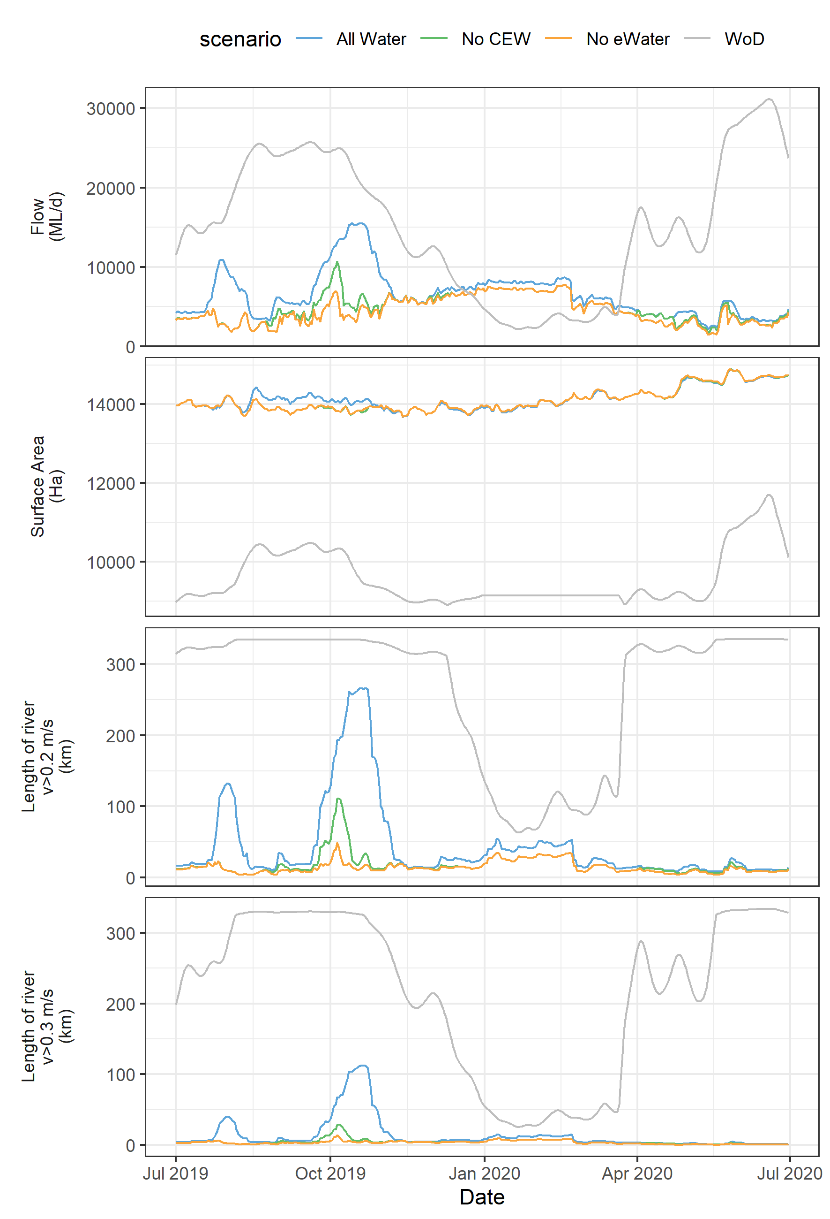

Figure 7. Discharge (Flow to South Australia), inundated area and length of river with faster flowing velocities (v>0.2 m/s and v>0.3 m/s) for the LMR between Locks 1 & 6 (excluding anabranches). Total length of river assessed in the LMR = 345 km.

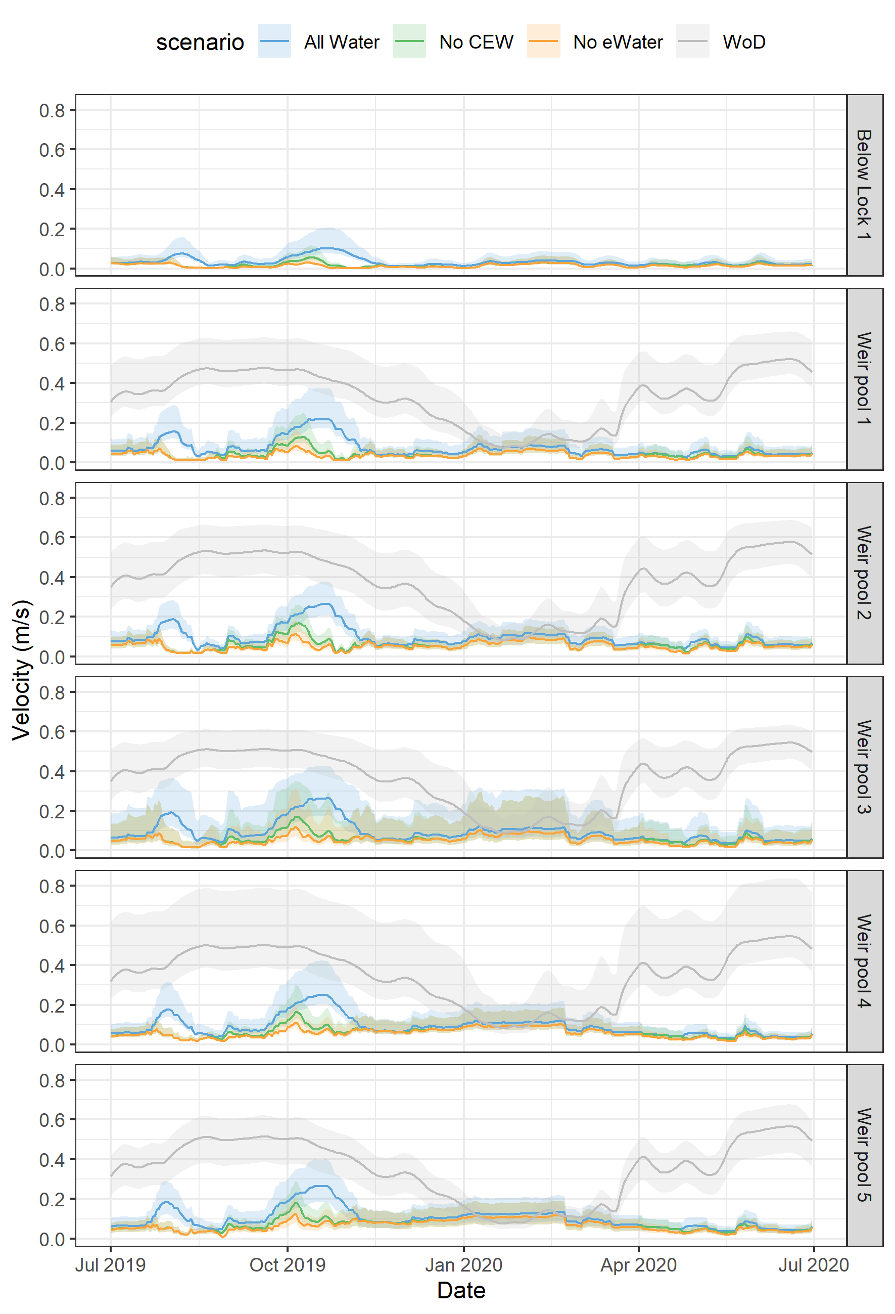

Figure 8. Median modelled velocity in each weir pool (line), with the range in velocities within the weir pool (the shaded area), defined by the 10th and 90th percentiles, in the LMR.

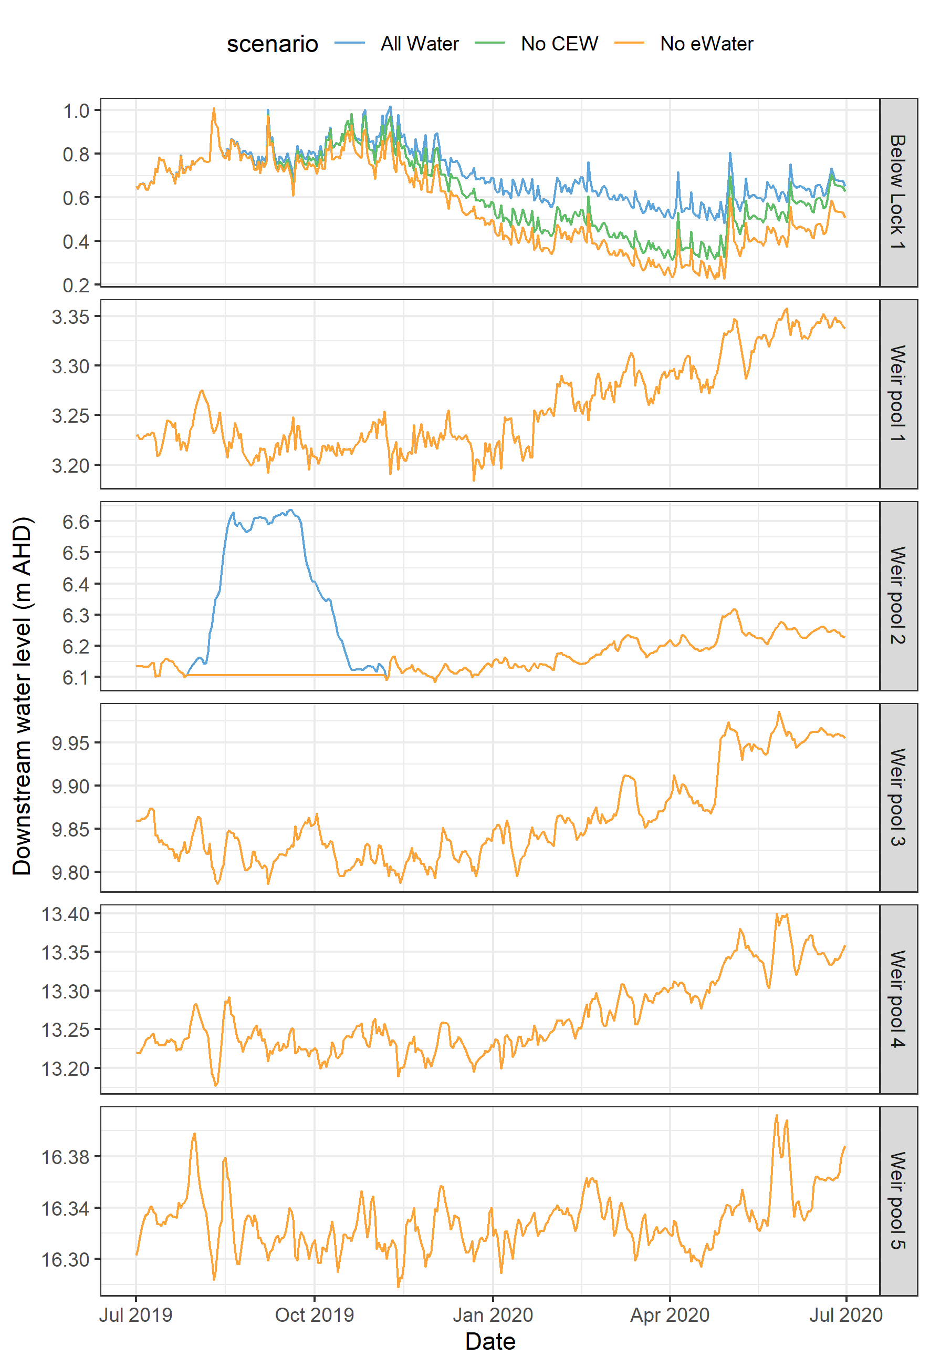

Figure 9. Modelled water level at the downstream end (i.e. at the lock and weir) of each weir pool in the Lower Murray Selected Area.

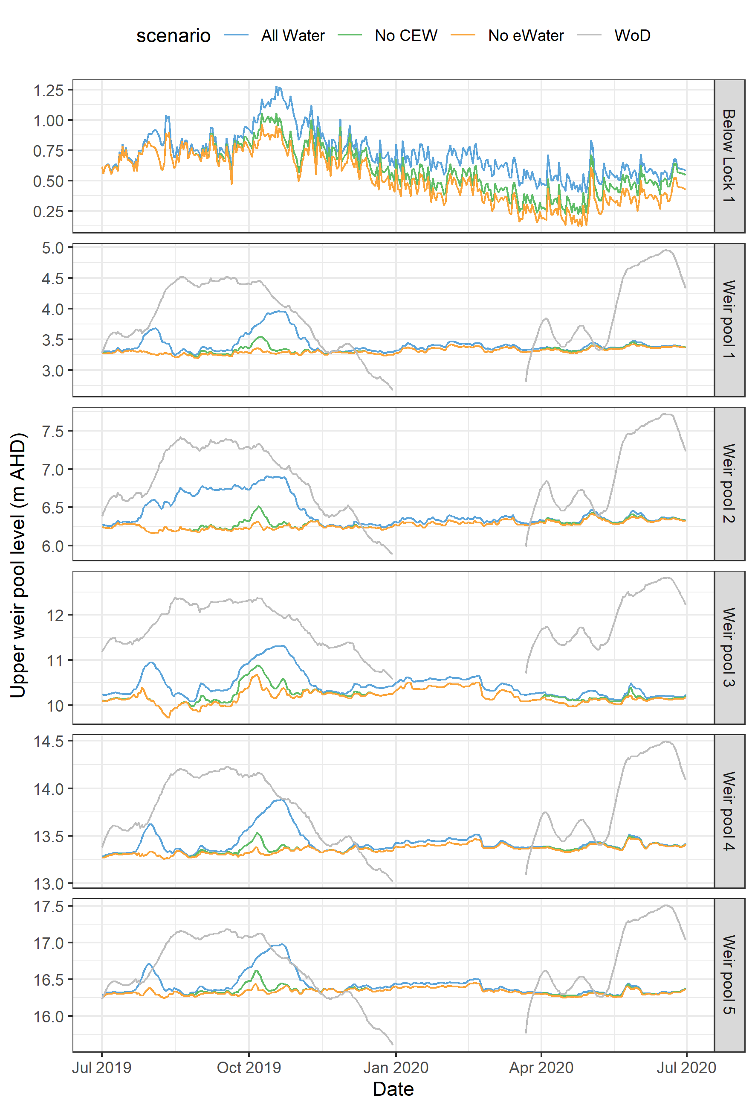

Figure 10. Modelled water level at the upstream end of each weir pool in the LMR.

### Evaluation

To evaluate the contribution of Commonwealth environmental water towards an outcome, a contribution significance level was assigned to each evaluation question answer for a single year or five-year period. The level was viewed as ‘to what extent Commonwealth environmental water contributed towards that observed outcome, with the ecological significance of the outcome considered where possible’. For example, the level assigned may be similar for an ecologically significant outcome of which Commonwealth environmental water had minor contribution towards versus an outcome that was considered negligible of which Commonwealth environmental water had major contribution towards. The thresholds for assigning the significance vary among indicators and questions, ranging from using arbitrary percentages or values, to qualitative assessment based on expert opinion.

Table 3. Hydrological Regime evaluation questions and answers. CEW = Commonwealth environmental water, eWater = environmental water.

| CEWO evaluation questions | Outcomes of CEW delivery | | | | | |
| --- | --- | --- | --- | --- | --- | --- |
| 2014-15 | 2015-16 | 2016-17 | 2017-18 | 2018-19 | 2019-20 |
| What did CEW contribute to hydraulic diversity within weir pools? | 13 km, 4% (17 km, 5%) | 18 km, 5% (22 km, 6%) | 20 km, 6% (53 km, 15%) | 36 km, 10% (49 km, 14%) | 15 km, 4% (19 km, 6%) | An additional 34 km or 10% of lotic conditions created by CEW for at least 30 days (An additional 74 km or 22% for at least 14 days) |
| CEW provided a moderate contribution towards increasing lotic habitat, with an additional 34 km of river (10%) for 30 days.  Length of river with lotic conditions (velocity >0.3 m/s) has been used to represent hydraulic diversity. If there is some fast flowing water, it is expected there will be greater hydraulic diversity due to changes in habitat complexity (bends, backwaters, benches, etc.). Length of river with lotic conditions exceeded for 30 days over the year is presented, and 14 days in brackets. The time periods represent a number of flow-related ecological or life-history processes that could occur over periods of ~2−4 weeks. Total length of river assessed in the LMR = 345 km. | | | | | |
| What did CEW contribute to variability in water levels within weir pools? | 0.10 m | 0.15 m | 0.08 m | 0.17 m | 0.10 m | Interquartile range (IQR) in water level increased by 0.13 m with and without CEW in the tailwaters (i.e. just downstream of each weir) across Weir Pools 1–5. |
| CEW increased water level variability (IQR) in the tailwaters of weir pools in 2019/20 to a similar degree that has been expected over the previous 5 years.  IQR is a measure of variability, as the difference between the 75th and 25th percentile values for water level over the year. If the IQR increases, the variability must have increased. | | | | | |
| What did CEW contribute to hydrological connectivity? | 28 ha  20% | 963 ha  37% | 0 ha  5% | 831 ha  39% | 484 ha  20% | Maximum area inundated not increased by eWater.  33% increase in volume at the SA border. |
| CEW contribution to connectivity has been assessed laterally, as the increase in maximum inundated area each year, and longitudinally, as the percentage increase in volume each year (as used for Basin Scale assessment).  CEW contribution to lateral connectivity was limited. While the Lock 2 weir pool raising and eWater delivered did increase the inundated area over the first half of the year, the maximum area inundated resulted from the raising of most weir pools within operational ranges at the end of the year.  Longitudinal hydrological connectivity was increased by CEW in 2019/20, where the Basin-wide eWater strategy target for a 30% increase in flows in the River Murray was met. Given this target was met, a ‘moderate’ contribution has been assigned for hydrological connectivity. | | | | | |
| What did CEW contribute to Meeting Environmental Water Requirements (of the LTWP) in the main channel of the Lower Murray? |  |  |  |  |  |  |
|  | | | | | |

Contribution (to what extent CEW contributed towards the outcome, with the significance of the outcome considered):

|  |  |  |  |  |  |  |  |  |  |  |  |
| --- | --- | --- | --- | --- | --- | --- | --- | --- | --- | --- | --- |
|  | Unknown |  | Negative |  | None/negligible |  | Minor |  | *Moderate* |  | Substantial |

### Discussion

2019/20 was a dry year, where only 1645 GL of the full 1850 GL of South Australia’s entitlement flow was available, and there was no unregulated flow. In dry years like this Commonwealth environmental water provides a substantial contribution to longitudinal connectivity, with an increase in 33% of the volume delivered at the SA border. Given the dry conditions, a minimal increase in lateral connectivity occurred, to the extent that a small increase in weir pool levels across the selected area for water resource management purposes resulted in a larger inundated area.

A range of metrics has been considered to assess the evaluations questions in Table 3. Relevant velocity thresholds, proportions of the river, time of year and duration required for different ecological processes to be promoted are the focus of further research, as the empirical evidence relating the conditions occurring, and different ecological processes being promoted, continues to grow. It is expected that this hydraulic information, and the methodology developed to derive it for the future, will help to develop eco-hydraulic relationships.

The evaluation of Commonwealth environmental water contribution to hydraulic diversity within weir pools in is in line with previous years. Figure 11 presents the Flow to SA over the past six years to compare the events delivered. It can be seen that events of similar magnitude and duration occurred in 2014/15, 2017/18 as this year of evaluation in 2019/20. Ye et al. (2020) demonstrated that the increase in discharge to this magnitude (e.g. 17,840 ML/d in 2017/18), compared to ~12,000 ML/d in the two dry years of 1015/16 and 2018/19, increased the total number of river km with lotic velocities created by Commonwealth environmental water by a factor of 2–2.8. This result highlights the substantial increases in lotic habitat in the LMR by increasing flow to South Australia in the order of 20,000 ML/d.

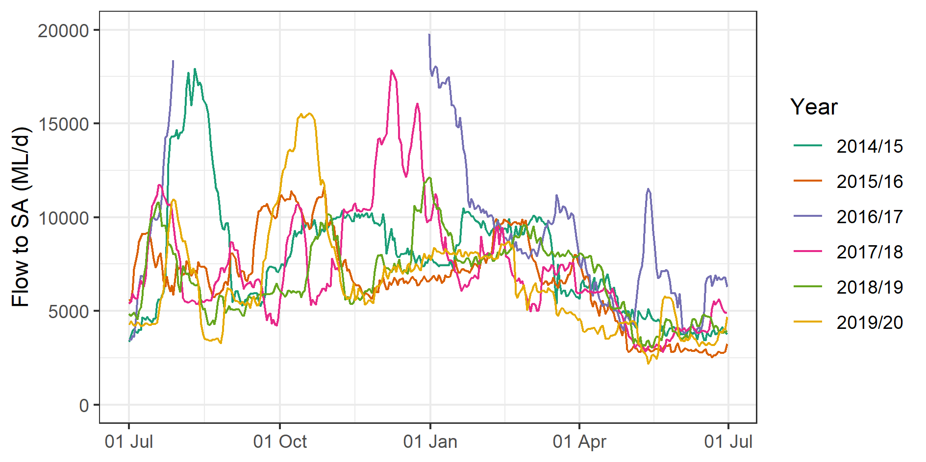

Figure Flow to SA over the past six years, where events of similar magnitude and duration have occurred in 2014/15, 2017/18 and 2019/20. The high flow year of 2016/17 peaked at 94350 ML/d.

### Management implications

The hydraulic model outputs underpinning the results have been presented in Figures 11 and 12 to help inform changes that can be expected from environmental water delivery and weir pool management. From these plots, the change in inundated area and proportion of the reach with lotic conditions (velocity >0.3 m/s) for each weir pool can be determined.

The inundated area can be seen in Figure 11, with the more horizontal the contour line, the greater the influence of weir pool raising on inundation extent. As discharge increases, the contour lines can be seen to slope to be more vertical, indicating that increases in discharge have a larger effect on inundated area, as the height of tailwaters of weir pools increase, with weirs close to overtopped by the maximum discharge shown of 45,000 ML/d (depending on the weir pool).

It is not just the maximum inundated area, or area inundated for a given duration that can enhance ecological responses, but also the variability in water levels. Variable water levels, and the coinciding periods of exposure and submergence of substrates beyond the euphotic zone, can result in the regular “re-setting” of biofilms (Steinman and McIntire 1990). The biofilm is a key component of riverine food webs, and this re-setting of the biofilm algal community produces higher quality food resources dominated by diatoms and unicellular algae (Wallace and Cummings 2016). Wallace and Cummings (2016) assessed biofilm changes during and following a 0.54 m raising of Lock 2 in 2015, and found only small changes in the biofilm composition directly upstream of Lock 2 immediately following the event, and no changes 35 days following the event. Based on this result, the authors suggested that frequent changes in weir pool level that mimic natural variability rather than annual “events” may be required to maintain early successional biofilm communities, expected to be a more nutritious food source.

The trade-off to increased inundation for the same discharge generated by raising water levels by operation of the weirs and other environmental water regulators is a reduction in velocity. This can be evaluated using Figure 12, showing the proportion of the weir pool with a velocity greater than 0.3 m/s for different combinations of discharge and weir pool manipulation. In Figure 12, the contour lines are close to vertical, indicating the weir pool manipulation has a marginal influence on the proportion of the weir pool exceeding this velocity threshold. Increases in discharge have a much larger influence on the proportion of the reach with velocity exceeding 0.3 m/s, with between 10–30% of the reach at a flow to South Australia of 10,000 ML/d, up to greater than 90% of the reach for flow of 30,000 ML/d. As noted earlier, further research is required to determine ecologically relevant metrics to interpret the consequences of changes in this particular reach scale metric.

The restoration of lotic habitats is important for ecological and life history processes for many native biota that are adapted to flowing riverine environments. For example, they provide stimuli for spawning of flow-cued species (e.g. golden perch) (King *et al.* 2016), facilitate downstream drift and transportation of plankton, macroinvertebrates and fish larvae (Gibbs *et al.* 2020), and provide diverse hydraulic habitats that are suitable for a range of species (e.g. Murray cod) (Zampatti *et al.* 2014). The reduction in the abundance and distribution of riverine (lotic) biota (e.g. Macquarie perch *Macquaria australasica* and Murray crayfish *Euastacus armatus*) throughout the MDB (Lintermans 2007) highlights the importance of restoring hydraulic conditions (e.g. lotic habitats), which is particularly needed in the heavily regulated LMR.

### Conclusion

The five-year period evaluated was dominated by low flow conditions. With the exception of the 2016-17 high flow year, without environmental water the only flow events greater than the minimum flow to be delivered to South Australia under Clause 88 of the MDB Agreement occurred at the start of 2014-15 and a short event in December 2017. Under these minimum flow conditions, water levels would have been very stable throughout the year, with low hydraulic diversity and minimal fast flowing conditions in the LMR.

The provision of some environmental water over most months in the five-year period increased longitudinal connectivity through the system. Environmental water introduced some hydraulic variability that would not have otherwise occurred, to a greater degree in 2017-18 when discharge was increased to 17,840 ML/d compared to ~12,000 ML/d in other years (excluding the unregulated flow in 2014-15 and 2016-17 high flow year). In combination with weir pool raisings, environmental water also increased water level variability each year, as demonstrated by time series of modelled water levels with and without the environmental water, and the resulting interquartile range.

The understanding of the most relevant velocity thresholds, proportions of the river, time of year and duration required to promote different ecological processes is in its infancy. As the body of empirical evidence of these ecological responses increases, the hydraulic information presented in this section is expected to be foundational in understanding causal relationships, and in turn, the contribution environmental water has made to ecological outcomes.

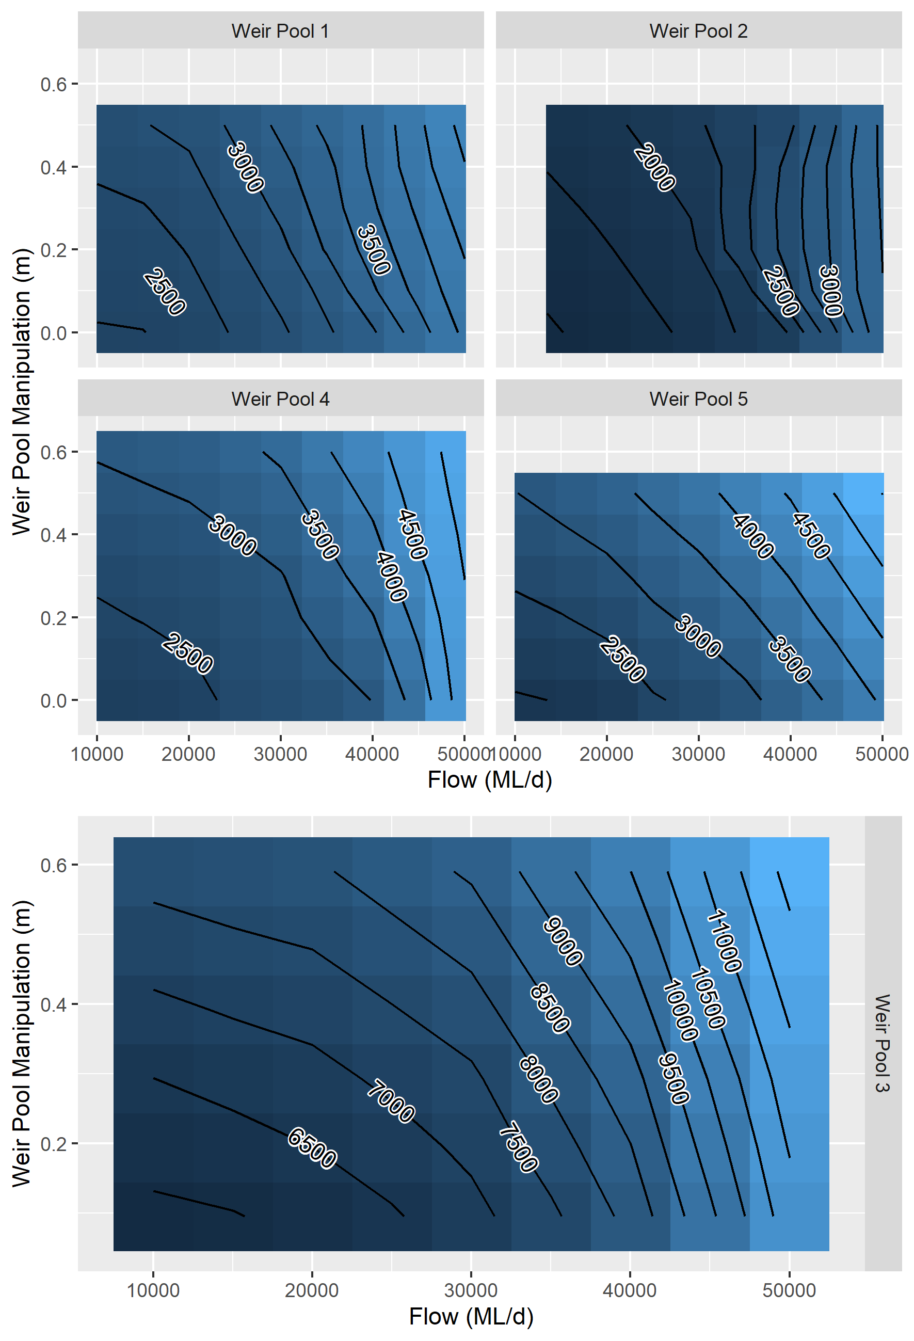

Figure 12. Area inundated (hectares) in each weir pool for changes in discharge and weir pool level in the LMR. Weir Pool 3 is shown on a different colour scale due to the larger areas in this weir pool.

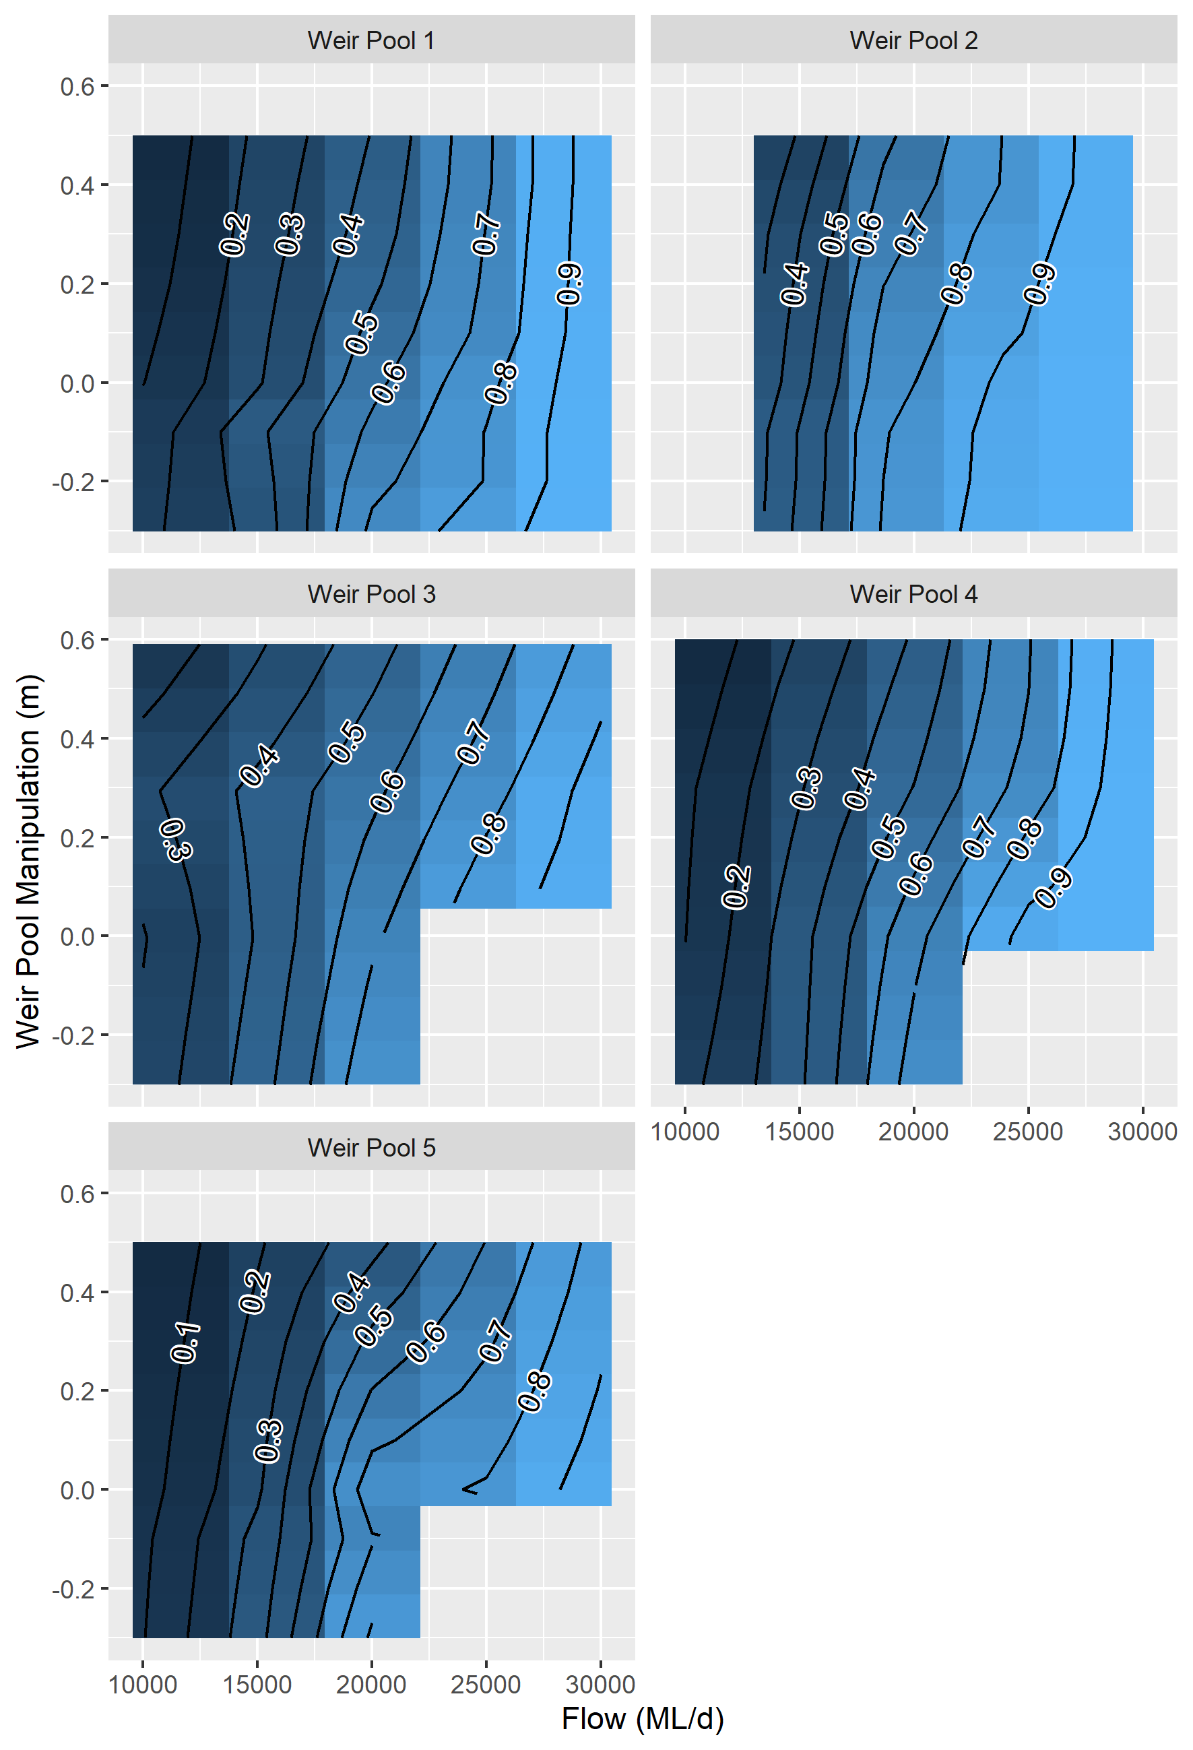

Figure 13. Proportion of the weir pool with velocities exceeding 0.3 m/s for changes in discharge and weir pool level in the LMR.

## Stream Metabolism and Water Quality

### Background

River food webs require organic materials as food resources. In deeper rivers with low light penetration, macrophyte growth is restricted and the microbiota (e.g. bacteria, protists and microalgae) form the lowest trophic levels of the food web. The incorporation of organic material by these organisms provides a major source of food for the higher trophic levels of microinvertebrates, macroinvertebrates and fish (Oliver and Merrick 2006).

There are two sources of organic carbon supplying the basal trophic levels. Photosynthetic microbes, comprised of microalgae and cyanobacteria, fix dissolved carbon dioxide using the energy of sunlight to form organic materials for cell growth. In deeper rivers this process is dominated by phytoplankton, the photosynthetic microbes that are suspended in the water column (Sellers and Bukaveckas 2003; Oliver and Merrick 2006; Várbíró *et al.* 2018). The availability of light for phytoplankton photosynthesis is influenced by the depth of light penetration relative to the average depth, and the intensity of water mixing that circulates phytoplankton through the upper illuminated surface layers. The availability and concentrations of nutrients also influence photosynthesis and the formation of organic materials (Reynolds 1984). Photosynthetic processes are affected by flow rates and water quality, and these are influenced by the catchment water sources, including environmental water contributions.

The second source of organic carbon is from external, terrestrial reserves (Berggren and del Giorgio 2015; Whitworth and Baldwin 2016). Terrestrial material can enter the river from wind movement, or from overhanging or fringing vegetation, but in floodplain rivers, like the Murray River, the transfer of terrestrial organic material is largely through flooding. Generally, this is comprised of materials that have accumulated on the floodplain between floods (Whitworth and Baldwin 2016). However, terrestrial materials that have accumulated on dry riverbanks and benches, or in fringing wetlands, can enter the river following increased channel flows that inundate these previously disconnected areas (McGinness and Arthur 2011). Flow patterns are important in determining the sources and supply of terrestrial organic carbon, and so environmental flows and their management will impact the carbon supply to the river food web (Oliver and Merrick 2006; Baldwin *et al.* 2016).

The respiratory breakdown of assimilated organic carbon provides energy and substrates for cell growth, with some associated loss of carbon as carbon dioxide. Although respiration is carried out by all river biota, the major contributors are the microbiota as they have higher respiration rates per unit mass and are usually present in greater quantities than organisms of larger size. Laboratory studies have shown that organic carbon recently fixed through photosynthesis is a primary source for phytoplankton respiration (Beardall and Raven 1990). In contrast, heterotrophic respiration is a result of the decomposition of organic materials sourced from the environment. Terrestrial organic carbon enters rivers in particulate and dissolved forms, but dissolved organic carbon is most actively incorporated by heterotrophic microbes such as bacteria and is a major driver of heterotrophic respiration (Graeber *et al.* 2018). Identifying the respiration associated specifically with phototrophs and heterotrophs is critical because they are both major contributors to the basal food resources (Graeber *et al.* 2018).

River metabolism measurements estimate the in-stream rates of gross primary production (GPP) and ecosystem respiration (ER), providing information on the sources and utilisation of organic carbon by riverine food webs (Odum 1956; Young and Huryn 1996; Oliver and Merrick 2006). Comparing rates of photosynthesis and respiration helps describe the fundamental trophic energy connections that characterise different food web types. It can indicate whether production or decomposition processes predominate, and whether the organic food materials have come from within the river (autochthonous sources) or from the surrounding landscape (allochthonous sources). The magnitude and characteristics of the metabolic processes indicate the size of the food web and its capacity to support higher trophic levels, including fish, which are key targets for ecosystem management (Odum 1956; Oliver and Merrick 2006; Oliver and Lorenz 2010; Sellars and Bukaveckas 2003).

Net ecosystem production (NEP), the difference between GPP and ER, is considered a measure of the overall carbon balance, and frequently used as an estimate of the basal food resource supply (Odum 1956; Young and Huryn 1996; Oliver and Merrick 2006). If GPP>ER, carbon is accumulating, while if GPP<ER, carbon is being lost from the system. However, this interpretation implicitly assumes that fixation of carbon through photosynthesis is the source of organic material fuelling respiration. This is not usually the case, as respiration is also due to the decomposition of allochthonous organic carbon by heterotrophs which results in heterotrophic production, an additional food resource not accounted for in the NEP calculation. Preferably the contributions of photosynthetic and heterotrophic organisms to net production can be estimated explicitly, as these are the two major pathways of organic carbon supply to the river food web.

During the five-year monitoring period, environmental water contributions to the flow in South Australia (Figure 5; 

Figure 4. Daily flow (ML/d) in the LMR at the South Australian border (blue solid line) from January 1996 to July 2020, compared to modelled flow under natural conditions (grey dashed line). Approximate bankfull flow in the main channel of the LMR is shown (black dashed line).

Table 1), provided the opportunity to investigate their influence on metabolism. The objective of this study was to provide a more comprehensive assessment of metabolism in the LMR as a basis for evaluating the effects of environmental flows.

*Major hypotheses*

Increased flow (including the delivery of environmental water) into the LMR (peak and duration) in spring/summer will:

* Alter phytoplankton photosynthesis and the supply of autochthonous organic carbon to food webs if changes in channel flow volumes and water quality modify light and nutrient availability.
* Enhance ecosystem respiration (ER) rates and heterotrophic production if flows better connect the channel with riparian, wetland or floodplain areas, increasing the supply of allochthonous organic carbon.
* Reduce the likelihood of low dissolved oxygen (DO) concentrations by increasing water mixing in otherwise low flow zones except if flows carry excessive loads of organic carbon.

### Methods

*Field sampling*

Rates of stream metabolism were estimated from changes in concentrations of dissolved oxygen, which also provided information on the suitability of DO to support the aquatic biota. Monitoring consisted of *in situ*, continuous ten-minute interval logging of DO, water temperature, and incident light at two river sites. One site was downstream of Lock 1 (‘Lock 1’ herein) in the gorge geomorphic zone, and one downstream of Lock 6 (‘Lock 6’ herein) in the floodplain geomorphic zone, refer to SARDI *et al.* (2018). Monitoring generally occurred from September to February/March each year (2014–2019), with occasional interruptions (< one day) during probe maintenance, except for the period 27 December 2015 to 20 January 2016 when data were not available for Lock 6 due to probe failure.

Two metre, depth-integrated water samples were collected during probe maintenance field trips (fortnightly to monthly), and analysed for chlorophyll *a*, total nitrogen, combined nitrate and nitrite, ammonium, total phosphorus, dissolved forms of phosphorus, and dissolved organic carbon. The detailed monitoring and analytical protocols described in Hale *et al.* (2014) were followed, but with some minor adjustments as detailed in Ye *et al.* (2018). In addition, the vertical light attenuation for Photosynthetically Active Radiation (PAR) was measured on each occasion using LiCOR underwater sensors.

Water quality measurements and vertical attenuation coefficients were considered relevant for two days before and two days after sampling, and this extended data set (220 points) was used to explore relationships with metabolic rates. In some cases, water quality data were supplemented with monitoring data from nearby sites provided by the Australian Water Quality Centre of South Australia Water.

*Estimating metabolic rates*

Daily volumetric rates for GPP and ER were estimated over 24-hour periods from midnight to midnight with the *BASE* program (Grace *et al.* 2015). This uses Bayesian regression routines to fit the measured changes in dissolved oxygen concentrations to a widely applied model that describes the daily fluctuations in water column dissolved oxygen concentrations (Odum 1956; Young and Huryn 1996; Oliver and Merrick 2006). The Levenberg-Marquardt curve fitting algorithm was also used to estimate metabolic rates as under some conditions it was computationally more efficient (Oliver and Merrick 2006; Oliver and Lorenz 2010). In general, both methods provide equivalent estimates of metabolic rates.

Oxygen based metabolic rates were converted to carbon units by assuming that the photosynthetic and respiratory quotients were equal to one. That is, every mole of oxygen transfer was considered matched by an opposite transfer of a mole of carbon dioxide.

The measured volumetric rates of metabolism were integrated over river depth and width based on channel morphometry. Daily flows measured during the monitoring periods were adjusted using hydrological modelling to estimate flows and water levels without Commonwealth environmental water, and without any environmental flows, and linked to channel morphometry. The morphometric data included the average cross-sectional areas, average depths, and average widths at different flow levels for river reaches stretching ca. 7 to 9 km upstream of each monitoring site. Currently, reliable estimates of water levels for flows modelled without environmental water are not available at the Lock 1 site. Water levels at this site are due not only to flow, but are complicated by interactions with Lower Lake levels and wind influences. Consequently, estimates of flow induced changes in metabolism are not presented for this site, but are expected to become available as modelling of water level progresses.

The volumetric metabolic rates were used to assess the influence of different water levels, while the cross-sectional metabolic rate, calculated as the product of the volumetric rate and the average cross-sectional area, was used to assess the effect of different flow volumes. The influence of flow on the average depth and cross-sectional area is a function of the channel morphometry, and increased flows may increase or decrease these depending on channel shape. Volumetric rates are reported as gm/m3/day (numerically equal to mg/L/day), area as m2 and so cross-sectional rates are for a 1 m length of river. Metabolic rates were integrated over time by summing daily rates to provide a basis for annual comparisons.

The influence of light on photosynthesis was analysed using the mean light intensity encountered by phytoplankton as they are mixed through the water column. The mean intensity depends on the incident irradiance (Io), the vertical attenuation of light passing through the water column (kd), and the average depth (zave). If the average depth is greater than the depth of the illuminated surface layer, then the mean irradiance (*Im*) is given by (Oliver and Merrick 2006):

$$Im=\frac{Io}{kd*zave} \left(1\right)$$

The amount of phytoplankton present was estimated from the chlorophyll concentration. Chlorophyll was converted to carbon by assuming it comprised 2.5% of cell ash-free dry weight and that cell carbon comprised 50% of ash-free dry weight, resulting in a multiplier of 20. Rates of GPP were standardised to chlorophyll concentrations in carbon units to account for differences in phytoplankton concentration (GPP(b)) and compared with the corresponding mean irradiances *Im*. The relative changes in GPP(b) due to Commonwealth environmental water, and total environmental water were calculated from the ratio of the average changes in depths resulting from these flows. Conversion of modelled GPP(b) estimates to GPP requires knowledge of the chlorophyll concentration. If it is assumed that the chlorophyll concentration on each day remains the same with and without environmental flows, then relative changes in GPP(b) and GPP are equivalent.

The contributions to ER by photosynthetic and heterotrophic microbiota was investigated using multiple regression. The potential component contributions to ER were estimated from a series of measures of respiratory sources. Chlorophyll-a provided a measure of the phytoplankton concentration, which has previously been shown to estimate their “maintenance” respiration when concentrations are high (Oliver and Merrick 2006). GPP provided a measure of the organic carbon produced by photosynthesis, which is a major source of phytoplankton respiration (Beardall and Raven 1990). DOC concentrations provided a measure of the resource supply for respiration of heterotrophic microbes. Components with insignificant regression coefficients were sequentially removed. Respiration rates were averaged for each two-day period before and after the sampling date and compared with similarly averaged GPP rates, as respiration is influenced by GPP of the preceding day. Respiration rates were standardised to 250C before analyses to account for the influence of temperature.

The overall NEP was calculated as the difference between volumetric GPP and ER. The phytoplankton net production (PNP) was calculated as the difference between the measured GPP and the estimated phytoplankton community respiration (PCR). Similar calculations could not be used to estimate bacterial net production (BNP) as metabolism measurements do not provide a measure of bacterial gross production. Instead estimates were based on the bacterial growth efficiency (BGE), which is the ratio of the BNP to the sum of BNP and the bacterial respiration (BCR). Re-arrangement of this relationship provides an approach for estimating BNP but requires knowledge of the BGE:

$$BNP=\frac{BGE*BCR}{1-BGE} (2)$$

The BGE is influenced by a range of environmental conditions including the chemical composition of DOC. However, an average value of 0.2 was considered reasonable for the Murray River within its typical temperature range and water quality attributes (Marra and Barber 2004; Rivkin and Legendre 2001; Berggren and del Giorgio 2015). The combined net production (CNP) was estimated as the sum of the calculated PNP and BNP.

### Results

*Daily metabolic rates*

Patterns of daily GPP (photosynthesis) and ER (respiration) varied markedly within and between years, and across sites, with particularly high respiration rates evident in the 2016-17 flood year (Figure 13). Generally, GPP and ER were of similar magnitude and daily NEP values varied between negative and positive values but were often close to zero, with integrals over time close to zero. Understanding the causes of these patterns and interpreting their significance to food resource supply is a key objective of the following analyses.

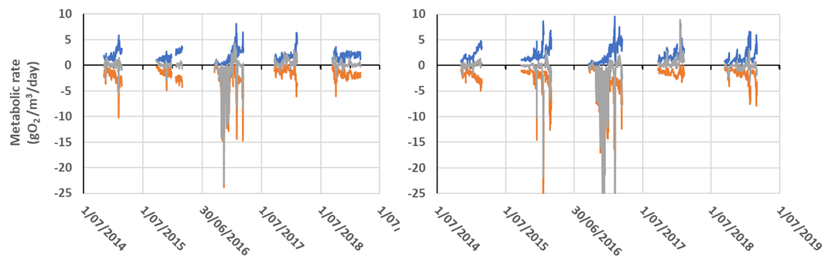

Figure 14. Rates of GPP (), ER () and NEP () at (left) Lock 6 and (right) Lock 1 over the five monitoring periods from 2014–2019.

*Gross primary production*

There was a strong correlation between GPP(b) and *Im*, although the variation was large, especially at the Lock 1 site. Previous metabolism measurements in the weir pools showed that at water velocities above ca. 0.2 m/s mixing entrained the phytoplankton and *Im* reliably described the light encountered (Oliver and Lorenz 2010). Re-analysing data for water velocities ≥0.22 m/s greatly improved the regression relationship, with GPP(b) proportional to *Im* (Figure 14).

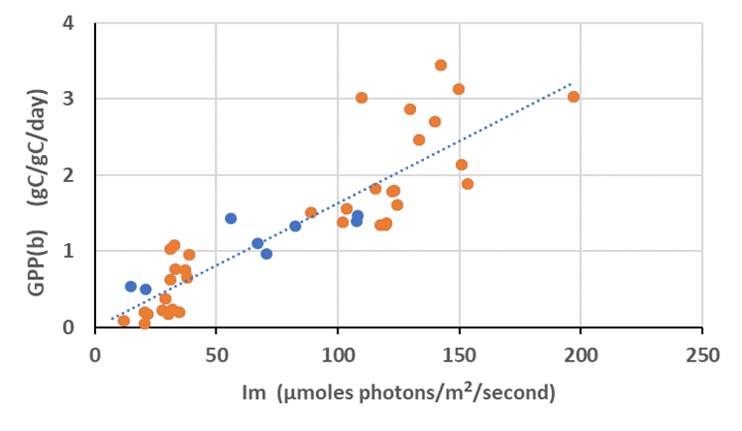

Figure 15. The response of GPP per unit phytoplankton biomass in carbon units, to the mean irradiance of the water column over the daylight period for Lock 6 (orange circles) and Lock 1 (blue circles) when water velocities were greater than 0.22 m/s. Regression, y = 0.0164x - 0.0024, r2= 0.78.

Combining this regression with Equation 1, GPP can be estimated from:

$$GPP=GPP\left(b\right)*chla=0.016*\frac{Io}{kd*zave}*chla (3)$$

This indicates that increases in the average depth reduce the volumetric rate of GPP(b) in inverse proportion to the relative change in depth. At Lock 6, the increases in flow due to environmental water (Figure 15A) generally reduced the volumetric GPP(b) as average depths increased (Figure 15B). The predicted change in GPP(b) ranged from an increase of 3% to a reduction of 28%. If water quality, including the chlorophyll concentration and kd, remain unchanged for the daily comparisons of flows with and without environmental water, then fractional changes in volumetric GPP are equivalent (Equation 3).

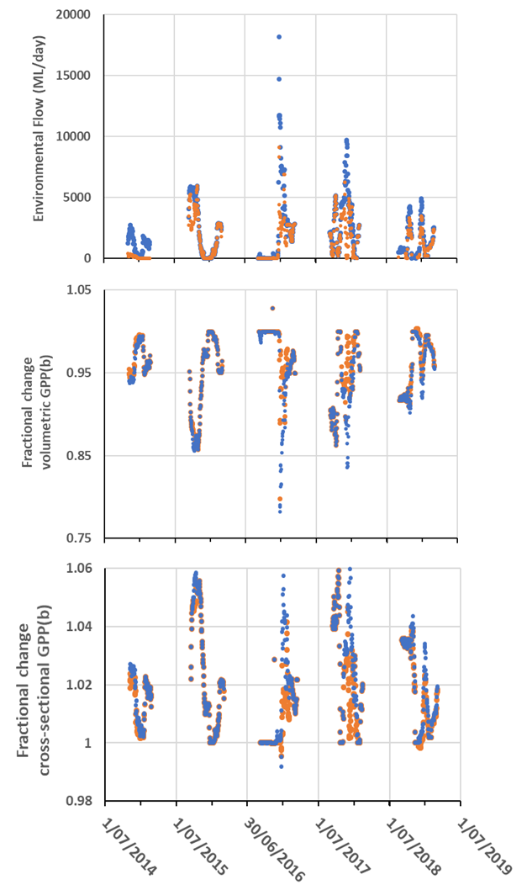

Figure 16. (A) Environmental water contributions to discharge at Lock 6, (B) Fractional change in volumetric GPP(b), (C) Fractional change in cross-sectional GPP(b), due to flow including all environmental water () or only CEW ().

In contrast, environmental flows were generally associated with increases in the cross-sectional area at Lock 6, leading to increased rates of daily river production per metre of river (Figure 15C). The change in cross-sectional GPP(b) with environmental water ranged from a reduction of 1% to an increase of 6.5%. Similar relative changes in volumetric and cross-sectional GPP(b) were estimated for Lock 1.

*Integrated Gross Primary Production*

At Lock 6, the addition of environmental water reduced the volumetric GPP integrated over the monitoring period by between 5 and 21.5 gO2/m3/monitoring period (Figure 16). These are small changes relative to the accumulated GPP without environmental flows, representing relative changes of 0.94 to 0.98 of accumulated rates without environmental flows, reflecting the small reductions in daily volumetric rates (Figure 15).

Increases in cross-sectional GPP due to the addition of environmental water were also small (Figure 15) and the accumulative outcome gave increases of between 637 and 2,445 gO2/river m/monitoring period (Figure 16). These represent increases of between 1.01 and 1.02 of the accumulated rates without environmental flows.

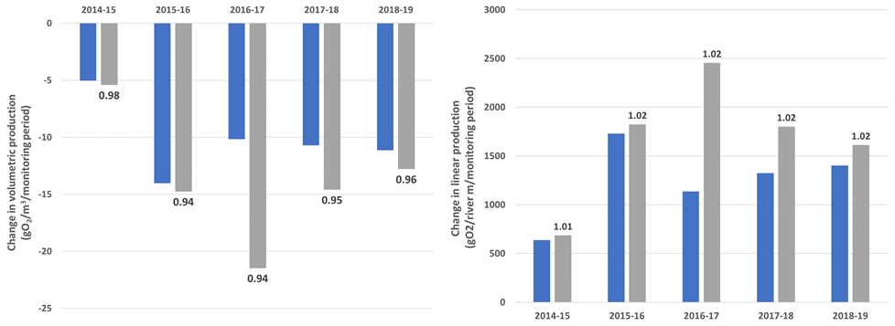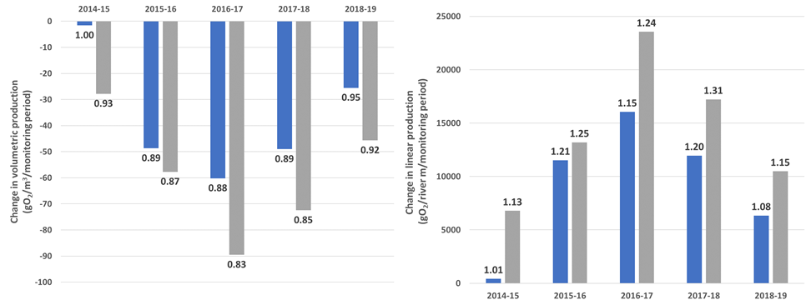

Figure 17. Flow induced changes at Lock 6 (top) and Hattah (bottom) in (left) cumulative volumetric GPP over each monitoring period, (right) cumulative cross-sectional production over each monitoring period, due to the addition of CEW (blue bars) and all environmental water (grey) from no environmental water. Fractions above each bar represent proportional changes in GPP due to environmental flows compared with no environmental flows (e.g. 1.02 indicates GPP increased by 2% over no environmental water).

These small changes in GPP in response to flow reflected the stable water levels within the weir pool systems. To demonstrate the scale of effects that might occur in unregulated river reaches, the responses were modelled for Hattah, a site previously monitored and for which channel morphometry was available (Oliver and Merrick 2006). Modelling assumed the same flow regimes as observed at Lock 6, and utilised the relationships between flow, average depth and cross-sectional area at the Hattah site. Due to the greater shifts in water level at this site, the modelled changes in GPP were significantly larger than at the Lock 1 and 6 monitoring sites (Figure 16). The volumetric GPP reduced by between 0 and 90 gO2/m3/monitoring period, representing reductions in rates to 0.83 of those without environmental flows. Similarly, the changes in cross-sectional GPP were larger with increases of between 0 and 23,600 gO2/river m/monitoring period, representing rates of up to 1.31 times those without environmental flows (Figure 16).

*Vertical attenuation of light*

The light available for photosynthesis is influenced not only by the average depth but also the depth of light penetration. This is determined by kd (Equation 4), which depends on the rate at which light is absorbed by coloured material and scattered by particles as it passes through the water (Kirk and Oliver 1995; Oliver *et al.* 2010; Cottingham *et al.* 2010). A multiple regression analysis indicated that DOC and turbidity (NTU) accounted for 92% of the variation in kd, described by the relationship:

$$kd=0.224*DOC+0.0577*NTU+0.1246 (4)$$

with standard errors for coefficients of 0.013, 0.003, and 0.16 respectively. Values for kd calculated from the regression were closely aligned with measured values (Figure 17). Consequently, any change in flow, or water source that alters the DOC concentration or turbidity, will alter the mean irradiance encountered by phytoplankton and affect GPP(b).

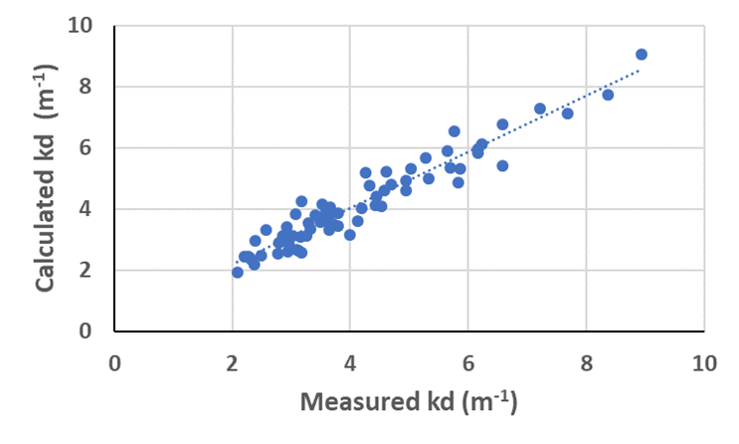

Figure 18. Comparison of the vertical attenuation coefficient kd measured in the field and calculated from the dissolved organic carbon concentration and the turbidity.

*DOC and turbidity*

The large differences in GPP between years were not explained solely by changes in depth and cross-sectional area, indicating that other environmental influences were at play. No strong relationships were observed with nutrient levels, but the three-fold changes in kd impacted significantly on GPP(b) which is inversely related to kd (Equation 3). Turbidity and DOC both affect kd (Equation 4) and comparing their contributions demonstrated the importance of turbidity in influencing GPP(b) (Figure 18). Similar results were obtained at the Lock 1 site.

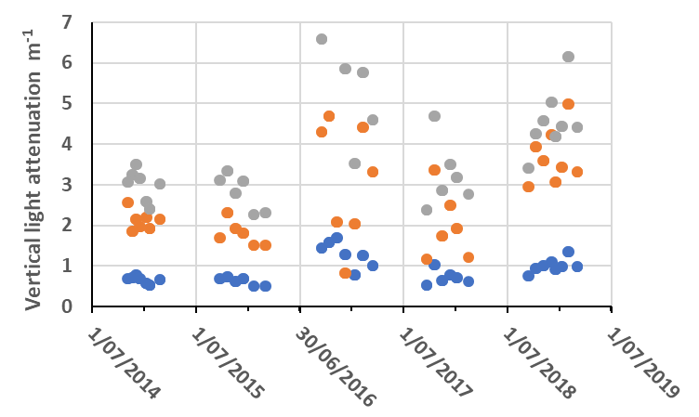

Figure 19. The vertical attenuation coefficient for Photosynthetically Active Radiation () and the contributions due to DOC () and NTU () at Lock 6 for each monitoring period.

*Ecosystem and Community Respiration*

A significant correlation was obtained between ER and the variables GPP and DOC (r2 = 47%, n = 96, GPP Coefficient 0.74 (± 0.12); DOC Coefficient 0.09 (± 0.01)). The regression included a small intercept that was not-significantly different from zero (*P*<0.01). These coefficients were used to provide a comparison of respiration rates due to phytoplankton and bacteria (Figure 19). In most monitoring periods the bacterial contribution to ER (BCR) was equivalent to, or less than the phytoplankton contribution (PCR), except early in the 2016-17 flood year when BCR made up almost all the respiratory activity.

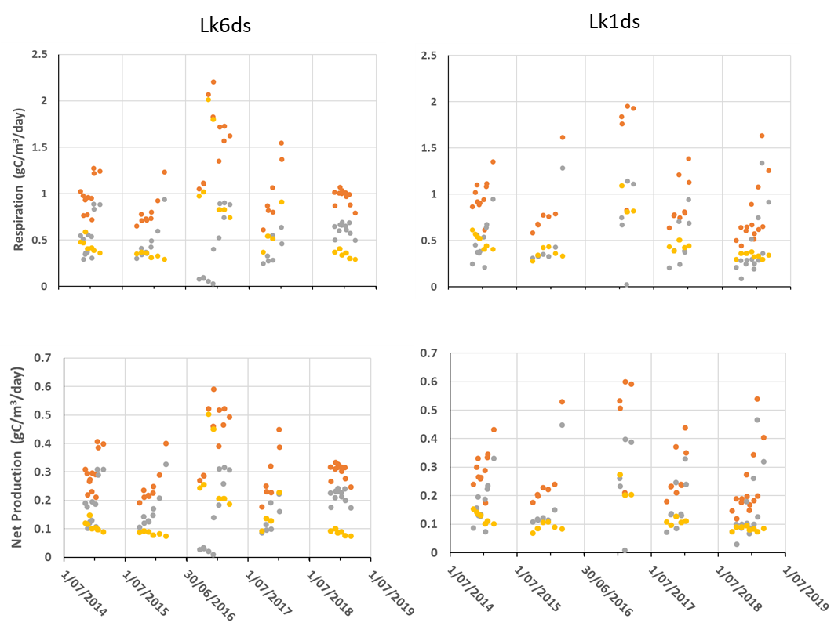

Figure 20. Respiration rates and net production for phytoplankton (), bacteria () and both combined ().

Using these respiration rates, net production was estimated for the phytoplankton and bacteria separately and showed large differences between years (Figure 19). At both sites values for CNP were positive and ranged between 0.1 and 0.6 gC/m3/day, with data clustered around a mean across both sites of 0.3 (± 0.03, 95%CL) gC/m3/day (Figure 19). The phytoplankton contribution to the CNP at Lock 6 varied between 40 and 80%, except early in the 2016-17 flood year when the contribution was reduced, ranging from 0 to 50%. At this time much larger contributions were attributed to bacterial net production associated with high respiration of DOC contained in flood waters. Similar results were obtained at Lock 1 (Figure 19).

*Ecosystem Respiration, Combined Net Production and altered flows*

Estimates of ER for the modelled flow conditions without Commonwealth environmental water or environmental water need to include the contributions from both phytoplankton and heterotrophs. Phytoplankton respiration was correlated with GPP, so the same assumptions were used as in estimating GPP under the different flow scenarios. These were, that on any day the chlorophyll concentration was the same with and without environmental water, and that water quality was largely unchanged, especially turbidity and DOC that influence light attenuation. Under these assumptions the relative changes in the phytoplankton respiration (PCR) will match the relative changes in GPP (Figure 16) for both volumetric and cross-sectional estimates.

The bacterial respiration (BCR) is correlated with the DOC concentration which was assumed to remain unchanged on any given day, enabling estimation of rates without environmental flows. In contrast to GPP, where flow induced changes in light availability influence the estimates of volumetric rate, if DOC concentration is unchanged then the volumetric BCR remains unchanged. Consequently, the linear river rates will alter in proportion to the relative changes in cross-sectional area. The effect of this can be estimated from Figure 16 by adjusting the relative changes in cross-sectional GPP rates for the relative changes in the volumetric rates. In the Lock 6 data the relative increases in BCR will be between 2 and 6% higher than the relative changes shown for cross-sectional GPP in response to environmental water, ranging between factors of 1.03 and 1.09. The modelled results for the Hattah site indicate relative changes in BCR between 7 and 17% higher than the relative changes shown for cross-sectional GPP, with factors ranging between 1.22 and 1.54, indicating substantial increases in the cross-sectional decomposition rate with the addition of environmental water.

The data indicate that phytoplankton net production is a constant fraction of GPP and so will change in proportion to GPP. Consequently, the proportional changes in GPP depicted in Figure 16 match the proportional changes expected in PNP, with increased flows reducing volumetric rates but increasing cross-sectional rates. The heterotrophic net production as estimated from Equation 2 is proportional to BCR and consequently heterotrophic net production increases proportionally to increases in BCR in response to flows.

If cross-sectional rates of NP reflect a “carrying capacity” for the river in terms of carbon production available for higher trophic levels, then at the unregulated Hattah site the modelled results indicate that in 2017-18 integrated cross-sectional PNP was increased by a factor of 1.31, and BNP by a factor of 1.54 as a result of environmental water flows.

*Dissolved oxygen*

Modelling of phytoplankton metabolism indicated that PNP was on average positive, generating a net oxygen surplus, while bacterial respiration of DOC reduced oxygen concentrations. The DO concentration resulting from this interplay depends not only on the light intensity and the concentration of DOC, but also on the gas exchange at the water surface. Reduced exchange rates enhance the possibility of oxygen depletion when DOC concentrations are high. The gas exchange coefficient was found to be a function of the water velocity, which along with wind generates mixing in the river (Figure 20A). At velocities below ca. 0.18 m/s, gas exchange was reduced to values approaching zero. This critical velocity was used to assess the influence of environmental flows in reducing the potential for low oxygen periods by increasing velocities and maintaining gas exchange rates. In most years, environmental flows made significant contributions, particularly during the spring and summer periods when respiration rates were high. The number of days in each monitoring period meeting the velocity criteria (0.18 m/s) without environmental water contributions, with Commonwealth environmental water, or with all environmental water, are presented in Table 4 and Figure 20B.

Table . Number of days in each monitoring period meeting the velocity criteria (0.18 m/s) without environmental water (eWater) contributions, with Commonwealth environmental water (CEW), or with all environmental water.

|  |  |  |  |  |
| --- | --- | --- | --- | --- |
| **Year** | **Total number of days** | | **Additional days due to** | |
| No eWater | All water | Other eWater | CEW |
| 2014-15 | 0 | 31 | 31 | 0 |
| 2015-16 | 0 | 69 | 16 | 53 |
| 2016-17 | 130 | 165 | 14 | 21 |
| 2017-18 | 12 | 80 | 18 | 50 |
| 2018-19 | 1 | 46 | 20 | 25 |

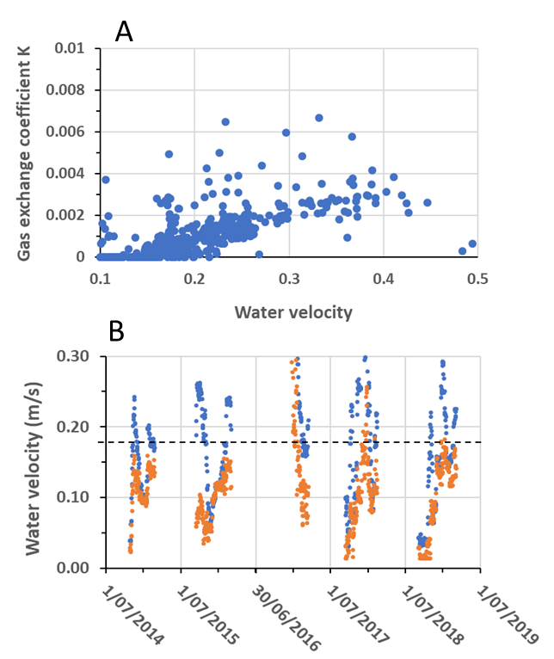

Figure 21. (A) The gas exchange coefficient at different water velocities and (B) the water velocities with () and without () environmental water at Lock 6.

### Evaluation

The evaluation approach, including assessment criteria, is described in the evaluation section for hydrological regime (Section 2.1).

Table 5. Stream Metabolism evaluation questions and answers relating to Commonwealth environmental water (CEW) and environmental water (eWater). The Lock 6 site has been used to answer the evaluation questions.

| **CEWO evaluation questions** | **Outcomes of CEW delivery** | | | | | | |
| --- | --- | --- | --- | --- | --- | --- | --- |
| **eWater type** | **2014-15** | **2015-16** | **2016-17** | **2017-18** | **2018-19** | **2019-20** |
| What did CEW contribute to dissolved oxygen levels? | All eWater | 31 | 69 | 35 | 68 | 45 | X extra days with reduced risk of low DO |
| CEW | 0 | 53 | 21 | 50 | 25 | X extra days with reduced risk of low DO |
| eWater decreased the likelihood of low DO by increasing water mixing and oxygen exchange at the surface. This was assessed as the extra days per year with water velocities > 0.18 m/s due to eWater. A substantial contribution was considered greater than 30 days, moderate 15-30 days, minor 7-14 days and negligible < 7days. | | | | | | |
| What did CEW contribute to patterns and rates of primary productivity? | All eWater | 1.01 | 1.02 | 1.02 | 1.02 | 1.02 | X fractional increase in cross-sectional GPP |
| CEW | 1.01 | 1.02 | 1.02 | 1.02 | 1.02 | X fractional increase in cross-sectional GPP |
| Increased flows generally reduced the volumetric rate of primary production but increased the cross-sectional rate. This increased the overall “carrying capacity” of the river, although the implications of changes in the ratios of these two measures are unknown. At the LMR sites, the fractional increases in cross-sectional GPP due to eWater were negligible due to the largely fixed water levels set by weirs. A substantial contribution was considered an increase in cross-sectional GPP of 20% or greater, moderate 11-19%, minor 5-10%, negligible <5%. | | | | | | |

| **CEWO evaluation questions** | **Outcomes of CEW delivery** | | | | | | |
| --- | --- | --- | --- | --- | --- | --- | --- |
| **eWater type** | **2014-15** | **2015-16** | **2016-17** | **2017-18** | **2018-19** | **2019-20** |
| What did CEW contribute to patterns and rates of decomposition? | All eWater | 1.03 | 1.09 | 1.09 | 1.07 | 1.06 | X fractional increase in cross-sectional BCR |
| CEW | 1.03 | 1.09 | 1.09 | 1.07 | 1.06 | X fractional increase in cross-sectional BCR |
| Bacterial respiration (BCR), a measure of decomposition, is directly related to DOC concentrations. Modelling of the influence of flows on BCR assumed that for any given day DOC concentrations were the same with and without eWater. Relative changes in river linear BCR due to the addition of CEW at Lock 6 were relatively small due to the constant water level maintained by the weirs. A substantial contribution was considered an increase in cross-sectional BCR of 20% or greater, moderate 11-19%, minor 5-10%, negligible <5%. | | | | | | |
| What did CEW contribute to water quality? | All eWater |  |  |  |  |  |  |
| CEW |  |  |  |  |  |  |
|  | | | | | | |

Contribution (to what extent CEW contributed towards the outcome, with the significance of the outcome considered):

|  |  |  |  |  |  |  |  |  |  |  |  |
| --- | --- | --- | --- | --- | --- | --- | --- | --- | --- | --- | --- |
|  | Unknown |  | Negative |  | None/negligible |  | Minor |  | Moderate |  | Substantial |

### Discussion

The linear correlation between GPP(b), the gross primary production per unit of phytoplankton biomass, and the mean irradiance (Im) was comparable with those previously reported for the Murray River, supporting its reliability (Oliver and Merrick 2006; Oliver and Lorenz 2010). Using this relationship (Equation 3), in conjunction with measurements of channel morphometry, enabled estimation of volumetric and cross-sectional rates of GPP(b) with and without environmental flows. To convert biomass specific rates to GPP, the biomass of phytoplankton is required, but this is difficult to determine independently for the different flow conditions. Also, *Im* is influenced not only by changes in water depth but also by water quality, particularly turbidity and DOC concentrations, which could be influenced by the water quality of the environmental flows. It was difficult to identify and quantify the different sources of environmental flows delivered during the monitoring periods, and what the water quality conditions would have been like without the environmental flows. To assess the influence of flows it was assumed that daily modelled flows without environmental water had the same water quality and chlorophyll concentrations as the measured flows, so that relative changes in GPP(b) corresponded to the changes in GPP.

At the monitoring sites in the LMR, the effects of environmental flows on volumetric and cross-sectional GPP were small across all years due to the weirs that maintained relatively constant water levels (Figure 15; Figure 16). To indicate the potential effects of flow interactions with channel morphology, changes in GPP were modelled for a less regulated channel reach at Hattah, using the same flows observed at the Lock 6 site (Figure 16). At the Hattah site, GPP underwent large changes with up to 17% reductions in volumetric rates and 24% increases in cross-sectional rates. This demonstrated that the interaction of flows and channel morphometry can have a major influence on the volumetric and cross-sectional rates of GPP.

In addition to photosynthetic production, the food web is also supported by the supply of heterotrophic production through DOC utilisation. Rates of ER were partitioned into respiration by phytoplankton (PCR) and by the heterotrophic bacteria (BCR), and this also enabled individual estimates of their net production (Figure 19). In most monitoring periods the bacterial contribution to ER (BCR) through decomposition was of similar magnitude to the phytoplankton photosynthate respiratory contribution (PCR). Only during the flood in early 2016-17 was the BCR consistently larger than PCR as a result of high DOC concentrations in the flood waters (Figure 19). The combined net production (CNP) of these two components estimated their supply of organic carbon to the food web. This ranged between 0.1 and 0.6 gC/m3/day, with a mean of 0.3 gC/m3/day, providing a very different perspective on carbon supplies to the river food webs compared to the traditional analyses of NEP. In comparison, NEP fluctuated between negative and positive values that were often close to zero, with integrals over time also close to zero, as previously reported (Oliver and Merrick 2006; Gawne *et al.* 2007). The CNP estimates demonstrate that both heterotrophic and phytoplankton production are important sources of organic carbon to the river. Improved supplies of DOC will be critical to providing food webs with organic carbon food resources through the heterotrophic pathway, but an upper limit is set by the influence of DOC respiration on DO concentrations. Models assessing the level of DOC concentrations that lead to “black water” events are developing (Baldwin *et al.* 2016; Whitworth and Baldwin 2016), but a holistic approach that considers the full implications of river metabolism could further benefit management of environmental flows.

The effects of environmental flows on volumetric and cross-sectional rates of decomposition were estimated from the changes in bacterial community respiration (BCR). As with GPP, assumptions were necessary to estimate BCR in the absence of environmental flows. In this case, it was assumed that the DOC concentration on any day was the same with and without environmental water. Integrated rates of BCR over the monitoring periods provided a means for comparing annual differences with and without environmental flows. As BCR rates are a function of DOC, the assumption of equivalent DOC concentrations on any day meant that volumetric rates of BCR did not differ with flow. In contrast, relative changes in the cross-sectional BCR were equivalent to the relative changes in cross-sectional area with flow. Differences in river cross-sectional BCR were small at the monitoring sites in the LMR due to the weirs that maintained relatively constant water levels (Figure 15; Figure 16). In contrast, changes at the modelled Hattah site were large with relative increases of up to 1.54 due to increased flows.

Between year differences in metabolism were large and mainly related to changes in water quality, especially turbidity and DOC (Figure 13). These water quality differences could not be attributed specifically to environmental flows, and so further inter-annual analyses were not undertaken. However, they highlight the major impact that water quality has on river metabolism.

The dissolved oxygen concentration is influenced by water quality, particularly through the respiration of DOC by bacteria, but it is also influenced by flow, especially in low flow areas such as weir pools where surface oxygen exchange is reduced. Increased flows caused by environmental water can improve the DO conditions in low flow reaches by increasing mixing and enhancing oxygen exchange at the surface. At velocities above 0.2 m/s, phytoplankton GPP(b) is proportional to *Im* indicating that mixing is occurring (Figure 14). Also, the gas exchange coefficient is close to zero below 0.18 m/s and increases at higher velocities (Figure 20). These findings suggest that if water velocity can be sustained above 0.18 to 0.2 m/s then mixing will be enhanced and help minimise DO depletion, except when DOC concentrations are high. The contributions to flow from environmental water (including Commonwealth environmental water) made substantial contributions to improving gas exchange conditions in most years (Table 4) helping to avoid potential water quality impacts and associated potential for fish kills.

Analyses of the monitoring data have provided new and important insights into river metabolism and its significance in supplying food resources to the river ecosystem. In general, these findings support the hypotheses regarding the influences of flow on river metabolism and dissolved oxygen concentrations. Currently these findings are restricted to the monitoring sites, but the modelled relationships provide an opportunity to extend this understanding to the Murray River more generally, especially in conjunction with currently available hydrological models such as Source (Beh *et al.* 2019). Such collaboration holds significant promise to further our understanding of river metabolism and the influence of flows, including those due to environmental water.

### Management implications

Increased flows interact with channel morphometry altering the average depth and the cross-sectional area of the flow and affecting the rate of volumetric and cross-sectional GPP. Depending on channel shape, changes in flow are likely to be more beneficial at some water levels in the channel than at others, particularly where the channel broadens. Using environmental flows to target these water levels could increase river productivity. Also, the manipulation of weir levels could alter metabolic conditions within weir pools, potential shifting the interaction between volumetric and cross-sectional GPP and altering carrying capacity. Further exploration of this potential is being explored using the developed hydrological and metabolic models.

In general, Commonwealth environmental water deliveries increased the average water depth and reduced volumetric GPP, but increased cross-sectional areas which increased the cross-sectional GPP. These opposite shifts in local food production versus total river food production are likely to have fundamental effects on the composition and functioning of food webs, but the significance is currently not understood.

GPP(b) relies directly on the mean light within the water column. In addition to average depth, the mean light also depends on light attenuation which is related to turbidity and DOC concentrations. Environmental flows which alter the attenuation of light through increased turbidity and DOC, can greatly influence GPP(b). However, DOC concentrations are important to heterotrophic metabolism, with increased concentrations enhancing heterotrophic net production. These opposite influences of DOC on phytoplankton and heterotrophic net production is one example of several trade-offs that need to be considered regarding the water quality of flows.

Bacterial respiration is a function of the DOC concentration and leads to bacterial production which enhances carbon supplies to the food web. However, high DOC concentrations can cause enhanced bacterial respiration rates leading to oxygen depletion. Environmental flows need to be managed to achieve beneficial DOC concentrations either by selecting appropriate sources of water supply from the catchment, or by managing flows to achieve suitable interactions with terrestrial supplies of organic carbon as flows progress downstream. The latter approach will need to consider the accumulation of terrestrial carbon on the floodplain, the area that might be inundated to provide a beneficial supply of DOC, without leading to concentrations that have detrimental effects, especially on DO concentrations.

Phytoplankton and bacteria both contribute to the basal net production supplying food resources to river food webs. The quantity, quality and characteristics of the food supply will be influenced by the contributions from each of these sources which flows and water quality influence through their effects on GPP and heterotrophic production. The food web requirements for the supply of these various resources are not well known but they are expected to influence the riverine community structure so a better understanding of the links with higher trophic levels is required.

Commonwealth environmental water can help reduce the likelihood of low DO concentrations in the LMR, if it increases water velocities above a critical level of ~0.2 m/s, below which surface oxygen exchange is poor. This critical velocity may vary with channel morphology and further investigation is required in other river sections where de-oxygenation has been a problem. The level of flow required to help offset de-oxygenation is also influenced by the DOC concentration, and if this is high then it may not be possible to offset with surface exchange.

### Conclusion

The analyses identified key environmental influences on GPP and ER including: the reliance of GPP on the mean light encountered by phytoplankton; the effects on GPP of interactions between flow and channel morphometry; the reliance of the mean light on turbidity and DOC; the individual respiration rates of phytoplankton and bacteria; contributions of phytoplankton and bacteria to net production and their reliance on the mean light and DOC concentrations; the combined net production of phytoplankton and bacteria; the effect of water velocity on surface oxygen exchange and the contribution of Commonwealth environmental water to improving velocities and reducing the likelihood of low DO. These understandings are critical to predicting the likely changes in metabolism and net production within a river reach due to the delivery of environmental flows of given volume and water quality. They provide a means of assessing the effects of supplying environmental flows from different catchment sources on the basal river food resources.

## Matter Transport and Coorong Habitat

### Background

Modification to the flow regime can alter the biogeochemistry of rivers and the adjacent floodplain system. For example, reduced flow may increase the intrusion of salt into the system and decrease the export of salt from the system. Additionally, a change in the flow regime will alter the mobilisation of nutrients from the floodplain and change the primary productivity with the river. As there is continual deposition of salt onto the landscape predominately from rainfall, it will accumulate unless transported by flow and exported from the system. Environmental flows can be used to reinstate some of the natural processes, or increase the magnitude of the processes that control the availability and transport of dissolved and particulate matter. Salinity, dissolved and particulate organic nutrients, and chlorophyll *a* are often measured or modelled to understand the influence of flows on the concentrations and transport of matter.

Nutrients drive system productivity and so understanding how they are transported between the various components of riverine ecosystems can offer insights into river and estuary productivity. Dissolved inorganic nutrients are essential resources for the growth and survival of biota and are readily assimilated (Poff *et al.* 1997). Nitrogen, phosphorus and silica are particularly important because they often control the productivity of aquatic ecosystems. Flow results in the mobilisation and transport of dissolved nutrients through the leaching of nutrients from dried sediments and dead organic matter.

Particulate organic nutrients (phosphorus and nitrogen) are those nutrients incorporated into the tissue of living and dead organisms. Flow can influence particulate organic nutrient concentrations and transport through a number of mechanisms, including through increased productivity associated with elevated dissolved nutrient concentrations.

Chlorophyll *a* is a measure of phytoplankton biomass and indicative of the amount of primary production in riverine ecosystems. Flow can influence chlorophyll *a* concentrations and transport through increased phytoplankton productivity.

To assess the contribution of environmental water delivery to matter transport in the LMR from 1 July 2014 to 30 June 2019, a hydrodynamic-biogeochemical model was applied for the region below Lock 1 to the Murray Mouth (Figure 1). The model was validated with water quality data.

*Major hypotheses*

Commonwealth environmental water will increase:

* The mobilisation of salt from the Basin and increase the transport of salt passing from Lock 1 through the Murray River Channel (and through the Lower Lakes and Murray Mouth)
* The mobilisation of nutrients from the Basin and increase nutrient loads passing from Lock 1 through the Murray River Channel (and through the Lower Lakes and Murray Mouth)
* Suspended solid loads (including phytoplankton biomass) passing from Lock 1 through the Murray River Channel (and through the Lower Lakes and Murray Mouth).

### Methods

The contribution of environmental water to the transport of salt, nutrients and phytoplankton was assessed with a coupled hydrodynamic-biogeochemical model for the reach below Lock 1 to the Murray Mouth. Salt, nutrient and phytoplankton transport was predicted for three different flow scenarios: with all environmental water (i.e. the observed flow), flow without Commonwealth environmental water, and flow without any environmental water.

When modelling, it is necessary to make assumptions on the relationships between flow and nutrients or salt, nutrient dynamics in sediments and floodplain habitats, and the utilisation of nutrients by phytoplankton. This leads to a degree of uncertainty in model outputs; however, it is considered that this uncertainty is within reasonable bounds (Aldridge *et al.* 2013) and the results can be used to assess the general response to environmental water.

*Water quality sampling and analyses*

Water quality was monitored for the Murray River Channel (at Wellington), Lower Lakes and Coorong between 1 July 2014 and 30 June 2016, and for the Murray River Channel (at Morgan) between 1 July 2013 and 30 June 2019 (Table 6). At each sampling site, measurements of water temperature, electrical conductivity, dissolved oxygen, pH and turbidity were taken. In addition, integrated-depth water samples were collected and sent to the Australian Water Quality Centre, a National Association of Testing Authorities accredited laboratory. Samples were analysed for filterable reactive phosphorus (hereafter referred to as phosphate), total phosphorus (TP), combined nitrate and nitrite (NOx), ammonium, total Kjeldahl nitrogen (TN), dissolved silica and chlorophyll *a* using standard techniques. Organic nitrogen was calculated as the difference between total Kjeldahl nitrogen and ammonium.

Table 6. Water quality sampling sites within each water-body.

| **Water-body** | **Sampling site** | **Sampling frequency** | **Data source** |
| --- | --- | --- | --- |
| Murray River Channel | Morgan | Approximately weekly between 01/07/2013 and 30/06/19 | SA Water |
| Wellington | Approximately four times between 01/07/2014 and 30/06/16 | Murray Futures (DEW) |
| Lower Lakes | Lake Alexandrina Opening |
| Poltalloch |
| Milang |
| Lake Alexandrina Middle |
| Point McLeay |
| Finniss River |
| Currency Creek |
| Goolwa Barrage |
| Lake Albert Opening |
| Lower Lakes | Lake Albert Middle | Approximately four times between 01/07/2014 and 30/06/16 | Murray Futures (DEW) |
| Meningie |
| Coorong | Monument Road |
| Murray Mouth |
| Ewe Island |
| Tauwitchere |
| Mark Point |
| Long Point |
| Parnka Point |
| Villa de Yumpa |
| Jack Point (north) |
| Salt Creek (south) |

*Hydrodynamic–biogeochemical modelling*

The model platform used to assess the effects of environmental water delivery on salt and nutrient transport was the coupled hydrodynamic-biogeochemical model TUFLOW-FV-AED, developed by BMTWBM and the University of Western Australia. TUFLOW-FV is now used extensively in the region for hydrological purposes, and was used to assess the contribution of environmental water to dissolved and particulate matter for water years 2013-14 to 2017-18 (Ye *et al*. 2016a; 2016b; 2017; 2018; 2019). A single model domain was applied spanning Lock 1 to the Southern Ocean, including the Coorong (Table 6; Figure 21). The TUFLOW-FV model (BMTWBM) adopts an unstructured-grid model that simulates velocity, temperature and salinity dynamics in response to meteorological and inflow dynamics. In this application, the Aquatic EcoDynamics (AED) model was configured to simulate the dynamics of light, oxygen, nutrients, organic matter, turbidity and phytoplankton.

The model runs were initialised with data from a range of data sources. Inflow data (Lock 1), used to drive the main river domain, were provided by the MDBA for the three scenarios (Figure 22), i.e. with all environmental water (“with all water”, representing observed conditions), without Commonwealth environmental water (“no CEW”), and without any environmental water (“no eWater”). These simulations were run for the period between 1 July 2014 and 30 June 2019.

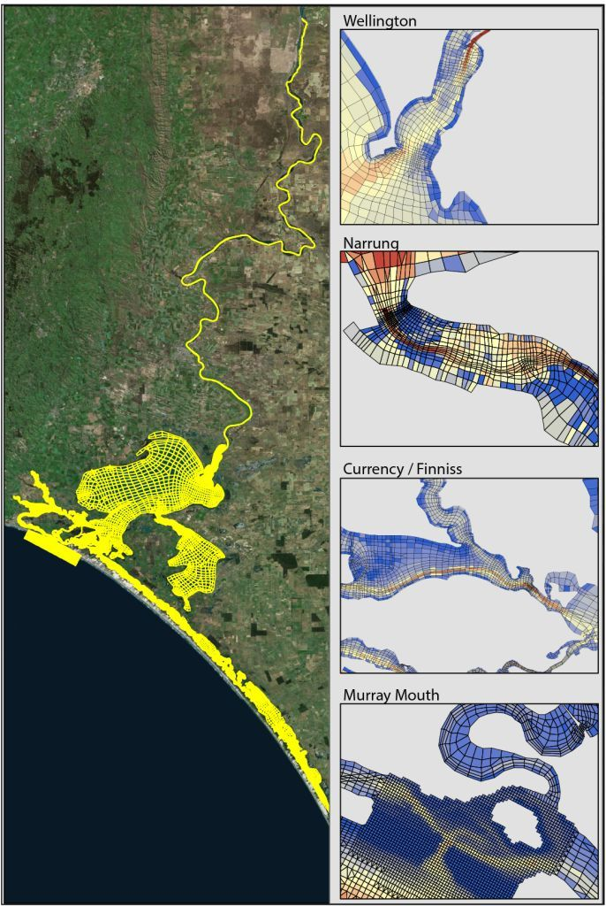

Figure 22. Overview of model domain applied in the Matter Transport study of LTIM using TUFLOW-FV. Grid provided courtesy of DEW. Coloured grids in maps on the right-hand side represent depths, i.e. increasing depth from shallow (blue) to deep (red).

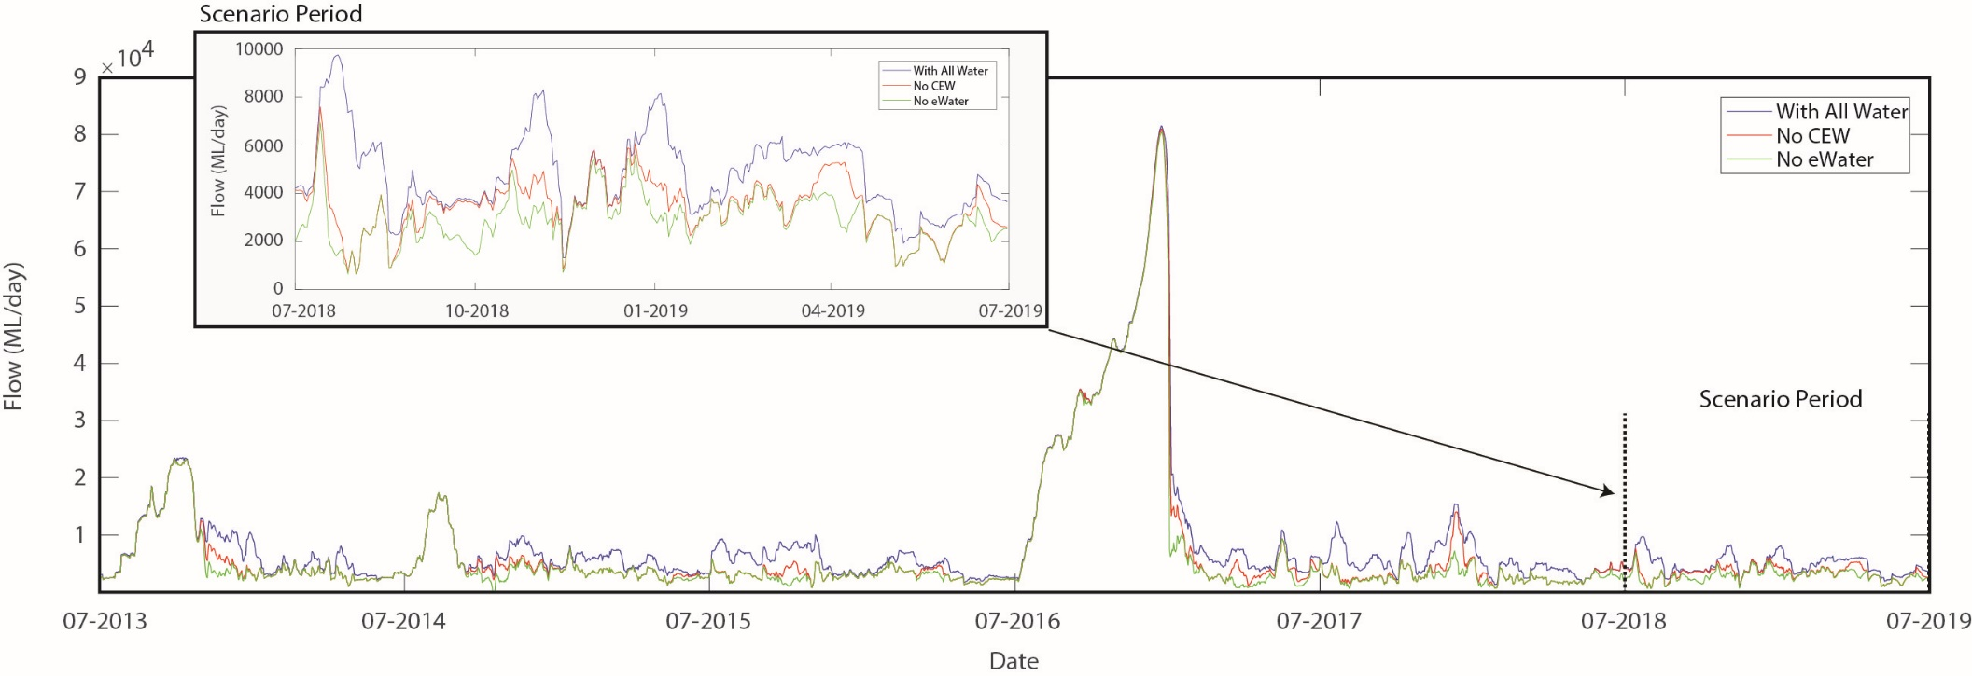

Figure 23. Overview of the three flow scenarios assessed by the model simulations. Scenarios include flow with all water, flow without Commonwealth environmental water (no CEW) and flow without any environmental water (no eWater). Flows were applied to the matter transport model at the upstream boundary, which is at Lock 1.

Additional flow specifications for SA Water off-takes were also included. Irrigation return flows were assumed to be negligible over this period and were not included in the model. Similarly, flows from Eastern Mount Lofty Ranges were not included since their contribution to the Lower Lakes is considered to be relatively minor (Cook *et al.* 2010). Meteorological conditions were based on data from Narrung. Between Lake Alexandrina and the Coorong, five barrages were included (Goolwa, Mundoo, Boundary Creek, Ewe Island and Tauwitchere) and set with a spill-over height of 0.72 m AHD. The barrage operation was set to include gate operation based on operational information provided through discussions with representatives of DEW. At the bottom of the domain, two open boundaries were specified, one at the Murray Mouth and one at Salt Creek. Murray Mouth water level was based on Victor Harbor tidal data, which are available at 10 minute resolution. Salt Creek flow data were set based on available flow data from the WaterConnect website (DEW).

Water quality conditions for both boundary points were set based on a linear interpolation of the measured nutrient and salinity data collected as part of this study. Water quality conditions for the river inflow at Lock 1 were determined based on interpolation of available data from Lock 1 or Morgan. For water quality properties for the without environmental water scenarios, rating curves were developed for flow and concentration. Based on the daily flow difference, a scaled concentration was estimated for water quality parameters including salinity, phosphate, ammonium, nitrate, total nitrogen and silica. The physico-chemical information at other sites was used to validate the model.

The influence of environmental water on the concentrations of matter was assessed through a comparison of modelled concentrations for the various scenarios for the Murray River Channel (Wellington), Lower Lakes (Lake Alexandrina Middle) and Coorong (Murray Mouth). Modelled concentrations are presented as medians of modelled cells within areas surrounding sampling sites (Figure 23). A range in concentrations within those cells is also presented for the ‘with all water’ scenario.

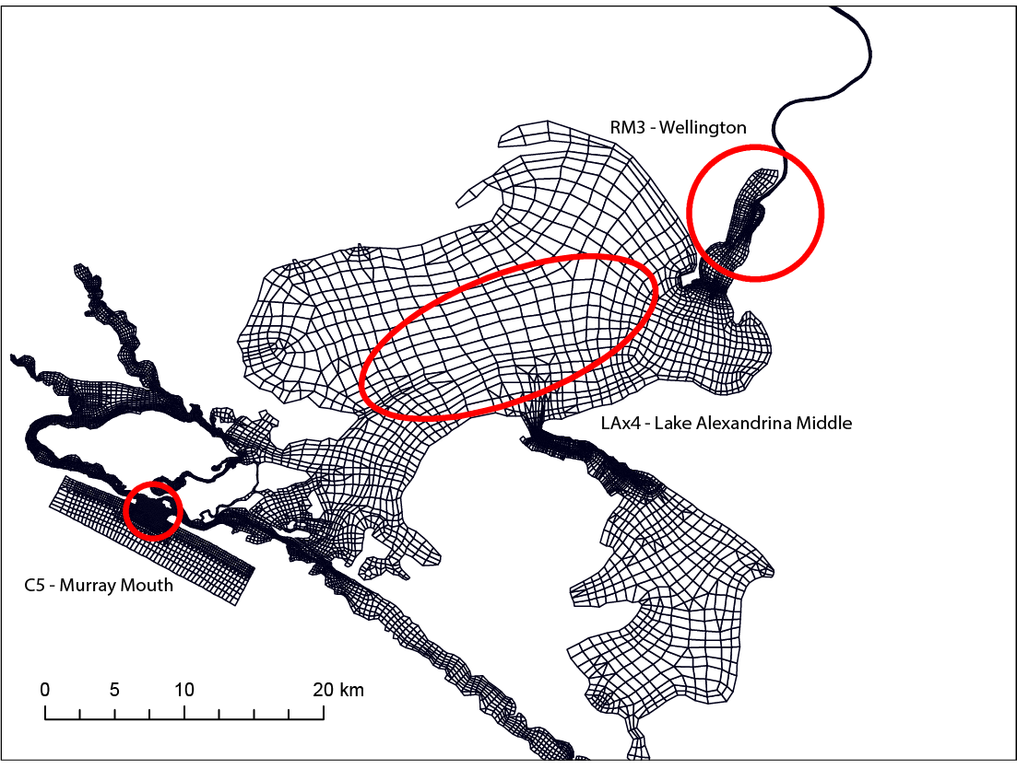

Figure 24. Modelled cells (circled) used for calculating the modelled concentration of nutrients or salt at the Wellington, Lake Alexandrina Middle and Murray Mouth sites.

The transport of matter was assessed through modelled exports from the Murray River Channel (Wellington), Lower Lakes (Barrages) and Coorong (Murray Mouth). Findings are presented for salinity, ammonium, phosphate, dissolved silica, organic nitrogen, organic phosphorus and chlorophyll *a*. Salinity is presented as practical salinity units (PSU), a measurement of the measured conductivity to standard potassium chloride (KCl) conductivity. PSU was used for validating model outputs as it overcomes observed differences in electrical conductivity caused by changes in water temperature. One PSU is approximately equal to one part per thousand.

The inflow data that were used to drive the main river domain are treated as indicative only as they do not account for all complexities associated with water accounting, water attenuation through the system and different management decisions that may have been made if the volume of environmental water provided had not been available (Neville Garland, MDBA, pers. comm.). Assumptions made to address these complexities result in uncertainty in the model outputs and so outputs are not to be treated as absolute values (refer to Aldridge *et al.* 2013 for more detail). When assessing the relative differences between scenarios, the uncertainties are considered to influence the accuracy of each scenario equally and so the model outputs are used to assess the general response to environmental water delivery.

### Results

*Salinity*

Environmental water reduced salt concentrations in the Murray River Channel (Wellington), Lake Alexandrina and the Coorong at the Murray Mouth during each of the five years of LTIM monitoring (Figure 24). In 2017-18, for example, the median salinity in the Coorong at the Murray Mouth was 26.20 PSU across the entire year. Without Commonwealth environmental water, it would have been approximately seawater salinity (33.85 PSU).

Environmental water increased salt export over the barrages over the five-year period (Figure 24; Table 7). During the low flow years, Commonwealth environmental water accounted for 64, 87, 69 and 70% of salt export over the barrages, respectively, in 2014-15, 2015-16, 2017-18 and 2018-19. In the high flow year (2016-17), a total of 1.5 million tonnes of salt was exported over the barrages and Commonwealth environmental water contributed 8% (120,867 tonnes) (Table 7).

Like all other low flow years, in 2018-19, there was a net import of salt into the Coorong (through the Murray Mouth) of 2.68 million tonnes (Table 7). Without environmental water, the net import of salt would have been 5.44 million tonnes. Environmental water decreased salt import by 2.76 million tonnes, of which 2.47 million tonnes was attributable to Commonwealth environmental water. In 2016-17, 3.68 million tonnes of salt was exported from the Coorong, of which 0.52 million tonnes was attributable to Commonwealth environmental water.

Table 7. Five year record of modelled salt export (tonnes) over the barrages to the Coorong estuary and through the Murray Mouth into the Southern Ocean.

|  |  |  |  |  |  |
| --- | --- | --- | --- | --- | --- |
| **Scenario** | **2014-15** | **2015-16** | **2016-17** | **2017-18** | **2018-19** |
| Barrages |  |  |  |  |  |
| With all water | 446,855 | 288,516 | 1,504,541 | 349,893 | 228,293 |
| No CEW | 161,791 | 36,884 | 1,383,674 | 109,171 | 67,396 |
| No eWater | 152,406 | 31,031 | 1,317,791 | 48,923 | 0 |
| Murray Mouth |  |  |  |  |  |
| With all water | -157,852 | -1,850,028 | 3,679,277 | -527,042 | -2,680,574 |
| No CEW | -3,202,552 | -6,441,297 | 3,159,985 | -3,459,211 | -5,151,627 |
| No eWater | -5,048,511 | -6,649,380 | 1,958,989 | -6,115,353 | -5,438,075 |

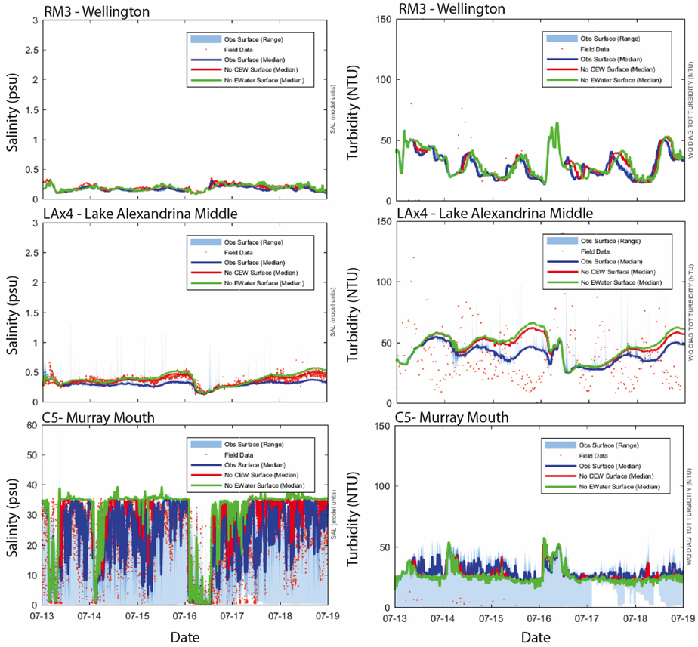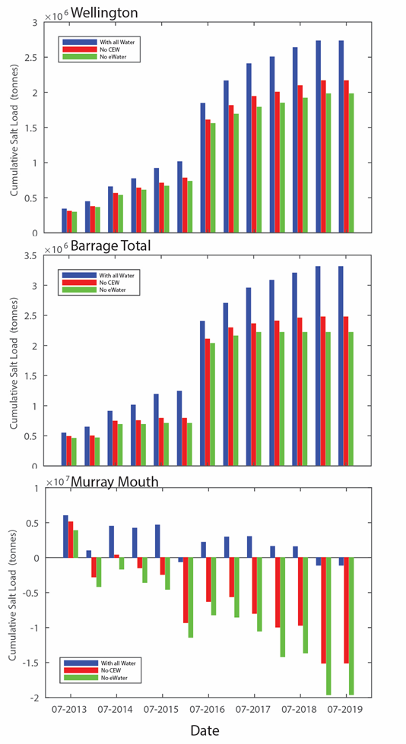

Figure 25. Modelled daily salinity concentrations (left) and six monthly cumulative salt exports (net, right) with and without environmental water delivery for 2013–2019. Scenarios include with all water, without Commonwealth environmental water (no CEW) and without any environmental water (no eWater).

*Dissolved nutrients*

The median concentrations of nitrogen and phosphorus do not vary considerably for any of the three modelled scenarios in any of the years between 2014–2019. Phosphate in Lake Alexandrina showed the greatest proportional difference, however, the difference between phosphate with no environmental water and with all water was only 6 µg/L in 2018-19 (Table D1 in Appendix D). Environmental water contributed considerably to the transport of nutrients, but this was primarily due to additional flow not a change in the nutrient concentrations. In low flow years, total nitrogen (TN) export ranged between 1,238–2,174 tonnes and total phosphorus (TP) export ranged between 113–204 tonnes. In the high flow year, the TN and TP export were 11,029 and 1,049 tonnes, respectively. The annual TN export attributable to Commonwealth environmental water ranged 609–1,507.8 tonnes, and TP export attributable to Commonwealth environmental water ranged 11.1–137 tonnes. In 2018-19, the transport of phosphate over the barrages would have been nil without environmental water (no e-water) and 0.113 tonnes without Commonwealth environmental water.

The silica load over the barrages ranged 9,428–14,587 tonnes in low flow years, considerably lower than the 70,207 tonnes that flowed over the barrages in 2016-17. Silica export attributable to Commonwealth environmental water was 0–6,836 tonnes.

*Chlorophyll a*

Commonwealth environmental water contribution towards chlorophyll transport over the barrages to the Murray Mouth varied across years (Table 8). In 2015-16, Commonwealth environmental water contributed to 92% (22 tonnes) of the total export of phytoplankton biomass. During high flows in 2016-17, the total phytoplankton loads were two orders of magnitude higher than 2015-16. In 2016-17, Commonwealth environmental water contributed to 6% (191 tonnes) of the total export of phytoplankton biomass over the barrages.

Table 8. Five year record of modelled phytoplankton export (as carbon, tonnes) over the barrages to the Coorong estuary.

|  |  |  |  |  |  |
| --- | --- | --- | --- | --- | --- |
| **Scenario** | **2014-15** | **2015-16** | **2016-17** | **2017-18** | **2018-19** |
| With all water | 27 | 23.5 | 2,939 | 221.5 | 5.8 |
| No CEW | 21 | 1.9 | 2,748 | 63.9 | 1.6 |
| No eWater | 19 | 1.5 | 2,629 | 25.7 | 0 |

### Evaluation

The evaluation approach, including assessment criteria, is described in the evaluation section for hydrological regime (Section 2.1).

Table 9. Matter Transport evaluation questions and answers. CEW = Commonwealth environmental water.

| **CEWO evaluation questions** | | **Outcomes of CEW delivery** | | | | | |
| --- | --- | --- | --- | --- | --- | --- | --- |
| **2014-15** | **2015-16** | **2016-17** | **2017-18** | **2018-19** | **2019-20** |
| What did CEW contribute to salinity: | Levels?  Reduction at the Murray Mouth due to CEW (Median salinity presented, PSU) | From 34.6 to 24.0 | From 35.1 to 29.7 | From 21.6 to 11.3 | From 34.4 to 26.2 | From 34.8 to 30.9 | From X (without CEW) to X (with CEW) |
| Transport?  Additional export over barrages due to CEW (tonnes salt per year) | 285,064 | 251,632 | 120,867 | 240,722 | 160,897 |  |
| What did CEW contribute to the salinity regime? | | CEW reduced salinity in the Murray River Channel and Lower Lakes; increased salt export over the barrages; and reduced salt intrusion into the Murray Mouth from the ocean, which reduced salinity in the Coorong.  CEW has played a key role in salt export from the Basin, accounting for 64, 87, 69 and 70% of salt export, during the four years of low flow (2014-15, 2015-16, 2017-18 and 2018-19), respectively. In the low flow years, the total salt export ranged 228,293–446,855 tonnes, which is well below the Basin Plan target of 2 million tonnes of salt per year.  In the high flow year (2016-17), 1.5 million tonnes was exported and CEW contributed 8% (120,867 tonnes) of salt export. | | | | | |

| **CEWO evaluation questions** | | **Outcomes of CEW delivery** | | | | | |
| --- | --- | --- | --- | --- | --- | --- | --- |
| **2014-15** | **2015-16** | **2016-17** | **2017-18** | **2018-19** | **2019-20** |
| What did CEW contribute to nutrient concentrations and transport? | Nitrogen concentrations?  Reduction in Lake Alexandrina due to CEW (median TN, mg/L) | 1.77 to 1.57 | 2.05 to 1.58 | 1.94 to 1.67 | 2.33 to 1.85 | 2.78 to 1.95 |  |
| CEW played a negligible/minor role in reducing nitrogen concentrations from 2014−2019. It is not determined whether the levels of change are biologically important. | | | | | |
| Transport?  Export over barrages due to CEW (tonnes) | 609 | 1,007 | 123 | 1,508 | 816 |  |
| CEW increased nitrogen export as nitrogen load was largely a function of flow volume. | | | | | |
| Phosphorus concentrations?  Reduction in Lake Alexandrina due to CEW (median TP, mg/L) | 0.166 to 0.146 | 0.192 to 0.144 | 0.182 to 0.162 | 0.224 to 0.174 | 0.282 to 0.194 |  |
| CEW played a minor role in altering phosphorus concentrations from 2014−2019. Lake Alexander normally acts as a sink for phosphorus. As the nutrient concentrations are reasonably high, a reduction acts to reduce the risk of problematic algal blooms. | | | | | |
| Transport?  Export over barrages due to CEW (tonnes) | 54 | 90 | 11 | 137 | 77 |  |
| CEW increased phosphorus export as phosphate load was largely a function of flow volume. | | | | | |

| **CEWO evaluation questions** | | **Outcomes of CEW delivery** | | | | | |
| --- | --- | --- | --- | --- | --- | --- | --- |
| **2014-15** | **2015-16** | **2016-17** | **2017-18** | **2018-19** | **2019-20** |
| What did CEW contribute to nutrient concentrations and transport? | Silica concentrations?  Reduction in Lake Alexandrina due to CEW (mg/L) | 11.5 to 9.52 | 19.7 to 11.4 | 15.3 to 12.5 | 17.8 to 11.6 | 24.8 to 15.1 |  |
| CEW played a negligible/minor role in altering silica concentrations but it is not determined whether the levels of change in silica are biologically important. | | | | | |
| Transport?  Export over barrages due to CEW (tonnes) | 3,551 | 6,836 | 0 | 8,787 | 5,469 |  |
| CEW increased silica export as silica load was largely a function of flow volume.  2016-17 was a flood year and so the silica export that year may be a function of the concentrations used to model. Total silica export was 70,207 tonnes, although not attributed to CEW. | | | | | |
| What did CEW contribute to phytoplankton: | Concentrations?  Change in Lake Alexandrina due to CEW (mg/L) | 12.5 to 13.8 | 9.50 to 10.7 | 23.9 to 23.9 | 15.4 to 14.2 | 10.8 to 9.02 |  |
| CEW played a negligible role in altering chlorophyll concentrations from 2014−2019. At different flows, different phytoplankton species will dominate; higher flow conditions will reduce the risk of cyanobacteria blooms and promote the diatom *Aulacoseira*, which are a nutritious food source to support the riverine food web. | | | | | |
| Transport?  Export over barrages due to CEW (tonnes) | 8 | 6 | 14 | 12 | 6 |  |
| CEW increased phytoplankton export as chlorophyll load was a function of flow volume. | | | | | |
| What did CEW contribute to improving *Ruppia tuberosa* habitat in the Coorong? | |  | | | | |  |
| What did CEW contribute to improving fish habitat in the Coorong? | |  | | | | |  |

Contribution (to what extent CEW contributed towards the outcome, with the significance of the outcome considered):

|  |  |  |  |  |  |  |  |  |  |  |  |
| --- | --- | --- | --- | --- | --- | --- | --- | --- | --- | --- | --- |
|  | Unknown |  | Negative |  | None/negligible |  | Minor |  | Moderate |  | Substantial |

### Discussion

*Salinity*

Environmental water has diluted salt in the LMR channel (Wellington), Lake Alexandrina and the Coorong (the Murray Mouth). The salinity was maintained well within the range required for potable water in the river and lake over the last five years, but water was about 10% fresher with the environmental flows. The median salinity in the Murray Mouth in 2018-19 was 30.9 PSU, which was similar to 2017-18 (median salinity 26.20 PSU) but higher than in 2016-17 (12.97 PSU), where flow into South Australia peaked at 94,600 ML/d. Nevertheless, Commonwealth environmental water created fresher conditions at the Murray Mouth in 2018-19, compared to without environmental water.

Salinity in the Coorong is primarily a function of riverine inflows and tidal movement. When barrage flows are low, seawater enters the Murray Mouth and salt can accumulate in the Coorong. The relatively low flows in 2014–2017 and 2018-19 meant that there was considerable import of salt (i.e. 527,042 tonnes in 2017-18 and 2.98 million tonnes in 2018-19) from the sea to the Coorong. Environmental water played a key role in reducing salt import into the Coorong. Without environmental water, the net import of salt would have been 6.1 million tonnes in 2017-18 and 5.4 million tonnes in 2018-19. During the Millennium Drought, and particularly in 2008 and 2009, the import of salt into the Coorong resulted in salinity in the South Lagoon that was five times seawater salinity, and demise of much of the aquatic life (Brookes *et al.* 2009). Environmental water provides freshening flows but also acts to inhibit seawater intrusions, thereby maintaining more appropriate salinity conditions in the Coorong. Without the environmental water there would have been an additional 20 million tonnes of salt enter the Coorong over the period 2014–2019.

*Dissolved Nutrients*

Environmental water contributed to the transport of nutrients, but this was primarily due to additional volume not a change in the nutrient concentrations. It was evident that environmental flows contributed a considerable load of nutrients to the Murray Mouth. From this evidence, it can be concluded that over the last 5 years environmental flows were a key driver in promoting estuarine productivity. The particulate nutrient load was much higher than the dissolved fractions. Environmental water was responsible for a large proportion of the particulate organic nutrient load over the barrages with Commonwealth environmental water accounting for approximately 67% in 2018-19. If there was no environmental water, the nutrient load over the barrages would have been zero.

*Chlorophyll a*

Chlorophyll *a* is a photosynthetic pigment that is ubiquitous in the phytoplankton, so is often used as a measure of the relative size of the phytoplankton community. A considerable amount of the total organic nutrients is likely to be bound within phytoplankton, and so the chlorophyll loads reflect the loads of particulate organic nitrogen and phosphorus. Chlorophyll export can be interpreted as a transfer of food resources from one site to another. As flow in 2017-18 and 2018-19 was low, there was limited transfer of food from the river to the Coorong and coastal environments. During the high flow of 2016-17, the river discharge likely played a significant role in promoting estuarine productivity, contributing 167 tonnes of chlorophyll over the barrages to the Murray Mouth.

### Management implications

There is approximately 1011 tonnes of salt in groundwater in the MDB and an additional 1.5 million tonnes of salt is deposited in the basin each year by rainfall (Herczeg *et al.* 2001). Unless salt is exported from the basin with flow, there will be a net accumulation of salt within the basin. The Basin Plan sets out a salt export objective (section 9.09) to ensure adequate flushing of salt from the Murray River system into the Southern Ocean. The Basin Plan’s indicative target for salt export from the basin is 2 million tonnes per year. The five years of salt export modelling enable the contribution of environmental flows to salt export to be scrutinised (Table 7). Flow has been relatively low in four of the five years of LTIM monitoring. In the low flow years (2014-15, 2015-16, 2017-18 and 2018-19) Commonwealth environmental water plays a key role in salt export from the basin, accounting for 64–87% of total salt export. In the high flow year (2016-17), 1.5 million tonnes was exported and Commonwealth environmental water contributed 8%.

Maximum exports of matter from the Murray Mouth are likely to be achieved by delivering environmental water during periods of low oceanic water levels (e.g. summer). In contrast, environmental water delivery to the Murray River Channel at times of high oceanic water levels is likely to increase the exchange of water and associated nutrients and salt through the Coorong, rather than predominately through the Murray Mouth. This may decrease salinities and increase productivity within the Coorong more than what would occur if water is delivered at times of low oceanic water levels.

The load of nutrients exported from the basin over the barrages is an interesting issue; on one hand nutrient export drives estuarine productivity, but on the other hand it is desirable to maintain an appropriate level of nutrients in the catchment where they can support aquatic productivity. It is not possible, with the current understanding, to make a judgement as to what is a desirable load to balance the need between systems. In the last five years, the dissolved nutrient concentrations were relatively low and the chlorophyll concentrations in the river, lake and Murray Mouth sites indicated the system was mesotrophic, i.e. had intermediate levels of productivity.

### Conclusion

The contributions of environmental water appear to have significantly increased the exchange of dissolved and particulate matter through the LMR to the Southern Ocean. In low flow years, environmental flow delivery can play a key role in salt export from the Basin. In previous low flow years (2014-15, 2015-16 and 2017-18), environmental water has contributed 66−89% of salt export. In 2018-19, however, environmental flow was responsible for all salt export. Environmental water is also critical in reducing salt import into the Murray Mouth from the ocean, lowering salinity in the Coorong and maintaining estuarine habitat to support ecological functions and biodiversity. Environmental flow deliveries during periods when there would otherwise be negligible water exchange between the Lower Lakes and Coorong can promote connectivity and allow matter exchange between these two water-bodies.

## Littoral Vegetation Diversity and Productivity

### Background

### Methods

### Results

### Evaluation

The evaluation approach, including assessment criteria, is described in the evaluation section for littoral vegetation diversity and productivity (Section 2.4).

Table 10. Littoral Vegetation Diversity and Productivity evaluation questions and answers. CEW = Commonwealth environmental water, eWater = environmental water.

| CEWO evaluation questions | Outcomes of CEW delivery (2019-20) |
| --- | --- |
| What did CEW contribute to littoral understorey vegetation diversity and productivity? |  |
| What did CEW contribute to above-ground biomass produced by understorey littoral vegetation? |  |

Contribution (to what extent CEW contributed towards the outcome, with the significance of the outcome considered):

|  |  |  |  |  |  |  |  |  |  |  |  |
| --- | --- | --- | --- | --- | --- | --- | --- | --- | --- | --- | --- |
|  | Unknown |  | Negative |  | None/negligible |  | Minor |  | Moderate |  | Substantial |

### Discussion

### Management implications

### Conclusion

## Microinvertebrate Assemblage

### Background

Aquatic microinvertebrates (microcrustaceans, rotifers and protists) are critical components of aquatic food chains. They are consumers of bacteria, algae and other microinvertebrates, and a major food source for larger organisms (e.g. macroinvertebrates) (Schmid-Araya and Schmid 2000; Pernthaler and Posch 2009). At the top end of food chains they are important first-feeds for early life stages of fish (i.e. larvae) (Arumugam and Geddes 1987; Tonkin *et al.* 2006). For example, availability of suitable microinvertebrate prey (e.g. copepods and cladocerans) for fish during the switch from endogenous (yolk sac absorption) to exogenous feeding can determine their survival and the level of recruitment success (year-class strength).

Aquatic microinvertebrates are rapid responders to environmental flows, as some organisms are often imported with the incoming water (hereafter termed the ‘imported community’) (Jenkins and Boulton 2003), while others emerge from diapause eggs within the sediment (Boulton and Lloyd 1992) and change the species composition and diversity of the resident assemblage within days (Tan and Shiel 1993). Different habitat types promote different assemblages of microinvertebrates within riverine ecosystems. At a very simplistic level, microinvertebrate assemblages can be categorised as littoral, limnetic, lotic or benthic. Following inundation of habitat, only a fraction of the organisms within the egg-bank emerges and combines with the imported community. This fraction is the ‘active egg-bank’ (as defined by Caceres and Hairston 1998). The remaining eggs supplement the ‘persistent egg-bank’ (see Brendonck and De Meester 2003), which provides an important buffer against periods when the active egg-bank becomes depleted. Due to this tendency for eggs to accumulate, the egg-bank can store a diverse array of organisms from past inundation events, which play an important role in future populations and communities.

One of the most important factors that influences the microinvertebrate community across all habits is water residence time (WRT). Generally, WRT has a strong positive relationship with microinvertebrate density and biomass. High microinvertebrate density is favoured by increased WRT due to their food resources often being more available and because microinvertebrates cannot reproduce, maintain their position, or depending on the species, survive within fast flowing water (e.g. Richardson 1992; Sluss *et al.* 2008). Therefore, most species depend on still or slow flowing water environments to maintain their populations. Consequently, longer WRT’s favour microinvertebrate development within off-channel sites including the littoral and limnetic habitats of floodplain lakes, billabongs and wetlands. Within in-channel sites, microinvertebrate community development occurs predominantly in weir pools and in littoral and limnetic backwater habitats (e.g. Reckendorfer *et al.* 1999; Baranyi *et al.* 2002). Organisms can then be transferred between habitats by hydrological mixing and exchange, or due to the entrainment of organisms from limnetic or littoral into lotic habitats. This is however, a very simplistic overview, with successional changes occurring and the physico-chemical environment also playing a major role in driving community dynamics.

*Major hypotheses*

* Microinvertebrate species richness will increase with discharge (influenced by environmental water) due to organisms emerging from the egg bank and the entrainment of organisms from a wider range of habitats in the main river channel.
* Microinvertebrate density will increase with discharge (influenced by environmental water) and temperature due to the inundation and flushing of slow-flowing habitats and increased productivity.
* During times of longitudinal connectivity (influenced by environmental water), the microinvertebrate assemblage structure in the LMR will reflect the community assemblage of its source community (e.g. during times in which discharge is coming from the Darling River, tropical species will be present in the LMR).
* Microinvertebrate assemblage responses to discharge (including environmental water) will be reflected in the dietary components of fish larvae (golden perch).

### Methods

*Sampling sites and procedure*

Microinvertebrate sampling was conducted approximately fortnightly between September and January each year at three core LTIM sites within each of the floodplain and gorge geomorphic zones of the LMR (Table 11 and Table 12), concurrent with larval fish sampling (Section 2.6). Three replicate samples were taken at each site during the day.

Table 11. Microinvertebrate sampling dates from 2014–2018 in the LMR.

|  |  |  |  |  |
| --- | --- | --- | --- | --- |
| **Trip no.** | **2014-15** | **2015-16** | **2016-17** | **2017-18** |
| 1 |  |  | 26-28/09/2016 |  |
| 2 |  | 6-7/10/2015 | 11-12/10/2016 | 3-4/10/2017 |
| 3 |  | 20-21/10/2015 | 24-25/10/2016 | 16-17/10/2017 |
| 4 | 3-4/11/2014 | 2-3/11/2015 | 7-8/11/2016 | 30-31/10/2017 |
| 5 | 19-20/11/2014 | 17-18/11/2015 | 21-22/11/2016 | 13-14/11/2017 |
| 6 | 1-2/12/2014 | 30/11-1/12/2015 | 6-8/12/2016 | 27-28/11/2017 |
| 7 | 14-15/12/2014 | 15-16/12/2015 | 21/12/2016 | 11-12/12/2017 |
| 8 | 7-8/01/2015 | 5-6/01/2016 | 10-11/01/2017 | 3-4/01/2018 |
| 9 | 19-20/01/2015 | 20-21/01/2016 |  |  |

A Perspex Haney plankton trap (4.5 L capacity) was used mid-channel (by boat) to collect surface and bottom volumes (9 L), which were filtered through a 37 µm-mesh plankton net suspended in a bucket and rinsed into a 200 ml PET bottle screwed to a purpose-built ferrule at the net end. The filtrate was then preserved in the field (100% ethanol) to a final concentration of ~75%, and a volume of <200 ml. In the laboratory, the sample was decanted into a measuring cylinder, the volume noted, the cylinder agitated, and a 1 ml aliquot withdrawn using a Gilson auto pipette. This 1 ml was run into a Pyrex 1 ml Sedgewick-Rafter cell, and the microinvertebrates present were counted and identified. Counts for each sample were based on a single subsample.

Table 12. Details of microinvertebrate sampling sites downstream (DS) of Lock 1 and Lock 6 in the LMR.

|  |  |  |  |
| --- | --- | --- | --- |
| **Zone** | **Site** | **Latitude** | **Longitude** |
| Floodplain | 5 km DS Lock 6 | S34.01902 | E140.87572 |
| Floodplain | 7 km DS Lock 6 | S34.01764 | E140.85461 |
| Floodplain | 9 km DS Lock 6 | S34.0319 | E139.61723 |
| Gorge | 5 km DS Lock 1 | S34.4052 | E139.61723 |
| Gorge | 7 km DS Lock 1 | S34.42263 | E139.61293 |
| Gorge | 9 km DS Lock 1 | S34.44596 | E139.61102 |

*Statistical analyses*

To assess the influence of Commonwealth environmental water on microinvertebrate density, species richness and assemblage structure (including rotifers, cladocerans and copepods) over the long-term (4 years), variation between sampling years (i.e. 2014-15, 2015-16, 2016-17 and 2017-18) and sites was investigated. Protists and macroinvertebrates were excluded to allow multi-year analysis. Temporal and spatial variation in microinvertebrate mean density, mean species richness and assemblage structure was analysed using permutational multivariate analysis of variance (PERMANOVA), Similarity Percentages (SIMPER) analysis and Non-metric Multi-Dimensional Scaling (MDS) in the software package PRIMER v. 6.1.12 (Clarke and Gorley 2006) and PERMANOVA + v.1.02 (Anderson *et al.* 2008). To simplify all analysis, the three replicates from each of the three sites within both geomorphic zones were averaged, and the average from each site used as a replicate for the corresponding zone (e.g. the average of site one below Lock 6 was used as a single replicate for the floodplain geomorphic zone). Trips 4 to 8 (between early November and January) were the only trips that were consistent between all four years and therefore other trips were excluded from PERMANOVA analysis for inter-annual comparisons. Analysis was conducted on each year independently and included all trips for intra-annual comparisons. In instances when multiple comparison were made, the Bonferroni correction was not applied due to its conservative nature and potential for increasing type II error. Therefore, raw alpha values have been presented and all post-hoc statistically significant results interpreted within the context and with careful consideration of current conceptual understanding and other research results. A 50% contribution cut off was applied to SIMPER analysis. Species assemblage data were graphically presented in MDS plots. Species density data was averaged across sites to reduce overcrowding within the MDS plots. Two separate MDS plots were generated, one with species correlations and a second with water temperature and discharge correlations overlain. The two plots were combined to create a single plot with both sets of correlations. Each species was classified as either littoral, littoral (facultatively pelagic) or pelagic and used to simplify labelling. For definitions of these categories and species categorisation, see Appendix D. All statistical analyses were conducted on square-root transformed day-time Haney trap data from below Lock 1 and Lock 6 between early November and January. When the number of unique permutations were low (i.e. <100), Monte Carlo p-values have been reported. All results are reported to two significant figures and ±1 standard error reported in brackets.

*Larval gut analysis*

To determine if Commonwealth environmental water contributed to the timing of microinvertebrate productivity and presence of key species in relation to diet of large-bodied fish larvae, diet composition of fish larvae was assessed. Gut contents of golden perch, freshwater catfish and Murray cod larvae, collected opportunistically through larval fish sampling as part of the Fish Spawning and Recruitment indicator (Table 13; Section 2.6), were analysed using traditional taxonomic methods. The abundance of microinvertebrate prey in the stomachs of fish larvae (by species) were summarised in stacked bar charts.

Table 13. Sample sizes of large-bodied fish larvae analysed for gut contents from 2014–2018, indicating the number of fish with contents in their stomachs. Total lengths (TL) are for all fish sampled.

|  |  |  |  |  |  |  |
| --- | --- | --- | --- | --- | --- | --- |
|  | **Freshwater catfish** | | **Golden perch** | | **Murray cod** | |
| Year | TL (mm) | *n* food (*n* total) | TL (mm) | *n* food (*n* total) | TL (mm) | *n* food (*n* total) |
| 2014/15 | 12.0–15.0 | 3(7) | 11.0–14.0 | 2(2) | 10.0–12.0 | 5(16) |
| 2015/16 | 12.3–20.7 | 9(14) | 12.9 | 1(1) | 9.7–14.7 | 8(29) |
| 2016/17 |  | 0(0) |  | 0(0) | 7.8–12.8 | 2(20) |
| 2017/18 | 14.0–16.0 | 8(10) | 3.5–20.0 | 10(13) | 12.0–38.0 | 0(3) |

### Results

*Inter-annual comparisons*

Throughout the four years, microinvertebrate density varied between 72 (±6.09) and 2,408 (±100) ind/L(Figure 25 and Figure 26). A PERMANOVA on mean density indicated that there was a significant difference between years (*P*≤0.001) and sites (*P*≤0.001) (Table 14). There was no significant interaction between year and site (*P=*0.055). Pairwise comparisons indicated that microinvertebrate densities were significantly different in 2014-15 in comparison to 2015-16 (*P*=0.0017) and 2017-18 (*P*=0.047), and significantly different in 2016-17 in comparison to 2015-16 (*P*=0.002) and 2017-18 (*P*=0.019) (Table 14; Figure 25 and Figure 26). Pairwise comparisons also indicated that densities were significantly different at Lock 6 in comparison to at Lock 1 (*P*≤0.001) (Table 14; Figure 25 and Figure 26).

Throughout the four years, species richness varied between 4.3 (±0.51) and 34 (±1.2) taxa (Figure 27). A PERMANOVA on mean species richness indicated that there was a significant difference between years (*P*=0.0031) and between sites (*P*=0.0042) (Table 15; Figure 27). There was no significant interaction between year and site (*P=*0.065). Pairwise comparisons indicated that mean species richness was significantly greater in 2016-17 in comparison to all other years (*P*=0.039–0.0078) (Table 15; Figure 27). Pairwise comparisons also indicated that mean species richness was significantly different between Lock 6 and Lock 1 (*P*≤0.001) (Table 15; Figure 27).

A PERMANOVA on community assemblage across the four years indicated that there was a significant interaction between year and site (P≤0.001) (Table 16). Pairwise comparisons indicated that community assemblages between Lock 6 and Lock 1 were significantly different within all years (*P*=0.0001–0.0371) (Table 16; Figure 28). Pairwise comparisons indicated that community assemblage at Lock 6 was significantly different between all years (*P*≤0.001) and community assemblage at Lock 1 was significantly different between all years (*P*≤0.001) (Table 16; Figure 28). Community assemblages changed seasonally in all years, indicating changes associated with increasing water temperature (diagonally upwards from right to left in the MDS plot) (Figure 28). Community assemblages also indicated changes in relation to increasing discharge (diagonally downwards from right to left in the MDS plot) (Figure 28).

Assemblages in 2014-15 and 2015-16, when discharge was low, were more similar than when compared to other years and demonstrated overlap between the two years (Figure 28). This however, excluded assemblages in November and December 2015-16 (trips 5, 6 and 7) at Lock 1 when discharge was considerably lower than at the same time in other years and was primarily associated with lower densities of pelagic microinvertebrates (Figure 25; Figure 26; Figure 28). Assemblages in 2016-17, when discharge was high, demonstrated the least overlap with other years and showed an association with high discharge into South Australia (QSA) throughout November and December (trips 4, 5, 6 and 7 in November and December) and greater densities of a range of pelagic and littoral organisms (Figure 25; Figure 26; Figure 28). Assemblages in 2017-18, when there was a within-channel rise of greater magnitude than 2014-15 and 2015-16, demonstrated the widest variety in community structure. This included: a distinct community in October (trips 2 and 3) in comparison to all other years; a community that fell between those detected during lower flow years (2014-15 and 2015-16) and during the flood (2016-17) in late-November and early December; and similarity with communities detected in 2016-17 during the flood, from mid-December to January. Interestingly, the distinct community detected in October was largely associated with high densities of cladocerans and copepods, particularly at Lock 6 (Figure 25; Figure 26; Figure 28).

Table 14. PERMANOVA table of results for pairwise comparisons on density data between years, where 2014 = 2014-15, 2015 = 2015-16, 2016 = 2016-17 and 2017 = 2017-18, and sites where Lk1 = Lock 1 and Lk 6 = Lock 6. *P*-values presented in bold are significant comparisons.

|  |  |  |  |
| --- | --- | --- | --- |
| **Groups** | **t** | ***P* (perm)** | **Unique perms** |
| Years:  2014, 2015 | 3.1176 | **0.0017** | 9940 |
| 2014, 2016 | 1.224 | 0.2267 | 9929 |
| 2014, 2017 | 2.007 | **0.0469** | 9933 |
| 2015, 2016 | 3.111 | **0.002** | 9929 |
| 2015, 2017 | 1.2507 | 0.2145 | 9938 |
| 2016, 2017 | 2.3583 | **0.019** | 9938 |
| Sites:  Lk1, Lk6 | 4.6502 | **0.0001** | 9958 |

Table 15*.* PERMANOVA table of results for pairwise comparisons on species richness data between years, where 2014 = 2014-15, 2015 = 2015-16, 2016 = 2016-17 and 2017 = 2017-18, and sites where Lk1 = Lock 1 and Lk 6 = Lock 6. *P*-values presented in bold are significant comparisons.

|  |  |  |  |
| --- | --- | --- | --- |
| **Groups** | **t** | ***P* (perm)** | **Unique perms** |
| Years:  2014, 2015 | 1.2876 | 0.2016 | 9926 |
| 2014, 2016 | 2.7371 | **0.0078** | 9912 |
| 2014, 2017 | 0.64407 | 0.5236 | 9923 |
| 2015, 2016 | 3.1158 | **0.0042** | 9936 |
| 2015, 2017 | 0.72906 | 0.4797 | 9925 |
| 2016, 2017 | 3.0018 | **0.0039** | 9911 |
| Sites:  Lk1, Lk6 | 2.8099 | **0.0046** | 9909 |

Table 16*.* PERMANOVA table of results for pairwise comparisons on community assemblage data between years, where 2014 = 2014-15, 2015 = 2015-16, 2016 = 2016-17 and 2017 = 2017-18, and sites where Lk1 = Lock 1 and Lk 6 = Lock 6. *P*-values presented in bold are significant comparisons.

| **Groups** | **t** | ***P* (perm)** | **Unique perms** |
| --- | --- | --- | --- |
| Years (Lock 1):  2014, 2015 | 3.0504 | **0.0001** | 9924 |
| 2014, 2016 | 3.0323 | **0.0001** | 9927 |
| 2014, 2017 | 3.5463 | **0.0001** | 9937 |
| 2015, 2016 | 3.204 | **0.0001** | 9931 |
| 2015, 2017 | 3.4245 | **0.0001** | 9946 |
| 2016, 2017 | 3.1871 | **0.0001** | 9925 |
| Years (Lock 6):  2014, 2015 | 2.7953 | **0.0001** | 9946 |
| 2014, 2016 | 3.2266 | **0.0001** | 9937 |
| 2014, 2017 | 2.9587 | **0.0001** | 9940 |
| 2015, 2016 | 2.8804 | **0.0001** | 9922 |
| 2015, 2017 | 2.6148 | **0.0001** | 9922 |
| 2016, 2017 | 2.8329 | **0.0001** | 9923 |
| Sites (LK1, LK6):  2014-15 | 1.5623 | **0.0371** | 9906 |
| 2015-16 | 2.1983 | **0.0001** | 9926 |
| 2016-17 | 1.7633 | **0.0027** | 9928 |
| 2017-18 | 2.1464 | **0.0008** | 9937 |

*Intra-annual comparisons*

*2014-15*

In 2014-15, microinvertebrate density varied between 376 (±17) and 2,076 (±117) ind/L (Figure 25; Figure 26), while species richness varied between 11.89 (± 1.66) and 25.78 (±0.22) (Figure 27). PERMANOVAs indicated that there was a significant interaction between site and trip for both density (*P*=0.0001) and species richness (*P*=0.016), which suggests that differences in microinvertebrate composition among trips were not consistent between sites and vice versa.

In November 2014, the delivery of Commonwealth environmental water increased discharge to South Australia from ~6,000 to ~10,000 ML/d (Figure 5). At Lock 6, these increases in discharge in combination with the operation of the Chowilla regulator coincided with a higher representation of littoral (facultatively pelagic) rotifers within the microinvertebrate community and the presence of standing-water pelagic microcrustaceans (Figure 25; Figure 28; Appendix B). All taxa driving significant differences between sampling trips are known from the upper Murray and southern tributaries (Table 17). These organisms contributed to significantly greater microinvertebrate densities at Lock 6 in comparison to Lock 1 on 3 November and 19 November 2014 (*P*=0.003 and 0.0496, respectively) and the highest microinvertebrate densities observed during the study for October and early November at Lock 6 (Figure 25). At Lock 6 and Lock 1, these increases in discharge coincided with significantly higher species richness on 3 November 2014 than the 19 November 2014 trip (*P*=0.0322 at Lock 6 and *P*=0.0243 at Lock 1) (Figure 27). Species richness was high for November 2014 in comparison to those recorded in early November in all other years at both sites (excluding at Lock 1 in 2015-16 during weir pool raising) (Figure 27).

In mid-January 2015, the delivery of Commonwealth environmental water, which increased discharge from ~7,000 to 10,000 ML/d (Figure 5), coincided with the highest microinvertebrate density and species richness recorded for the sampling period at Lock 6 and Lock 1 (Figure 25; Figure 26; Figure 27). Despite microinvertebrate density commonly being greatest in January at both sites, those observed at Lock 1 were the greatest measured across all four years for that site (Figure 26). Microinvertebrate density at Lock 1 gradually increased with increasing temperature throughout the sampling period (Figure 26). Species richness was significantly higher at Lock 6 and Lock 1 on 19 January 2015 in comparison to all other trips excluding 3 November 2014 and 14 December 2014 at Lock 6 (*P*=0.0004–0.0124) (Figure 27). Contributing to the high species richness and densities in January was a high representation of littoral (facultatively pelagic) rotifers within the microinvertebrate community (Figure 25; Figure 26).

*2015-16*

In 2015-16, microinvertebrate density varied between 72 (±6.1) and 1,955 (±205) ind/L (Figure 25; Figure 26), while species richness varied between 5.7 (±0.69) and 26 (±1.1) taxa (Figure 27). PERMANOVAs indicated that there was a significant interaction between site and trip for both density (*P*=0.0001) and species richness (*P*=0.0001), which suggests that differences in microinvertebrate composition among trips were not consistent between sites and vice versa.

From September to November 2015, environmental water (77 % Commonwealth environmental water), maintained discharge at a peak of 9,600–11,700 ML/d, where it would have otherwise been ~4,100–4,900 ML/d (Figure 5). At Lock 6, microinvertebrate density was significantly greater on 2 November 2015 in comparison to 6 October 2015 and 20 October 2015 (*P*=0.0006) and coincided with maximum water levels at the Chowilla regulator (Figure 25). Additionally, at Lock 6 there was significantly higher species richness on 2 November 2015, 17 November 2015 and 30 November 2015 than the 20 October 2015 (*P*=0.0072, 0.0042 and 0.0271, respectively) which coincided with the drawdown of the Chowilla regulator and Lock 6 (Figure 27; Appendix B). However, these increases in density and species richness were relatively small. At Lock 1, microinvertebrate density was significantly greater on 6 October and 20 October 2015 than Lock 6 (*P*=0.0088 and 0.0003, respectively) (Figure 26). These microinvertebrate densities at Lock 1 were high for October in comparison to all other years (Figure 26). Microinvertebrate density at Lock 1 gradually increased with increasing temperature throughout the study period (Figure 26; Figure 28). Species richness was also significantly greater at Lock 1 in comparison to Lock 6 from the 6 October until the 2 November 2015 (*P*=0.0005–0.0163) (Figure 27). Species richness on the 2 November 2015 at Lock 1 was the highest for the sampling period (26±1.1 taxa) and was high in comparison to all other years excluding 2016-17 (Figure 27). As for the previous year, most microinvertebrates originated from the southern basin (Murray and tributaries) and were common species (Table 17). *Keratella javana* was likely from a northern tributary. Notable was the occurrence of *Keratella americana*, first record for the continent of this tropical species first described from the Americas.

*2016-17*

In 2016-17, a high flow year, microinvertebrate density (2,408 ±100) and species richness (34 ±1.18) was the highest for all four years (Figure 25; Figure 26; Figure 27). PERMANOVAs indicated that there was a significant interaction between site and trip for both density (*P*=0.0001) and species richness (*P*=0.0001), which suggests that differences in microinvertebrate composition among trips were not consistent between sites and vice versa.

From September until mid-December 2016, very small volumes of environmental water were released in comparison to unregulated flows (Figure 5). Increases in microinvertebrate density and species richness coincided with increases in discharge and water temperature at both Lock 6 and Lock 1 (Figure 25; Figure 26; Figure 27). This excluded the 6 December 2016 when microinvertebrate density and species richness was significantly lower than the preceding trip at both Lock 6 and Lock 1 (*P*=0.0001 and 0.0003, respectively for density, and *P*=0.0096 and 0.0003, respectively for species richness). At this time, dissolved oxygen levels had fallen below 2 mg/L at both sites due to the hypoxic effects of blackwater (Ye *et al.* 2018) which was the likely cause for reduction in density.

In late-December 2016, Commonwealth environmental water delivery in the LMR reduced the steepness of the flow recession and peaked on the 22 December 2016 at 8,100 ML/d (Figure 5).This coincided with the recovery of microinvertebrate density and species richness at both Lock 6 and Lock 1 on the 21 December 2016 to values similar to those observed prior to the blackwater event (Figure 25; Figure 27). Dominant taxa during December/January were a mix of Murray and Darling River taxa, primarily rotifers, including the tropical warm water brachionids *B. caudatus personatus* and *B. durgae*, the latter new to the continent (Table 17). The introduced *Keratella americana* was again recorded at both Lock 6 and 1. Also recorded during December/January were *Hexarthra braziliensis* a South American rotifer, and *Daphnia galeata*, a Holarctic species (Karabanov *et al.* 2018), both new to the continent.

Microinvertebrate density and species richness at Lock 6 and Lock 1 gradually increased with increasing temperature and discharge throughout the study period (excluding the 2 December 2016 during the blackwater event) (Figure 25; Figure 26; Figure 27).

*2017-18*

In 2017-18, microinvertebrate density varied between 97 (±17) and 1,552 (±57) ind/L, while species richness varied between 4.3 (±0.51) and 25 (±1.12) taxa (Figure 25; Figure 26; Figure 27). PERMANOVAs indicated that there was a significant interaction between trip and site for both density (*P*=0.0001) and species richness (*P*=0.0005), which suggests that differences among trips were not consistent between sites and vice versa.

From July to October 2017, environmental water (almost entirely Commonwealth environmental water) contributed to increases in discharge in the LMR from 4,500 to 8,700 ML/d in early September 2017 (Figure 5). This watering action coincided with the concurrent raising of Weir Pools 2 and 5 (August to October) (Appendix B). These combined actions did not correspond with high microinvertebrate density or species richness at either Lock 6 or Lock 1 at first sampling on 3 October 2017 (Figure 25; Figure 26; Figure 27). Predominant microinvertebrate taxa during this period were primarily southern Basin assemblages (Table 17)

From November 2017 to January 2018, environmental water (62% The Living Murray and 30% Commonwealth environmental water)) was delivered to the LMR, increasing discharge from 6,700 to 17,800 ML/d in early December 2017 (Figure 5). This watering action followed the raising of Weir Pools 7 (September to December), 8 (September to November) and 9 (September to October). At Lock 6, microinvertebrate density was significantly greater on the 30 October 2017 and the 13 November 2017 than the previous two sampling trips on the 3 October 2017 and 16 October 2017 (*P*=0.001–0.0018) and significantly greater than at Lock 1 (*P*=0.0005 and 0.015, respectively) (Figure 25; Figure 26). These higher microinvertebrate densities were largely due to high representation of littoral (facultatively pelagic) rotifers within the microinvertebrate community (Figure 25; Figure 27). Microinvertebrate density at Lock 1 gradually increased with increasing temperature throughout the study period (Figure 26). Species richness at both sites increased with increasing temperature and discharge (Figure 27). During this period, the microinvertebrate assemblage was a mixed, species-rich assemblage primarily of warm-water taxa from, for example, the Murrumbidgee and Lake Victoria, with cool-water species from the Goulburn/southern Basin.

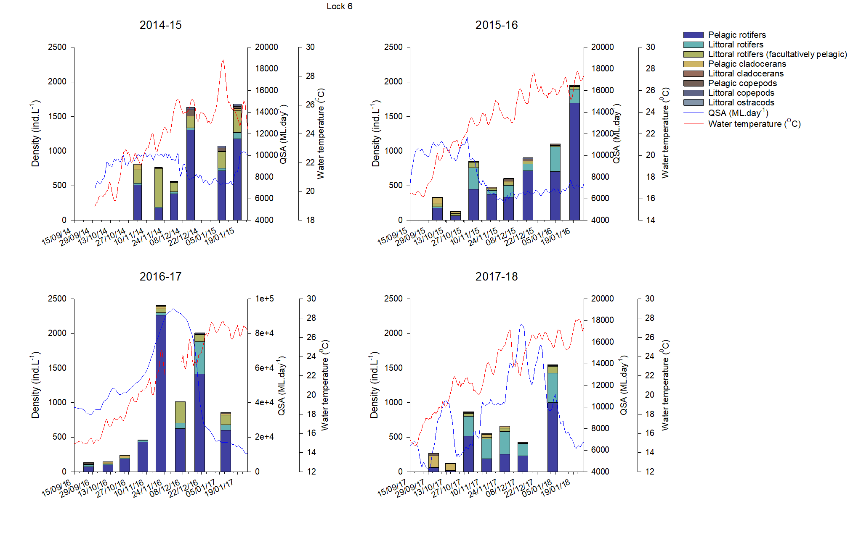

Figure 26. Mean microinvertebrate density collected in the LMR at below Lock 6 in the floodplain geomorphic zone, demonstrating community assemblage characteristics in a) 2014-15, (b) 2015-16, (c) 2016-17 and (d) 2017-18, plotted against flow discharge (blue line) and temperature at SA Border (red line).

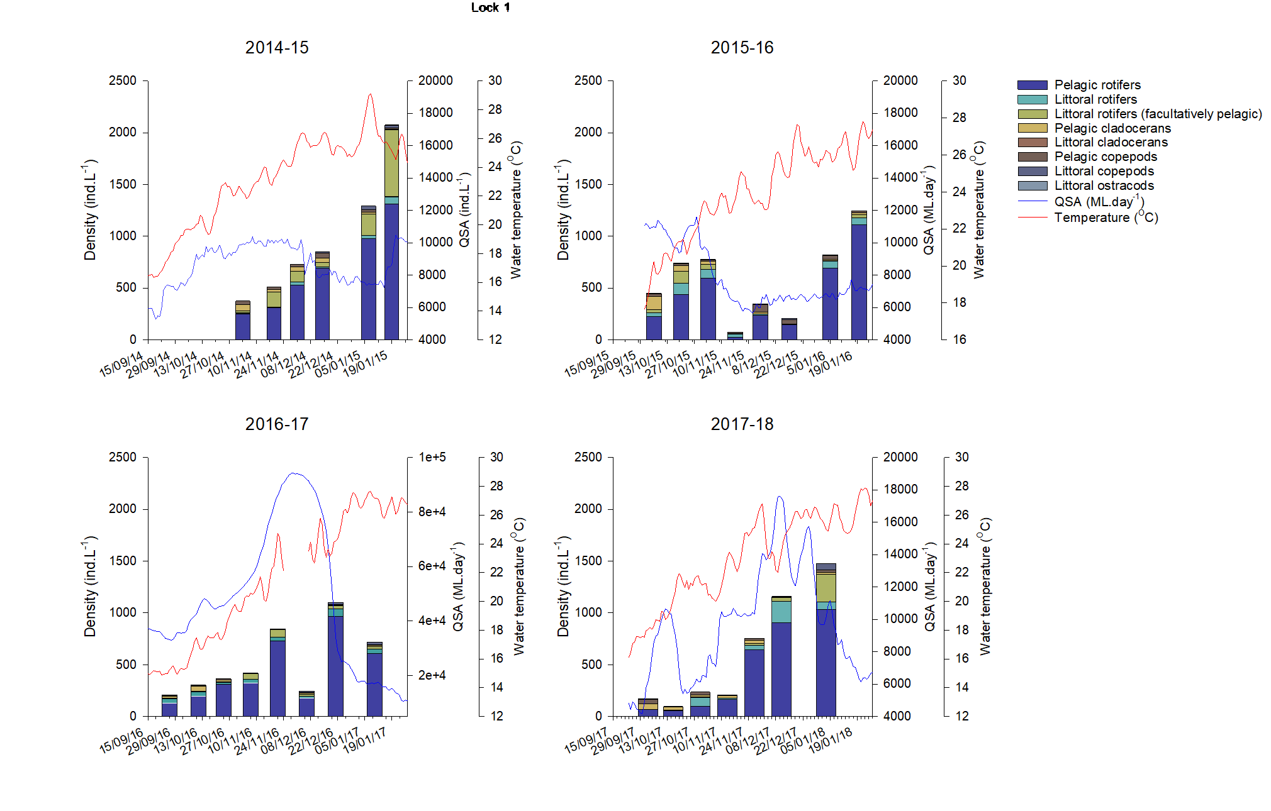

Figure 27. Mean microinvertebrate density collected in the LMR at below Lock 1 in the floodplain geomorphic zone, demonstrating community assemblage characteristics in a) 2014-15, (b) 2015-16, (c) 2016-17 and (d) 2017-18, plotted against flow discharge (blue line) and temperature at SA Border (red line).

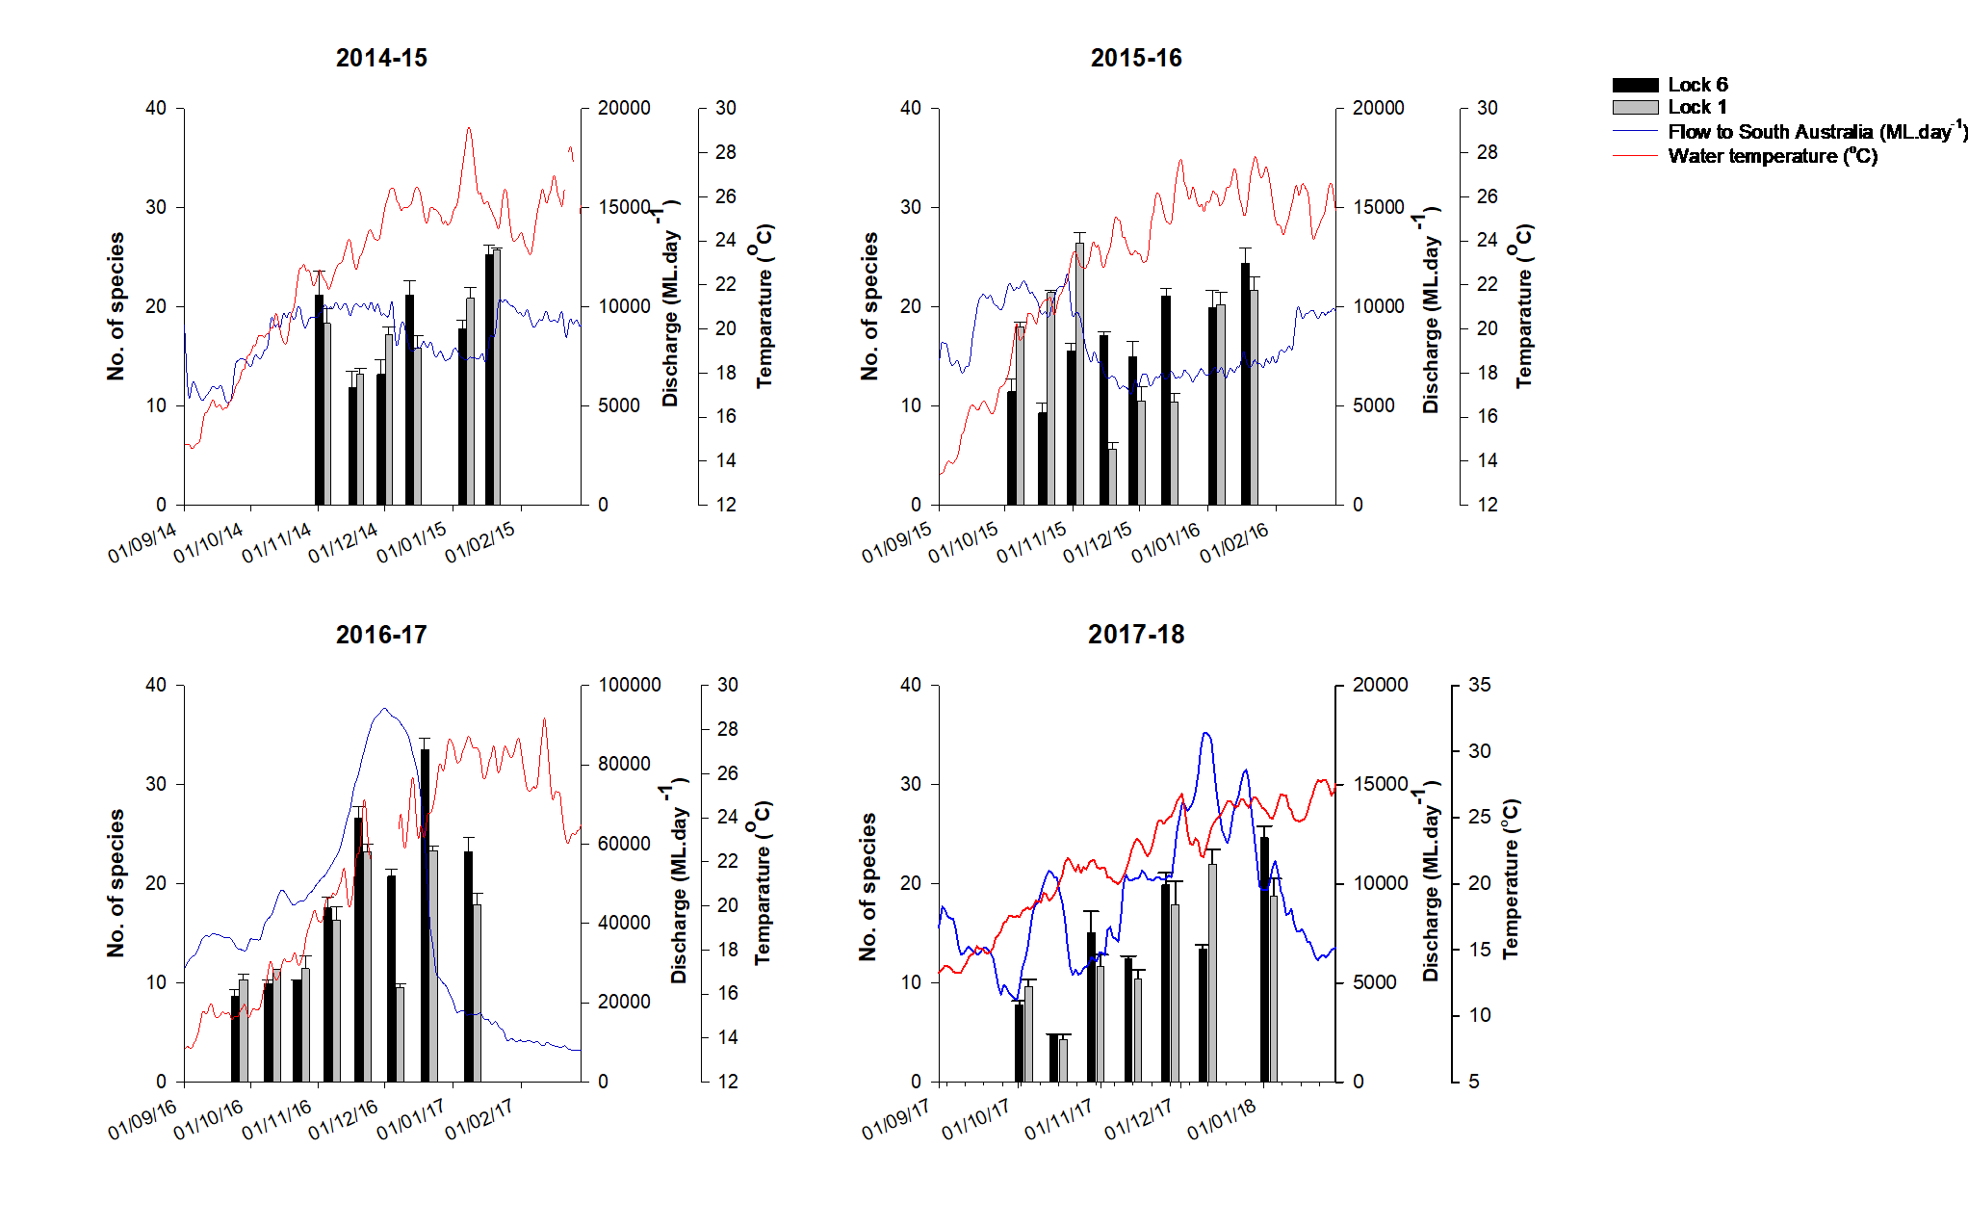

Figure 28. Mean (±S.E.) species richness of microinvertebrates collected in the LMR at sites below Lock 6 (black bars) and Lock 1 (grey bars).

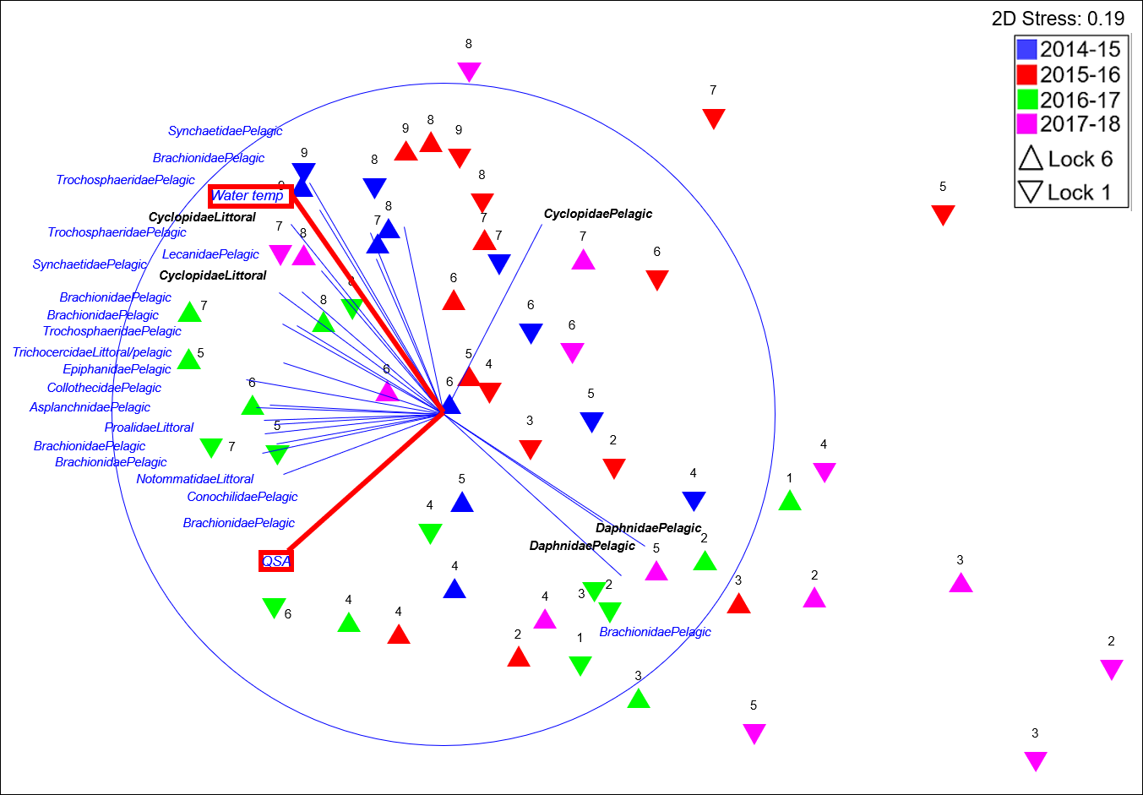

Figure 29. MDS ordination of microinvertebrate assemblage data (square-root transformed) at Lock 6 and Lock 1 during 2014–2018. Samples are labelled by sampling trip. Species density correlations are overlaid with blue vectors and water temperature (Water temp) and discharge into South Australia (QSA) correlations are overlain with red vectors. Species have been labelled by their family and preferred habitat (FamilyHabitat). Rotifer labels are blue and microcrustacean (cladocerans and copepods) labels are in black. Correlation value set to 0.5.

Table 17. Table summarising the timing and origin of environmental water delivered to the LMR in 2014-15, 2015-16 and 2017-18 and the species indicated by SIMPER analysis driving major differences in the microinvertebrate community due to higher densities at the time of delivery and likey community origin. The sampling period 2016-17 is not included due to the very low propotion of environmental water delivered during that period.

| **Year** | **Timing** | **E-water origin** | **Species driving differences (due to higher density) in the microinvertebrate community in comparison to sampling trips that fall outside of the delivery period defined in column two.** | **Indicators of community origin** |
| --- | --- | --- | --- | --- |
| **2014-15** | November (sampling trips 4 & 5) | Primarily from upstream of Yarrawonga, considerable contributions also from Lake Victoria and Victorian tributaries and a small percentage from the Murrumbidgee | *Filinia pejleri, Trichocerca similis grandis, Trichocerca pusilla, Synchaeta oblonga, Synchaeta pectinata, Polyarthra dolichoptera, Bosmina meridionalis, Trichocerca similis, Conochilus natans, Conochilus dossuarius* and *Filinia longiseta.* | All long-established taxa known from the Upper Murray and/or Goulburn systems (Shiel 1978; 1981) |
| Late January (sampling trip 9) | Primarily from upstream of Yarrawonga and Lake Victoria, and a small percentage from Victorian tributaries the Murrumbidgee. | *Polyarthra dolichoptera, Keratella tropica, Filinia terminalis, Trichocerca pusilla, Anuraeopsis fissa, Trichocerca similis grandis, Brachionus diversicornis, Keratella lenzi, Hexarthra* sp., *Conochilus natans,* *Collotheca* cf. *tenuilobata*. *Filinia longiseta, Keratella tropica*, and *Brachionus falcatus.* | As above. e.g. *Filinia terminalis* is a cool water taxon and was likely derived from an Upper Murray and/or southern (Victoria) source. |
| **2015-16** | September until November (sampling trips 2, 3 &4) | Primarily from the Murray, considerable contributions also from the Murrumbidgee, small contributions from Victorian tributaries and very small contributions from the Lower Darling. | *Bosmina meridionalis, Filinia pejleri, Keratella javana, Synchaeta oblonga, Conochilus dossuarius, Trichocerca pusilla, Trichocerca similis, Polyarthra vulgaris, Conochilus natans, Keratella australis, Filinia grandis. Brachionus bidens, Keratella tropica, Trichocerca pusilla, Synchaeta oblonga, Synchaeta pectinata, Brachionus calyciflorus amphiceros* and *Cephalodella catellina.* | With the exception of *Keratella javana*, all are known from the Upper Murray catchment. *K. javana* was not collected in the cited earlier studies, is a known tropical species, and likely derived from a northern tributary, |
| **2017-18** | July to October (sampling trips 2 & 3) | Return flows from the Goulburn and the Murrumbidgee rivers | *Bosmina meridionalis, Daphnia lumholtzi, Boeckella triarticulata, Ceriodaphnia* sp. | All common in the southern basin. |
| November until January (sampling trips 4, 5, 6 and 7) | Return flows from Barmah-Millewa Forest and Hattah Lakes and a pulse from the Goulburn. | *Trichocerca agnatha, Synchaeta oblonga, Synchaeta pectinata, Conochilus natans, Conochilus dossuarius, Keratella tropica, Keratella americana, Filinia terminalis, Trichocera similis grandis, Polyarthra dolichoptera, Bosmina meridionalis, Hexarthra intermedia, Collotheca pelagica* and *Polyarthra vulgaris.* | Again, well-established southern basin taxa, with the exception of the introduced *Keratella americana*, native to the Americas, and not recorded in Australia prior to LTIM. Source of introduction unknown. Possibly as a hitch-hiker with stocked fish or via the pet/aquarium trade, or (less-likely) bird-vectored propagules. |

*Larval gut content*

From 2014–2018, there was a larger proportion of Murray cod larvae with empty guts (69–100%), compared to freshwater catfish (20–57%) and golden perch (0–23%) (Table 13). The larval diet of the three species was comprised mostly of copepods and cladocerans (Figure 29; Figure 30). The pelagic calanoid copepod *Boeckella triarticulata* was the most frequent prey item for all species and was numerically abundant in the diet of all species, particularly golden perch. Whilst only present in guts during one year, the cladocerans *Ceriodaphnia cornuta* (pelagic) and *Picripleuroxus quasidenticulatus* (littoral) were abundant prey for Murray cod and freshwater catfish, respectively. The pelagic cladoceran *Bosmina meridionalis* and benthic atyid shrimp were numerically dominant in the diet of golden perch and freshwater catfish, respectively.



Figure 30. Abundance (number, *n*) of prey identified in the guts of post-flexion Murray cod (*n* = 15; TL = 7.8–12.0 mm) and golden perch (*n* = 13; TL = 6.5–20 mm) from 2014–2018. Prey taxa are presented as copepods (black), cladocerans (blue), rotifers (red), malacostracans (green), insects (grey) and oligochaetes (purple). * indicates littoral microcrustaceans.



Figure 31. Abundance (number, *n*) of prey identified in the guts of post-flexion freshwater catfish (*n* = 20; TL = 13.0–20.7 mm) from 2014–2018. Prey taxa are presented as copepods (black), cladocerans (blue), ostracods (orange), malacostracans (green) and insects (grey). * indicates littoral microcrustaceans.

### Evaluation

The evaluation approach, including assessment criteria, is described in the evaluation section for hydrological regime (Section 2.1).

Table 18. Microinvertebrate Assemblage evaluation questions and answers. CEW = Commonwealth environmental water, eWater = environmental water.

| CEWO evaluation questions | Outcomes of CEW delivery | | | | | |
| --- | --- | --- | --- | --- | --- | --- |
| 2014-15 | 2015-16 | 2016-17 | 2017-18 | 2018-19 | 2019-20 |
| What did CEW contribute to microinvertebrate diversity? | 25.8 ±0.2 taxa* | 26±1.1 taxa* | 34±1.2 taxa. | 25±1.1 taxa* | N/A |  |
| Commonwealth environmental water contributed to increases in discharge that coincided with increases in intra-annual species richness in the LMR in most years.  The number of distinct eWater releases were considered and the proportion of those events in which increases in diversity were achieved at one or both sites. E.g. in 2014-15, there were two distinct eWater releases. Both releases resulted in increases in diversity at both Lock 6 and Lock 1. Maximum mean species richness ± standard error is provided for each sampling year as a response to the overall flow regime of that year (not necessarily associated with CEW). | | | | | |
| What did CEW contribute to microinvertebrate abundance (density)? | 2,076±117 ind/L* | 1,955±205 ind/L* | 2,408±100 ind/L | 1,552±57 ind/L* | N/A |  |
| CEW, in combination with additional management levers, coincided with increases in intra-annual microinvertebrate density in most years.  The number of distinct eWater releases were considered and the proportion of those events in which increases in density were achieved at one or both sites. Maximum mean density ± standard error is provided for each sampling year as a response to the overall flow regime of that year (not necessarily associated with CEW). | | | | | |
| What did CEW contribute to communities of the Lower Murray Selected Area (via longitudinal and lateral connectivity)? | 29% | 42% | 32% | 44% | N/A |  |
| CEW contributed to longitudinal connectivity and most likely the transport of still- (heleoplanktonic), warm-water taxa, including novel taxa for the LMR or the continent, to the LMR in January 2017 and January 2018. These could have derived from northern tributaries, or from populations established in Lake Victoria.  For most years of LTIM, longitudinal connectivity of river flow was indicated by the transportation of microinvertebrate taxa, known only from upstream catchments (i.e. Murray and its tributaries), to the LMR (e.g. cool water taxa such as *Filinia terminalis* likely originated from Goulburn sources in 2015-16). With the exception of 2016-17, when high flows were unregulated and eWater was not delivered, the transport of mixed assemblages from different upstream Murray River sources coincided with upstream CEW watering events. It is difficult, however, to clearly distinguish between CEW and non-CEW delivery sources. As planktonic (pelagic) taxa must come from upstream in a flowing system, the proportion of planktonic taxa are provided for each sampling year as a response to the overall flow regime of that year (not necessarily associated with CEW). | | | | | |
| What did CEW contribute to the expected quality of food resources (microinvertebrates) for higher trophic organisms? |  |  |  |  |  |  |
|  | | | | | |

* = additional management levers were also used (Appendix B)

Contribution (to what extent CEW contributed towards the outcome, with the significance of the outcome considered):

|  |  |  |  |  |  |  |  |  |  |  |  |
| --- | --- | --- | --- | --- | --- | --- | --- | --- | --- | --- | --- |
|  | Unknown |  | Negative |  | None/negligible |  | Minor |  | Moderate |  | Substantial |

### Discussion

The microinvertebrate assemblage demonstrated consistent seasonal trends across years, with variability between years associated with variability in discharge. During low flow years, seasonal changes were primarily driven by changes in the dominance of pelagic rotifers. This was evident in 2014-15 and 2015-16. During periods of higher discharge, these changes still occurred, however more littoral and pelagic organisms played a role in driving community assemblages. This was particularly evident in 2016-17, but also in 2017-18 during a higher in-channel flow pulse than those in 2014−2016 in the LMR. Therefore, introducing variability in discharge increased variability in inter-annual microinvertebrate assemblage structure. There are a number of reasons as to why this variability may be important for the aquatic food web. Firstly, these increases in discharge increased the presence of littoral and pelagic organisms. Increases in these organisms during higher discharge indicates greater availability of food resources for higher trophic organisms. It also indicates enhanced lateral and longitudinal connectivity and thus dispersal, a crucial process in the maintenance of species and genetic diversity. The combination of dispersal and diversity also improves successional processes following disturbance (resilience) through the supply of new recruits both spatially (by transferring organisms into downstream habitats) and temporally (by increasing egg bank diversity). Finally, some studies have also found correlations between lower trophic level diversity (temporal and spatial) and enhanced productivity and community stability (e.g. Striebel *et al.* 2012) as well as enhanced diversity in higher trophic organisms (e.g. Eadie and Keast 1984). Interestingly, in late September and early October 2017-18, there were high densities of pelagic cladocerans, important food resources for Murray cod, golden perch and silver perch (Barlow *et al.* 1987; Arumugam and Geddes 1996; Warburton *et al.* 1998; Ingram and De Silva 2007; Kaminskas and Humphries 2009). It is possible that these higher cladoceran densities were due to a combination of egg bank replenishment, achieved during high discharge in 2016-17, and a small spring pulse (up to ~10,000 ML/d) that was enhanced by Commonwealth environmental water. Nevertheless, the early timing of these food resource increases were unlikely to benefit golden perch (and Murray cod) larvae, which had later spawn dates (Figure 34, Section 2.6).

The collection of larval fish (Section 2.6) provided an opportunity to explore the link between environmental water and fish diet (microinvertebrates). Unfortunately, the contribution of Commonwealth environmental water to the diet composition of large-bodied fish larvae could not be evaluated. Nevertheless, findings from this study add to our understanding of the larval diets of these native species. Whilst a mixture of pelagic and littoral prey species were consumed by all species, the diets of Murray cod and golden perch larvae were dominated by common pelagic calanoid copepods (e.g. *Boeckella triarticulata*) and cladocerans (e.g. *Bosmina meridionalis* and *Ceriodaphnia cornuta*). Freshwater catfish consumed larger quantities of littoral microcrustaceans (e.g. *Picripleuroxus quasidenticulatus*) and benthic decapods (i.e. atyid shrimp). In contrast to this study, littoral microcrustaceans were important in the diet of Murray cod larvae in the Chowilla anabranch (Gibbs *et al.* 2020), which has narrower channels and increased lateral connection. This suggests that environmental water delivery that increases lateral connectivity will enhance food resources for large-bodied fish larvae by directly increasing the abundance of littoral microcrustacean prey in the main channel.

Commonwealth environmental water contributed to increases in discharge that coincided with increases in intra-annual species richness in the LMR in most years. This included in October (in conjunction with the operation of the Chowilla regulator) and January 2014-15, in October and November 2015-16 (in conjunction with weir pool raising), and throughout the majority of the sampling period in 2017-18. Connectivity via Chowilla floodplain in 2014 and weir pool manipulation in 2015 likely promoted hatching events, leading to observed population density and/or species richness increases, in part due to increases in littoral organisms. The relationship between discharge and species richness was also evident in 2016-17 when the highest species richness for the entire study period occurred during peak flood. Different microinvertebrate species and/or groups of species are likely to support different higher trophic organisms and/or life history stages. This is because morphological and behavioural characteristics of prey can be restrictive to predators, where certain prey types may be restrictive to one predator, however not another (Vinyard and O'Brien1975; Cooper and Goldman 1980; Dodson and Egger 1980; Ranta and Nuutinen 1985; Mills *et al.* 1986; Schael *et al.* 1991; Bremigan and Stein 1994). For example, at times increases in species richness were in part driven by increases in littoral organisms, e.g. in October and November at Lock 6 in 2014-15 and in October and early-November 2015 at Lock 1. Species that prefer pelagic environments are often translucent (e.g. *Synchaeta* species) and/or are good swimmers in the open water. In comparison, littoral organisms are often darker in colour and/or poorer swimmers, limiting their ability to avoid predation when in the open water (e.g. species from the family *Chydoridae*) (e.g. Lair 2006). This may be particularly important for larval/juvenile fish with poor eyesight and/or poor swimming ability. Therefore, these increases in richness of prey options during increased discharge (including the delivery of environmental water) are likely to have increased the range of higher trophic organisms and life history stages which the microinvertebrate community can support.

A significant proportion (>90%) of recorded microinvertebrate taxa in the plankton of the LMR has been established in Murray River tributaries of the southern basin over a very long time frame, given the long evolutionary history of the MDB. It is from these established populations that increased river flow, including Commonwealth environmental water, effectively ‘restocks’ depleted microinvertebrate populations in the LMR, particularly after long periods of low or no flow. Peak microinvertebrate species richness below Lock 6 was observed during high flows in 2016-17 when different water sources, primarily the Murray and its tributaries, contributed to discharge to the LMR. Taxa known only from those catchments that were recorded in the LMR indicate increased longitudinal connectivity. A small proportion of taxa recorded in the LMR were warm stenothermal ‘tropical’ species not expected to persist in the cooler waters of the southern basin. These coincided with small late-summer Darling environmental flows, and likely originated from the Darling River headwaters.

Commonwealth environmental water, in combination with additional management levers, coincided with increases in intra-annual microinvertebrate density in some years. These management levers included the operation of the Chowilla regulator in 2014-15 and 2015-16 that coincided with increases in density at Lock 6, and the raising of Weir Pools 2 and 5 in 2015-16 and the raising of Weir Pools 7, 8 and 9 in 2017-18, which coincided with increases in density at Lock 1 and Lock 6, respectively. In 2016-17, environmental water was also delivered to mitigate the impacts of a severe blackwater event (Figure 5). Prior to this release, the low dissolved oxygen levels had resulted in a significant decline in the density of microinvertebrates at both Lock 6 and Lock 1. Multicellular rotifers and microcrustaceans experienced high mortality. The environmental water releases may have contributed to the recovery of microinvertebrate densities in late-December 2016. Increases in density have positive outcomes for the broader food web as microinvertebrates provide food for a range of higher trophic organisms and the greater the density of microinvertebrates, the higher the rate of predator-prey encounters. Therefore, predators aren’t required to expend as much energy to consume adequate food for their own physiological and behavioural requirements (Cooper and Goldman 1980; Vinyard 1980). Not surprisingly, microinvertebrate density also demonstrated relatively consistent increases with increasing water temperature at one or both sites in all years. This increased productivity with temperature was most likely due to greater primary productivity and therefore greater food availability, in combination with higher growth rates (e.g. Betsill and Van Den Avyle 1997). Therefore, despite at times environmental water delivery not appearing to increase density beyond what was expected at specific times of the year, there was no evidence of dilution effects. Therefore, these environmental water deliveries were contributing to considerable increases in the overall quantity of microinvertebrates available to higher trophic organisms during the warmer months.

### Management implications

Environmental water delivery, combined with river management such as weir pool manipulation and the operation of the Chowilla regulator, can potentially contribute to increases in microinvertebrate density and species richness, overall quantity of microinvertebrates available and facilitate long distance dispersal, as indicated on multiple occasions during the study period. Therefore, delivering environmental water at times known to be important for food-web productivity, e.g. spring, is likely to have a positive influence on a diverse range of higher trophic organisms, as increases in microinvertebrate species richness implies an increase in the diversity of available food resources to a range of higher trophic organisms and/or life history stages. Furthermore, environmental water delivery at times known to be important for zooplanktivorous fish, is likely to improve energy transferal to higher trophic organisms, as increases in microinvertebrate density is likely to increase the rate of predator-prey interactions. Lastly, environmental water delivery that contributes to increasing discharge in warmer months is likely to contribute to considerable increases in the overall quantity of microinvertebrates available to higher trophic levels due to the consistent positive relationship between increasing water temperature and microinvertebrate density and minimal evidence of dilution effects.

Similar management approaches however did not always have the same results at similar times of the year. This highlights the need for a greater understanding of what is driving the different outcomes so that consistent results can be achieved under similar flow scenarios. The primary flow scenario shaped by environmental water throughout the LTIM Project was the ‘spring pulse’, which naturally would have occurred on almost an annual basis (e.g. Figure 5). The ‘spring pulse’ is believed to be linked to key ecological processes in the LMR and is critical for the riverine productivity and life history strategies of many native fish species, e.g. spawning and recruitment. Thus, improving our understanding of flow effects on productivity and the ability to recreate increases in density and species richness of microinvertebrates (potential prey) consistently, through further monitoring and investigations, may have significant long-term positive outcomes for native fish and the aquatic food web in the LMR.

### Conclusion

The delivery of environmental water, combined with the use of management levers such as weir pool manipulation and the operation of the Chowilla regulator, coincided, at times, with increases in species richness, density and dispersal during the LTIM Project. Although, due to concurrence of multiple events and factors, the mechanisms facilitating these increases are not fully understood. Increased species richness and density are likely to have had short-term (through the provision of an abundance and variety of food resources) and long-term (through the replenishment and diversification of the egg-bank) outcomes, which with further monitoring and improvement will support the rebuilding of resilience into the aquatic food web throughout the Murray River.

## Fish Spawning and Recruitment

### Background

Spawning and recruitment of golden perch in the southern MDB corresponds with increases in water temperature and flow, either in-channel or overbank (Mallen-Cooper and Stuart 2003; Zampatti and Leigh 2013a; 2013b). Flow and hydraulic variability is a cue for spawning, but it may also enhance recruitment through increased larval dispersion and riverine productivity. Silver perch display similar life history characteristics and population dynamics, although in the lotic (flowing) reaches of the Murray River, silver perch may spawn circa-annually (Tonkin *et al*. 2017). Due to these flow-related traits, golden perch and silver perch are candidates for measuring ecological response to environmental water allocations. Understanding the influence of hydrology on the population dynamics of golden perch and silver perch, however, is reliant on accurately determining the hydrological conditions at the time and place of crucial life history processes. For example, to be able to accurately associate river flow with spawning, the time and place of spawning must be known.

Natural flow regimes in the southern MDB have been substantially altered by river regulation and increased extraction, leading to decreased hydrological (e.g. flow) and hydraulic (e.g. water level and velocity) variability, and reduced floodplain inundation (Maheshwari *et al.* 1995; Bice *et al.* 2017). From 2014–2019, >500 GL/year of Commonwealth environmental water was delivered to the LMR to augment flow regimes in the southern MDB to rehabilitate the health of aquatic ecosystems. In the LMR, Commonwealth environmental water was primarily used to contribute to increased base flows and freshes (i.e. increases in flow contained within the river channel) (Section 1.4). Through the delivery of these flows, one of the ecological objectives was to contribute to increased spawning and/or recruitment of flow-dependent fish species.

Over the five-year term of this project, we aimed to identify potential associations between reproduction (spawning and recruitment) of golden perch and silver perch and environmental water delivery. Our specific objective was to identify timing of spawning and the source (i.e. natal origin) of successful recruits to enable association of ecological response with hydrology, and to explore population connectivity between regions of the southern connected MDB.

*Hypotheses*

* Increased flow (nominally >15,000 ML/d, Zampatti and Leigh 2013a) in spring–summer will promote the spawning and recruitment (to young-of-year, YOY) of golden and silver perch.
* Multiple years of enhanced spring–summer flow will increase the resilience of golden perch and silver perch populations in the LMR.

### Methods

To evaluate the contribution of Commonwealth environmental water to the spawning and recruitment of golden perch and silver perch in the LMR from 2014–2019, we: (1) sampled larval and young-of-year (YOY) fish at sites in the gorge and floodplain geomorphic zones of the LMR (Figure 1); (2) used otolith microstructure and chemistry, specifically strontium (Sr) isotope ratios (87Sr/86Sr), to retrospectively determine the time and place of spawning; and (3) used electrofishing to collect a representative subsample of the golden perch and silver perch populations in the LMR to determine population age structure. Due to low numbers of silver perch collected during this project, we only present findings for golden perch in this report.

*Analysis of water 87Sr/86Sr at sites across the southern MDB*

To determine spatio-temporal variation in water strontium (Sr) isotope ratios (87Sr/86Sr) over spring–summer (early September to early February) of 2014–2019, water samples were collected weekly–monthly from approximately 11 sites across the southern MDB (Figure 31; Table 19). Water sample filtration and strontium isotope analysis procedures are described in full in Ye *et al.* (2016b).



Figure 32. Map showing the location of the Murray–Darling Basin and the major rivers that comprise the southern Murray–Darling Basin, the numbered Locks (L) and Weirs (up to Lock 26, Torrumbarry), the Darling, Lachlan, Murrumbidgee, Edward–Wakool, Campaspe and Goulburn rivers and Lake Victoria, an off-stream storage used to regulate flows in the Murray River.

Table 19. Locations of water sample collection for 87Sr/86Sr analysis from 2014–2019.

|  |  |
| --- | --- |
| **River** | **Location** |
| Murray | Lock 1, Lock 6, Lock 9, Lock 11, Torrumbarry, Barmah |
| Darling | Weir 32 |
| Edward–Wakool | Deniliquin |
| Murrumbidgee | Narrandera |
| Goulburn | Yambuna, Pyke Road |

*Sampling eggs and larvae*

From 2014–2019, larval fish sampling was conducted approximately fortnightly between early October and late January in the LMR (Table 20). Sites were located 5, 7 and 9 km downstream of Locks 1 and 6 (Figure 1). Three day-time and three night-time plankton tows were undertaken on the same day at sites 5 km below each lock, while one day-time plankton tow was undertaken at all other sites. Fish were preserved (70–95% ethanol) in the field and returned to the laboratory for processing. Golden perch and silver perch eggs are able to be visually differentiated from other fish eggs, but not from each other. When perch eggs were present, they were enumerated and a subsample were transported to the laboratory and hatched out to confirm the species.

Table 20. Larval fish sampling details from 2014–2019.

|  |  |  |
| --- | --- | --- |
| **Year** | **Number of trips** | **Date range** |
| 2014-15 | 6 | 3/11/14 – 20/1/15 |
| 2015-16 | 8 | 6/10/15 – 21/1/16 |
| 2016-17 | 8 | 26/9/16 – 11/1/17 |
| 2017-18 | 7 | 3/10/17 – 4/1/18 |
| 2018-19 | 7 | 8/10/18 – 9/1/19 |

*Sampling YOY and population age-structure*

From 2015–2019, adult and juvenile golden perch were sampled using a 7.5 kW Smith Root (Model GPP 7.5) boat electrofishing unit at approximately 16 sites in the LMR (Ye *et al.* 2016b; 2017; 2018; 2019). Annual sampling was undertaken in April–May to complement Category 1 Fish Assemblage sampling and to maximise the likelihood of collecting YOY from the spring–summer spawning season. In 2017, however, electrofishing was delayed to winter due to equipment failure/malfunction.

Electrofishing was conducted during daylight hours and all available littoral habitats were surveyed. At each site, the total time during which electrical current was applied ranged from approximately 676 to 2880 seconds. All individuals were measured to the nearest mm (total length, TL) and a subsample of golden perch proportionally representing the length-frequency of golden perch collected was retained for ageing.

*Ageing*

Larvae/YOY golden perch were measured to the nearest millimetre and sagittal otoliths were removed. To estimate the spawn date of larval and YOY golden perch, daily increments in otolith microstructure were examined. Otoliths were mounted individually in CrystalbondTM, proximal surface downwards, and polished down to the primordium using a graded series of wetted lapping films (9, 5, and 3 μm). Sections were then polished using 0.3 µm alumina slurry to a thickness of 50–100 µm. Sections were examined using a compound microscope (x 600) fitted with a digital camera and Optimas image analysis software (version 6.5, Media Cybernetics, Maryland, USA). Estimates of age were determined by counting the number of increments from the primordium to the otolith edge (see Ye *et al.* 2016b).

We investigated length and age-frequency distributions to assess the age structure and year-class strength of golden perch. Golden perch retained for ageing were euthanised and sagittal otoliths were removed. Whole otoliths were embedded in clear casting resin and a single 400 to 600 μm transverse section was prepared. Sections were examined using a dissecting microscope (x 25) under transmitted light. Estimates of age were determined independently by three readers by counting the number of discernible opaque zones (annuli) from the primordium to the otolith edge. YOY (<1 year old) fish were defined as individuals lacking clearly discernible annuli.

*Otolith 87Sr/86Sr analysis, natal origin and migration history of golden perch*

Sagittal otoliths were dissected and mounted individually in CrystalbondTM, proximal surface downwards, on an acid-washed glass slide and polished down to the primordium using a graded series of wetted lapping films (9, 5 and, 3 μm). The slide was then reheated and the polished otolith transferred to a ‘master’ slide, on which otoliths from all collection sites were combined and arranged randomly to remove any systematic bias during analysis. The samples were rinsed in Milli-Q water (Millipore) and air dried overnight in a class 100 laminar flow cabinet at room temperature. *In situ* microsampling analysis of 87Sr/86Sr in the otoliths of larval, juvenile and adult golden perch was achieved by laser ablation – inductively coupled plasma mass spectrometry (LA-MC-ICPMS). The laser ablation and mass spectrometry procedure is described in full in Ye *et al.* (2016b).

To investigate the natal origin and migration history of new recruits (larvae and YOY) and dominant cohorts of golden perch in the LMR from 2015–2019, we analysed 87Sr/86Sr from the otolith core to edge in a subsample of fish. We compared these transects to water 87Sr/86Sr measured at sites across the southern MDB from 2011–2019 (Zampatti *et al.* 2015; this report; SARDI unpublished data).

*Data analyses*

To compare golden perch egg and larval abundances across years, including years prior LTIM, we integrated data from other projects (e.g. Commonwealth environmental water Short-Term Intervention Monitoring, Ye *et al.* 2015a; 2015b; 2016a) and calculated catch-per-unit-effort (CPUE, individuals per trip) ± standard error. CPUE was calculated using two long-term sites: 5 km downstream Lock 1 and 5 km downstream Lock 6, between early October and late January. Data were represented graphically as bar charts.

Temporal variability in the relative abundance of golden perch was investigated by assessing changes in Category 1 electrofishing CPUE data (See Section 2.7, Fish Assemblage). Differences in the relative abundance (individuals per 90 seconds of electrofishing on-time effort) sampled between years at each site were analysed using univariate single-factor PERMANOVA (permutational ANOVA and MANOVA) in the software package PRIMER v. 6.1.12 and PERMANOVA+ (Anderson *et al.* 2008). These analyses were performed on untransformed, standardised relative abundance data.

### Results

*Water 87Sr/86Sr and hydrology*

From 2011–2019, water 87Sr/86Sr was measured at sites across the southern MDB. Throughout this period, water 87Sr/86Sr remained reasonably stable in the Darling River and the Murray River and its tributaries upstream of the Darling River junction. Water 87Sr/86Sr was highest in the Murray River at Barmah and Torrumbarry (>0.7180), and lowest in the Darling River (<0.7080) (Figure 32a). Water 87Sr/86Sr generally decreased longitudinally along the Murray River, particularly during low Darling River flow contribution, as tributaries with distinct and relatively temporally stable 87Sr/86Sr (e.g. Goulburn River) contribute to flow (Figure 6).

Water 87Sr/86Sr in the lower River Murray (Lock 9–Lock 1) was temporally variable, with water 87Sr/86Sr generally decreasing and becoming more similar with greater spatio-temporal contributions of Darling River flow (e.g. 2011-12 and 2012-13) (Figure 32b). In contrast, during years of negligible Darling River flow (i.e. 2014-15, 2015-16 and 2018-19), variation in water 87Sr/86Sr across sites in the LMR increased, while water 87Sr/86Sr at Lock 9 was similar to water 87Sr/86Sr at Lock 11 in the mid-Murray River.



Figure 33. (a) Mean 87Sr/86Sr (with minimum and maximum values as error bars) in water samples collected from spring–summer in the mid-Murray (Barmah, Torrumbarry and Lock 11), lower River Murray (Lock 9, 6 and 1) and Darling rivers from 2011–2019, and (b) annual discharge (GL) in the Murray River at the South Australian border (QSA) and the proportion of discharge from the Darling River at Burtundy that contributed to QSA.

*Larvae and eggs*

*Abundance*

Catch-per-unit-effort (CPUE) of golden perch larvae and fish eggs was temporally variable from 2010–2019. Abundance of larvae was relatively high (>8 ind./trip) between 2010-11 and 2013-14, peaking in 2011-12 (77 ± 51 ind./trip) (Figure 33a). In contrast, abundance was consistently low (<2.5 ind./trip) from 2014-15 to 2018-19.

Total egg abundance followed a similar pattern to golden perch larval abundance and was high (>100 ind./trip) from years 2010-11–2013-14 (Figure 33b), and low from 2014-15 to 2018-19 (<30 ind./trip), with the exception of the high flow year of 2016-17 (212 ± 142 ind./trip). Perch eggs (golden or silver perch) were not differentiated from other eggs prior to 2015-16. Nevertheless, total egg abundance is considered indicative of perch egg abundance because they formed the majority (97%) of the sampled pelagic fish egg community from 2015-16–2018-19 (Figure 33b).

*Spawn date and origin*

Golden perch larvae were collected annually below Locks 1 and 6 in the LMR from 2014–2019, except for 2015-16 when larvae (*n* = 2) were only collected below Lock 1. Ages of these larvae ranged 2–42 days, corresponding to spawn dates between 26September and 7 January (Figure 34). Most larvae collected across the five-year period originated from spawning that occurred on ascending and descending limbs of flow pulses (peaks ≥10,000 ML/d) between early November and late December, and in association with water temperatures ≥20ºC.

Larvae collected from 2014–2019 predominantly exhibited otolith core 87Sr/86Sr comparable to water 87Sr/86Sr in the lower River Murray (Murray River downstream of the Darling River junction) (Figure 33). In 2016-17, a 27-day-old larvae collected from Lock 6, born on 14 December 2016, had otolith core 87Sr/86Sr indicative of the Darling River. Similarly, in 2017-18, a 7-day larvae collected from Lock 6, born on 27 December 2017 had otolith core 87Sr/86Sr indicative of the mid-Murray River above Lock 11.

 

Figure 34. Mean catch-per-unit-effort (CPUE, individuals per trip) ± standard error of (a) golden perch larvae and (b) fish eggs collected below Lock 6 and Lock 1, in the LMR, from 2010-11 to 2018-19 during larval tow sampling. From 2014-15 onwards, natal origins of larvae (expressed in text as proportions) are inferred through a subsample of otolith core 87Sr/86Sr from larval and golden perch of that spawn year. LRM = Murray River, below the Darling confluence. Perch (i.e. silver or golden perch) eggs were not differentiated from other eggs prior to 2015-16. Daily flow to South Australia (SA) (solid blue line), modelled flow under non-regulated (natural) conditions (dotted grey line) and approximate bankfull flow (dotted black line) are shown.



Figure 35. Back-calculated spawn dates (frequency) for larval golden perch captured at Lock 6 (blue bars) and Lock 1 (red bars) in the LMR during spring/summer 2014–2019. Spawn dates are plotted against discharge (ML/d) at the South Australian border (solid blue line) and downstream of Lock 1 (solid red line), and water temperature (°C) (dotted black line).

*Juvenile/adult abundance*

Relative abundance of golden perch generally declined from 2015 (0.57 ± 0.08 ind./shot) to 2019 (0.28 ± 0.02 ind./shot, Figure 35). This was supported by PERMANOVA which demonstrated significant differences between years (Pseudo F4,44 =4.0271, *P*=0.0078). Pair-wise comparisons revealed significant differences between 2019 and 2015, and 2019 and 2016, but not between any other years (Table 21).



Figure 36. Mean catch-per-unit-effort (CPUE) ± standard error of golden perch captured during Category 1 Fish Assemblage electrofishing (individuals per 90 second shot) in the gorge geomorphic zone (10 sites) of the LMR in autumn from 2015–2019. CPUE data from five sites are presented for 2017 as other sites were sampled during winter 2017.

Table 21. PERMANOVA pairwise comparison test results for golden perch electrofishing abundance (individuals per 90 second shot) in the gorge geomorphic zone (10 sites) of the LMR in autumn from 2015–2019. *P*-values presented in bold are significant comparisons, using Bonferroni corrected α = 0.0050 (Narum 2006) for comparisons between years (ten comparisons).

|  |  |  |
| --- | --- | --- |
| **Comparison** | **Large-bodied** | |
| *t* | *P (perm)* |
| 2015 vs. 2016 | 0.27262 | 0.8132 |
| 2015 vs. 2017 | 1.4563 | 0.1768 |
| 2015 vs. 2018 | 0.82529 | 0.4424 |
| 2015 vs. 2019 | 3.6323 | **0.0017** |
| 2016 vs. 2017 | 1.6998 | 0.1172 |
| 2016 vs. 2018 | 0.69301 | 0.5219 |
| 2016 vs. 2019 | 4.7217 | **0.0006** |
| 2017 vs. 2018 | 0.8086 | 0.4507 |
| 2017 vs. 2019 | 2.1526 | 0.0646 |
| 2018 vs. 2019 | 2.8114 | 0.0150 |

*Length and age structure*

From 2015–2019, YOY (age 0+) golden perch were absent from electrofishing, although two individuals were collected in fyke nets in 2017. In 2015, the sampled population of golden perch ranged in age from 2+ to 18+ years, with dominant cohorts of age 4+, 5+, 14+ and 18+ fish, born/originating in 2010-11, 2009-10, 2000-01 and 1996-97, respectively (Figure 36). In 2015, age 4+, 5+, 14+ and 18+ fish comprised 30, 35, 9 and 10% of the sampled population in the LMR, respectively. These four cohorts persisted in the population from 2015–2019, but their relative contribution in the population shifted. In 2019, sampled golden perch ranged in age from 1+ to 22+ years, with dominant cohorts of age 5+, 7+, 8+ and 9+ fish, born/originating in 2013-14, 2011-12, 2010-11 and 2009-10, respectively, and comprising 9, 23, 41 and 13% of the sampled population in the LMR, respectively.

*Otolith 87Sr/86Sr, natal origin and migration history of golden perch*

From 2015–2019, a total of 206 golden perch (excluding larvae) were analysed for natal origin and migration history, from the following cohorts: 2016-17 (*n* = 6), 2013-14 (*n* = 19), 2012-13 (*n* = 13), 2011-12 (*n* = 34), 2010-11 (*n* = 56), 2009-10 (*n* = 46), 2005-06 (n = 9), 2000-01 (*n* = 8) and 1996-97 (*n* = 15) (Figure 36).

Individuals from the three most dominant year classes, 2011-12, 2010-11 and 2009-10, exhibited otolith core 87Sr/86Sr comparable to water 87Sr/86Sr in the lower River Murray (Murray River downstream of the Darling River junction) and the Darling River (Figure 36; Figure 32). This indicates that some fish from these cohorts were born and spent their entire lives in the lower River Murray, whilst others originated from the Darling River and transitioned into the lower River Murray in their first (i.e. age 0+, Figure 37a) or second year (i.e. age 1+, Figure 37b), and remained in this region until capture.

Golden perch from the 2005-06 cohort exhibited otolith core 87Sr/86Sr comparable to water 87Sr/86Sr in the lower River Murray and the mid-Murray River (Figure 36; Figure 32). This indicates that some fish from this cohorts were born and spent their entire lives in the lower River Murray, whilst others originated from the mid-Murray River, upstream of Lock 11, and transitioned into the lower River Murray early in their first year (i.e. age 0+, Figure 37c), and remained in this region until capture.

Dominant cohorts of older fish 2000-01 and 1996-97, generally exhibited otolith core 87Sr/86Sr comparable to water 87Sr/86Sr in the lower River Murray (Figure 36; Figure 32). Transects indicated these fish had spent their entire lives in the lower River Murray (Figure 37d).



Figure 37. Age frequency distribution of golden perch from the LMR from 2015–2019 showing the natal origins of dominant cohorts inferred from otolith core signatures of the sampled fish in comparison to the water sample reference collection (Figure 32). LRM = Murray River, below the Darling confluence. Percentage of origin for each cohort are based on the subsampled population. Age cohorts with grey bars were not assessed for natal origin.



Figure 38. An individual life history profile based on transect analysis of 87Sr/86Sr from the core to edge of an otolith from a (a) 2016-17 year class (age 1+) golden perch from Lowbank, (b) 2010-11 year class (age 8+) golden perch from Cobdogla, (c) 2005-06 year class (age 11+) golden perch from Rilli Island and (d) 1996-97 year class (age 21+) golden perch from Swan Reach. Green dashed line indicates the temporally stable water 87Sr/86Sr of the lower Darling River (i.e. ~0.7075) and the blue dashed lines represent the range of water 87Sr/86Sr in the lower River Murray (i.e. ~0.7080–0.7160). Red dashed lines represent the range of water 87Sr/86Sr in the mid-Murray River (Lock 11–Torrumbarry, ~0.7160–0.7190) (Figure 32).

### Evaluation

The evaluation approach, including assessment criteria, is described in the evaluation section for hydrological regime (Section 2.1).

Table 22. Fish spawning and recruitment evaluation questions and answers. CEW = Commonwealth environmental water, YOY = young-of-year.

| CEWO evaluation questions | Outcomes of flow delivery | | | | | |
| --- | --- | --- | --- | --- | --- | --- |
| 2014-15 | 2015-16 | 2016-17 | 2017-18 | 2018-19 | 2019-20 |
| Did the flow regime (including environmental water) contribute to recruitment of golden perch and silver perch? | Coincident spawning, negligible recruitment | Coincident spawning, negligible recruitment | Coincident spawning, negligible recruitment | Coincident spawning, negligible recruitment | Coincident spawning, negligible recruitment | Delivery of CEW to the LMR in 2019-20 coincided with spawning, but no detectable recruitment of golden perch (to YOY, age 0+). |
| Did the flow regime (including environmental water) contribute to the resilience of golden perch and silver perch populations? | From 2014-15 to 2018-19, flow (including CEW) in the LMR was not associated with recruitment of golden perch population. In 2019, ages 0+–4+ collectively represented 2.6% of the population. | | | | | |

Contribution (to what extent CEW contributed towards the outcome, with the significance of the outcome considered):

|  |  |  |  |  |  |  |  |  |  |  |  |
| --- | --- | --- | --- | --- | --- | --- | --- | --- | --- | --- | --- |
|  | Unknown |  | Negative |  | None/negligible |  | Minor |  | Moderate |  | Substantial |

### Discussion

Migratory, pelagic broadcast-spawning fishes are disadvantaged by the anthropogenic modification of rivers. Spawning migrations are interrupted by barriers, hydrologic cues for spawning are altered by flow regulation, and the obligate downstream drift of eggs and larvae is interrupted by the physical and hydraulic impacts of dams and weirs (Dudley and Platania 2007; Perkin *et al*. 2015). Many pelagic spawning fishes also demonstrate *periodic* life history strategies (Winemiller and Rose 1992), with high recruitment variability and low demographic resilience.

Golden perch and silver perch are migratory, pelagic spawning fish, native to the MDB. For both species, spawning and recruitment have been associated with hydrological variability and increased water temperatures during spring−summer (Mallen-Cooper and Stuart 2003; Zampatti and Leigh 2013a; 2013b). In the southern MDB, flow regulation, particularly the elimination of a perennial spring flow pulse (Mallen-Cooper and Zampatti 2018), compromises the recruitment and population resilience of golden perch and silver perch (Zampatti and Leigh 2013; Tonkin *et al.* 2019). As such, these species form a focus for environmental water management that aims to improve recruitment and restore population resilience.

Over the five-year term of this project, we aimed to identify potential associations between reproduction (spawning and recruitment) of golden perch and environmental water delivery. Our specific objective was to identify timing of spawning and the spatial source of successful recruits to enable association of ecological response with hydrology; and to explore population connectivity between regions of the southern connected MDB. We hypothesised that (1) increased flow (nominally >15,000 ML/d) in spring–summer would promote the spawning and recruitment to young-of-year (YOY), and (2) multiple years of enhanced spring–summer flow would increase the resilience of golden perch populations in the LMR by promoting a diverse age structure.

From 2014–2019, increased spawning, as indicated by the abundance of eggs and larvae, was associated with elevated in-channel (>20,000 ML/d) and overbank (>45,000 ML/d) flows in concert with water temperatures ≥20ºC during spring–summer. The high flow year of 2016-17 was associated with high egg abundance, relative to low flow years (2014-15, 2015-16, 2017-18, 2018-19). Egg abundance was of similar magnitude to other high flow years (i.e. 2010-11 to 2013-14) that were associated with recruitment and distinct cohorts of golden perch in the LMR population contingent. Nevertheless, in 2016-17, larval abundance was low and subsequent recruitment to YOY was negligible. It is possible that a hypoxic blackwater event associated with overbank floods in 2016 (Ye *et al.* 2018), compromised the survival of eggs and larvae, thus leading to recruitment failure.

In 2015, the sampled population of golden perch ranged in age from 2+ to 18+ years, with dominant year classes from 2010-11, 2009-10, 2000-01 and 1996-97. These cohorts persisted in the population to 2019, but the relative proportions of older age cohorts (e.g. 2009-10, 2000-01 and 1996-97) declined. Recruitment from 2015–2019, through either localised spawning or immigration, was poor and did not promote any strong year classes. In association with an ageing population, abundance of golden perch in the LMR steadily declined. Over the same period, declines in golden perch abundance were also observed in other monitoring programs in the region, for example, in *condition* monitoring at the Chowilla icon site (Fredberg *et al*. 2019). Potential factors contributing to decline are a lack of recruitment, mortality (fishing or natural) and upstream emigration of adults (Zampatti *et al*. 2018). Whilst in 2019, the golden perch population in the LMR is primarily comprised of mature adults (i.e. age 5+–9+ years), a lack of younger cohorts and low age structure diversity lead to a population that lacks resilience to environmental perturbations.

Recruitment and the establishment of distinct cohorts of golden perch in the LMR is influenced by local spawning and the downstream transport and migration of larvae/YOY (age 0+) and juveniles (predominantly age 1+) from spatially distinct spawning areas (Zampatti 2019). Fish originating from years of high flow (i.e. 2009-10, 2010-11 and 2011-12) in the Darling River contributed substantially to prominent age cohorts in the LMR. Thus, spawning and recruitment in the Darling River, and physical and hydrological connectivity between the Darling and Murray rivers, are substantial drivers of golden perch population dynamics of the lower River Murray. Whilst some downstream transport of eggs, larvae and early-stage juveniles from the Darling River to the lower River Murray may occur during low-intermediate flows, it appears that bank-full–overbank flows in both the Darling and Murray rivers are associated with significant downstream dispersal of juvenile golden perch from recruitment sources in the Darling River (Zampatti and Leigh 2013a; Zampatti 2019).

### Management implications

From 2014-19, >500 GL/year of Commonwealth environmental water were delivered to the LMR for a range of ecological objectives, including increased spawning and recruitment of flow-dependent species. These allocations generally increased discharge at the South Australian border from base (entitlement) flows (~3,000–7,000 ML/d) to small freshes (~12,000–17,800 ML/d) during spring/summer. For golden perch, some spawning coincided with periods when environmental water was used to promote flow pulses in the LMR. Nevertheless, recruitment was negligible. Evidence from this and allied investigations suggest that greater flow rates (>20,000 ML/d) are likely required to significantly influence golden perch spawning and recruitment in the LMR. Perennial spring–summer in-channel flow pulses of this magnitude were a key feature of the hydrograph of the LMR prior to regulation (Mallen-Cooper and Zampatti 2018), and would have occurred in recent years under natural, unregulated conditions (Figure 5).

Ultimately, fish behaviour and life history processes are influenced by the hydraulic characteristics of flow (i.e. hydrodynamics), rather than volumes of water and rates of flow (hydrology). Riverine hydrodynamics likely provide cues for movement and spawning, and facilitate the downstream dispersal of early life stages. Contemporary flow management in the MDB mainly focuses on volume and discharge, whereas a hydraulic perspective is more relevant to understanding ecological processes and eliciting ecological outcomes (Bice *et al*. 2017; Mallen-Cooper and Zampatti 2018). This is particularly relevant in the LMR, where contiguous weir pools result in a highly modified hydraulic environment. Indeed, the river only begins to substantially regain its lotic character at flows >20,000 ML/d (Bice *et al*. 2017). Decreasing weir height reinstates lotic characteristics at lower discharges and, in conjunction with restoration of spring pulses, may improve the recruitment and population structure of riverine fishes such as golden perch. A key knowledge gap, however, remains the role that water velocity and turbulence plays in the suspension, transport and retention of golden perch eggs and larvae.

### Conclusion

There has been no substantial recruitment of golden perch in the LMR since 2012-13, leading to a population dominated by a few distinct and ageing cohorts. To improve the resilience of golden perch populations in the LMR, it would be pertinent in the coming years to provide flows in the LMR that may facilitate golden perch spawning and recruitment. Specifically, Commonwealth environmental water could contribute to spring/early summer in-channel flow >20,000 ML/d.

## Murray Cod Recruitment

### Background

### Methods

### Results

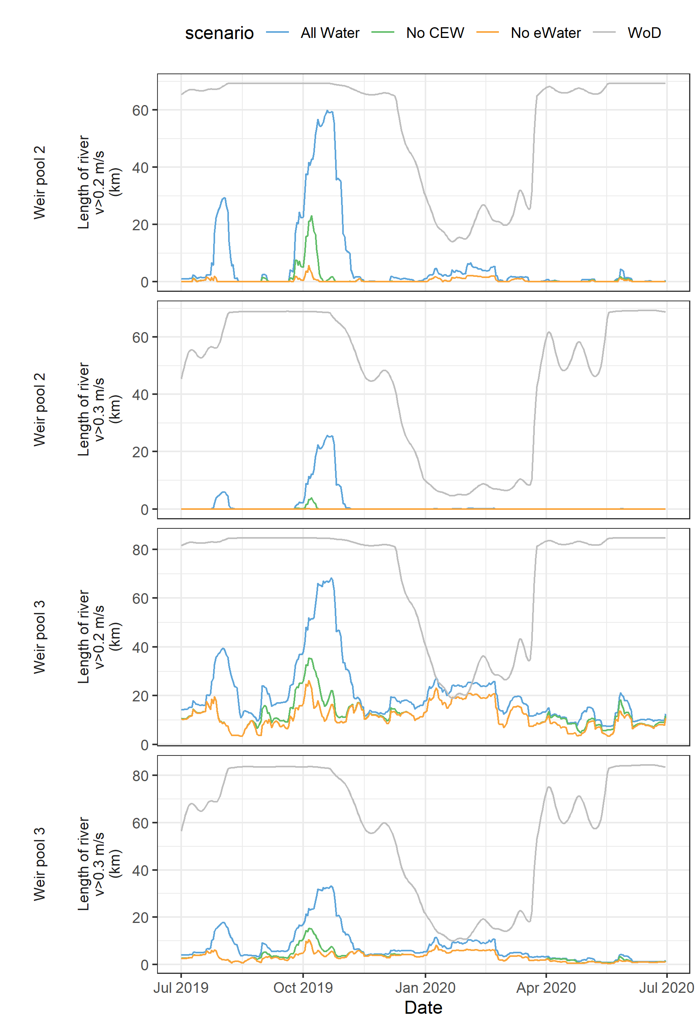

### Evaluation

The evaluation approach, including assessment criteria, is described in the evaluation section for Murray cod recruitment (Section 2.7).

Table 23. Murray Cod Recruitment evaluation questions and answers. CEW = Commonwealth environmental water, eWater = environmental water.

| CEWO evaluation questions | Outcomes of CEW delivery (2019-20) |
| --- | --- |
| What did CEW contribute to the growth and morphometric condition of Murray cod? |  |
| What did CEW contribute to recruitment of Murray cod? |  |
| What did CEW contribute to the resilience of Murray cod populations? |  |

Contribution (to what extent CEW contributed towards the outcome, with the significance of the outcome considered):

|  |  |  |  |  |  |  |  |  |  |  |  |
| --- | --- | --- | --- | --- | --- | --- | --- | --- | --- | --- | --- |
|  | Unknown |  | Negative |  | None/negligible |  | Minor |  | Moderate |  | Substantial |

### Discussion

### Management implications

### Conclusion

## Fish Assemblage

### Background

From 2015–2019, we collected fish assemblage data in the main channel of the LMR to inform Basin-scale evaluation of fish community responses to Commonwealth environmental water. This evaluation is being undertaken by the Centre for Freshwater Ecosystems at La Trobe University.

*Objectives*

In this report, our objectives are to: (1) provide summary statistics of the catch rates and population demographics for nominated species; (2) describe temporal variation in fish assemblage and population structure from 2015–2019; and (3) discuss key findings based on published research and our current understanding of fish life histories and population dynamics in the LMR. Our interpretations of the data for this indicator do not infer association with Commonwealth environmental water delivery.

### Methods

During autumn 2015–2019, small- and large-bodied fish assemblages were sampled from the gorge geomorphic zone of the LMR (Figure 1) using fyke nets and electrofishing, respectively. Prescribed methods (Hale *et al.* 2014) were used to obtain population structure data for seven target species (Figure 38). Refer to SARDI *et al.* (2018) for detailed sampling design and methodology. In 2017, electrofishing at half of the sites (sites 1, 3, 4, 6, 7) was delayed to winter due to equipment failure/malfunction.



Figure 39. Target species for the LMR: (a) Murray cod and (b) freshwater catfish (equilibrium life history); (c) golden perch and (d) silver perch (periodic life history); and (e) carp gudgeon, (f) Murray rainbowfish and (g) bony herring (opportunistic life history).

Temporal variation in fish assemblage structure (species composition and abundance), between sampling years, was investigated using Non-metric Multi-Dimensional Scaling (MDS), permutational multivariate analysis of variance (PERMANOVA) and Similarity Percentages (SIMPER) analysis in the software package PRIMER v. 6.1.12 (Clarke and Gorley 2006) and PERMANOVA + v.1.02 (Anderson *et al.* 2008). To determine temporal variation in population structure, length frequency histograms were qualitatively compared between sampling years.

### Results

*Catch summary*

From 2015–2019, a total of 43,010 individuals (ind.) from eight large-bodied fish species were collected by electrofishing. Across all years, bony herring (*Nematalosa erebi*) was consistently the most abundant species (75–97% of the catch/annum), followed by common carp (*Cyprinus carpio*), whose proportional abundance of the total catch varied across sampling years (1% in 2015 to 20% in 2017) (Figure 39a).

A total of 112,028 individuals from seven small-bodied species were collected by fyke nets. The total abundance of small-bodied species varied considerably across sampling years (9,661 ind. in 2017 to 37,678 ind. in 2018), but the proportional abundance of individual species remained similar. Carp gudgeon (*Hypseleotris* spp.) was the most abundant species (86–92% of catch/annum), followed by Gambusia (*Gambusia holbrooki*) (6–9%/annum) (Figure 39b).



Figure 40. Mean catch-per-unit-effort (CPUE) ± standard error of (a) large-bodied fish species captured using electrofishing (individuals per 90 second shot) and (b) small-bodied fish species captured using fine-mesh fyke nets (individuals per net per hour) in the gorge geomorphic zone (10 sites) of the LMR in autumn from 2015–2019. Electrofishing CPUE data from five sites are presented for 2017 as other sites were sampled during winter 2017.

*Temporal variability in fish assemblage structure*

MDS ordination of electrofishing data demonstrated separation of 2017 samples from all other years (Figure 40a). PERMANOVA indicated that large-bodied fish assemblages were significantly different between years (*Pseudo‑F*4,44 =5.0917, *P* ≤0.001). Pairwise comparisons revealed significant differences between 2017 and all other years, but not between any other year comparisons (Table 24).

Table 24. PERMANOVA pairwise comparison test results for large- and small-bodied fish assemblages in the gorge geomorphic zone of the LMR from autumn 2015–2019. *P*-values presented in bold are significant comparisons, using Bonferroni corrected α = 0.0050 (Narum 2006) for comparisons between years (ten comparisons).

|  |  |  |  |  |
| --- | --- | --- | --- | --- |
| **Comparison** | **Large-bodied** | | **Small-bodied** | |
| *t* | *P (perm)* | *t* | *P (perm)* |
| 2015 vs. 2016 | 2.0305 | 0.0068 | 1.1526 | 0.2412 |
| 2015 vs. 2017 | 3.5839 | **0.0008** | 2.0765 | 0.0131 |
| 2015 vs. 2018 | 1.7638 | 0.0382 | 1.207 | 0.2167 |
| 2015 vs. 2019 | 1.2874 | 0.1733 | 1.0302 | 0.3327 |
| 2016 vs. 2017 | 2.2942 | **0.0035** | 3.7883 | **0.0001** |
| 2016 vs. 2018 | 1.7945 | 0.0276 | 0.81273 | 0.5858 |
| 2016 vs. 2019 | 1.6992 | 0.0441 | 1.7025 | 0.0461 |
| 2017 vs. 2018 | 2.6821 | **0.0013** | 3.1583 | **0.001** |
| 2017 vs. 2019 | 3.1843 | **0.0004** | 1.9555 | 0.02 |
| 2018 vs. 2019 | 1.7619 | 0.0417 | 1.4932 | 0.0955 |

For small-bodied fish assemblages, there were significant differences between years (*Pseudo‑F*4,49 =3.8453, *P*≤0.001). PERMANOVA pair-wise comparisons revealed significant differences in small-bodied fish assemblages between 2017 and 2016, and 2017 and 2018, but not between any other year comparisons (Table 24).



Figure 41. Non-metric multi-dimensional scaling (MDS) plot of (a) large-bodied fish assemblages sampled by electrofishing and (b) small-bodied fish assemblages sampled by fyke netting in the gorge geomorphic zone of the LMR from 2015–2018. Sites (*n* = 5) sampled in winter 2017 were removed from the ordination.

SIMPER indicated that differences between years for large-bodied fish assemblages were primarily driven by higher abundance of common carp in 2017, lower abundance of common carp in 2015 and 2019, and lower abundance of bony herring in 2016 (Figure 39). SIMPER indicated that differences between 2017 and 2016 and 2018 for small-bodied fish assemblages were driven by a lower relative abundance of carp gudgeon in 2017 (Figure 39).

*Temporal variation in length/age structure of large-bodied species*

In 2015, the sampled golden perch population was mostly comprised of age 4+ (35%), 5+ (25%) and 18+ (13%) cohorts. In 2018, these cohorts persisted as age 7+ (51%), 8+ (19%) and 21+ (4%), respectively, but age 6+ fish were also apparent (23%) (Figure 41).

Low numbers of silver perch (*Bidyanus bidyanus*) and freshwater catfish (*Tandanus tandanus*) were sampled from 2015–2019. In 2015, silver perch ranged in age from 2+ to 5+ years, whilst only one silver perch (age 1+) was sampled in 2018 (Figure 42). Freshwater catfish ranged in age from 5+ to 9+ years in 2015, and 8+ to 13+ years in 2018 (Figure 43).

In 2015, the sampled Murray cod population was represented by individuals 103–145 mm (age 0+) and 1310 mm (not sacrificed for ageing). In 2018, the sampled Murray cod population consisted of individuals 74–140 mm (age 0+), 307 mm (age 1+), 409 mm (not sacrificed, potentially age 2+ or 3+) and 515 mm (not sacrificed, potentially age 3+ or 4+) (Figure 44).

From 2016 to 2019, the sampled bony herring population ranged in age from 0+ to 6+ years and was dominated by age 0+ fish (83–91%) in each year (Figure 45).



Figure 42. Length frequency distributions and age structures of golden perch collected from the gorge geomorphic zone of the LMR from 2015–2019.



Figure 43. Length frequency distributions and age structures of silver perch collected from the gorge geomorphic zone of the LMR from 2015–2019.



Figure 44. Length frequency distributions and age structures of freshwater catfish collected from the gorge geomorphic zone of the LMR from 2015–2019.



Figure 45. Length frequency distributions and age structures of Murray cod collected from the gorge geomorphic zone of the LMR from 2015–2019.



Figure 46. Length frequency distributions and age structures of bony herring collected from the gorge geomorphic zone of the LMR from 2016–2019.

### Evaluation

There are no CEWO evaluation questions for this indicator for the LMR Selected Area. The Basin-scale evaluation of fish community responses to Commonwealth environmental water is being undertaken by the Centre for Freshwater Ecosystems at La Trobe University. For this report, fish monitoring data were consolidated to evaluate a number of fish targets of DEW’s Long-Term Watering Plan (Appendix C).

### Discussion

During 2014-15 and 2015-16, relatively low (<15,000 ML/d), stable flows predominated in the LMR. In these years, small-bodied fish abundance and diversity were high. Abundances of flow-cued spawning species (i.e. golden perch and silver perch) remained similar in both years and overall, fish assemblage structure was characteristic of low flows in the LMR and similar to that during drought in 2007–2010 (Bice *et al.* 2014).

In 2017, following flooding in spring–summer 2016 (peak flow ~94,600 ML/d), there was a significant change to the small- and large-bodied fish assemblages, with an overall decrease in the abundances of small-bodied species and an increase in the abundance of common carp. A reduction in submerged vegetation in the main channel of the LMR during 2016-17, due to a combination of increased water depth/decreased light penetration and physical scour, likely resulted in a decrease in habitat availability and decreased abundance of small-bodied fishes (Bice *et al.* 2014). In 2017, increased abundance of common carp appeared to be driven by a large recruitment event in 2016-17 associated with flooding. Following a recession in water levels in summer 2017, large numbers of age 0+ common carp likely entered the main channel from off-channel floodplain and wetland habitats (their typical spawning habitat) and were captured during sampling in autumn and winter 2017.

The fish assemblage in 2017 was more typical of high flows, similar to the one in 2010–2012 (Bice *et al.* 2014). Nevertheless, in 2016-17, recruitment of native, large-bodied flow-cued spawners (e.g. golden perch) was negligible, despite a flow regime that was potentially conducive to spawning of these species (Mallen-Cooper and Stuart 2003; Zampatti and Leigh 2013a; 2013b) (also see Section 2.6). It is possible, that water hypoxia, associated with blackwater during the spring–early summer spawning season (Ye *et al.* 2018), impacted the survival of eggs and larvae.

Following in-channel flows (up to 17,800 ML/d) in spring–early summer 2017-18, small-bodied fish species composition and abundance reverted back to that of pre-flood conditions (i.e. 2016 and 2015), presumably due to structural and hydraulic habitats (i.e. submerged vegetation and stable water levels) conducive to small-bodied fish recruitment in the main river channel. The large-bodied fish assemblage trended towards one typical of ‘low flows’ (e.g. 2016, 2015 and 2008, Bice *et al.* 2014) due to a reduction of common carp abundance in 2018, relative to 2017. Common carp abundance, however, was still significantly greater in 2018, relative to 2016 and 2015, indicating the progression of fish from the 2016-17 cohort (age 0+) into the population as age 1+ (Ye *et al.* 2019). In 2019, following similar hydrological conditions to 2018 (i.e. low, within channel flows <18,000 ML/d), the small- and large-bodied fish assemblages remained comparable to the previous year. Common carp abundance, however, continued to decline in 2019 to levels similar to 2015 and 2016.

Based on electrofishing length frequency data, no recruitment (to age 0+) was observed for freshwater catfish in the LMR from 2014–20­19. In the LMR, the spawning biomass of freshwater catfish may be historically low (Ye *et al.* 2015b) and their recruitment dynamics are poorly understood.

From 2015–2019, regular recruitment of Murray cod (i.e. fish <150 mm TL) was observed in the LMR, including during years following an in-channel flow pulse (15,000–18,000 ML/d) and a high, overbank flow (>90,000 ML/d), but also during three years of low, stable, in-channel flows (<12,000 ML/d). Furthermore, these cohorts have generally persisted in the population, although were not sampled during 2019, likely due to low abundance and/or inadequate sampling effort. These results contrast with data collected from 2003–­2010, during the Millennium Drought, when Murray cod recruitment, measured as abundance of YOY in autumn, was limited in the predominantly lentic main channel habitats of the LMR. Subsequently, recruitment was observed in association with spawning that occurred in high flow years from 2010–2013 (Zampatti *et al.* 2014). The mechanisms that facilitate recruitment of Murray cod (to YOY) in the LMR are unclear, but likely relate to enhanced survival of early life stages associated with riverine hydraulics and productivity. The CEWO Monitoring, Evaluation and Research (MER) Project aims to explore these mechanisms by assessing aspects of Murray cod recruitment (e.g. abundance, growth, condition) in association with flow.

### Management implications

Prolonged low, in-channel flows (<15,000 ML/d) promote hydraulic (e.g. lentic) and structural (submerged plant) habitat conditions suitable for low flow generalist species, e.g. small-bodied species. Increased variability in the annual flow regime that includes large, overbank (>45,000 ML/d) flows will lead to increased recruitment of a range of species with different life histories (e.g. flow-dependant), promoting diversity and resilience in the fish assemblage. These desired flow outcomes may not be achieved with environmental water due to large volumes of water required and/or operational constraints. Nevertheless, coordinated environmental water delivery could contribute to within-channel flows ~20,000 ML/d and thereby promote variability in the annual flow regime, including hydraulics.

### Conclusion

During 2015 and 2016, in the main channel of the LMR, fish assemblages were characterised by high abundances of small-bodied species and a lack of recruitment of native, large-bodied flow-cued spawners. This fish assemblage structure was similar to that during drought in 2007–2010 (Bice *et al.* 2014) and characteristic of a low flow scenario. Following high flows in 2016-17, the fish assemblage shifted towards one characterised by low abundances of small-bodied species and high abundance of a large-bodied species, common carp. This assemblage was more typical of high flows, similar to 2010–2012 (Bice *et al.* 2014). Nevertheless, recruitment of native, large-bodied flow-cued spawners (e.g. golden perch) was negligible in 2016-17, likely due to water hypoxia associated with the blackwater event. During 2018 and 2019, a return to low, in-channel flows (<18,000 ML/d) resulted in the fish assemblage trending back towards that of 2015 and 2016, following: an increase in small-bodied fish abundance; a lack of recruitment from native, flow-cued spawners; and a decrease in common carp abundance.

# Contingency Monitoring

## Background

Contingency monitoring activities will be undertaken during MER under different flow scenarios to support current monitoring or undertake additional short-term activities to inform environmental water use planning and management. During 2019-20, contingency monitoring funding supplemented existing monitoring of lamprey migration funded under the Murray-Darling Basin Authority (MDBA) The Living Murray program. These additional resources ensured an appropriate level of monitoring to assess abundance and movement of lamprey, and the contribution of Commonwealth environmental water to connectivity and migration of lamprey. A summary of the key findings and evaluation are presented below. Detailed methods, results and discussion are reported in Bice *et al.* (2020).

## Lamprey migration in 2019-20: key findings and evaluation

Summary of lamprey findings and CEW evaluation to be added

# Synthesis and Evaluation

To be updated

Table 25. CEWO evaluation questions by indicators for the Lower Murray, which includes the Lower Murray River (LMR) and the Coorong, Lower Lakes and Murray Mouth (CLLMM). Evaluation questions are sourced or adapted from Gawne *et al.* (2014). Evaluation of CEW for hydraulic and matter transport questions is based on modelled data. CEW = Commonwealth environmental water. Refer to the evaluation in respective indicator sections (Section 2) for more detail.

| **CEWO evaluation questions** | **Outcomes of CEW delivery** | | | | | |
| --- | --- | --- | --- | --- | --- | --- |
| **2014-15** | **2015-16** | **2016-17** | **2017-18** | **2018-19** | **2019-20** |
| What did CEW contribute to hydraulic diversity within weir pools? (LMR) |  |  |  |  |  |  |
| What did CEW contribute to variability in water levels within weir pools? (LMR) |  |  |  |  |  |  |
| What did CEW contribute to hydrological connectivity (lateral and longitudinal)? (LMR) |  |  |  |  |  |  |
| What did CEW contribute to Meeting Environmental Water Requirements (of the LTWP) in the main channel? (LMR) |  |  |  |  |  |  |
| What did CEW contribute to dissolved oxygen levels? (LMR) |  |  |  |  |  |  |
| What did CEW contribute to patterns and rates of primary productivity? (LMR) |  |  |  |  |  |  |
| What did CEW contribute to patterns and rates of decomposition? (LMR) |  |  |  |  |  |  |
| What did CEW contribute to water quality? (LMR) |  |  |  |  |  |  |
| What did CEW contribute to salinity levels and transport? (LMR, CLLMM) |  |  |  |  |  |  |
| What did CEW contribute to the salinity regime? (LMR, CLLMM) |  | | | | |  |
| What did CEW contribute to nitrogen and silica concentrations and transport? (CLLMM) |  |  |  |  |  |  |
| What did CEW contribute to phosphorus concentrations and transport? (CLLMM) |  |  |  |  |  |  |
| What did CEW contribute to phytoplankton concentrations? (CLLMM) |  |  |  |  |  |  |
| What did CEW contribute to phytoplankton transport? (CLLMM) |  |  |  |  |  |  |
| What did CEW contribute to improving *Ruppia tuberosa* habitat? (Coorong) |  | | | | |  |
| What did CEW contribute to fish habitat? (Coorong) |  | | | | |  |
| What did CEW contribute to littoral understorey vegetation diversity and productivity? |  | | | | |  |
| What did CEW contribute to above-ground biomass produced by understorey littoral vegetation? |  | | | | |  |
| What did CEW contribute to microinvertebrate diversity? (LMR) |  |  |  |  |  |  |
| What did CEW contribute to microinvertebrate abundance (density)? (LMR) |  |  |  |  |  |  |
| What did CEW contribute to communities of the Lower Murray (via longitudinal and lateral connectivity)? (LMR) |  |  |  |  |  |  |
| What did CEW contribute to the expected quality of food resources (microinvertebrates) for higher trophic organisms? (LMR) |  |  |  |  |  |  |
| Did the flow regime (including environmental water) contribute to recruitment of golden perch and silver perch? (LMR) |  |  |  |  |  |  |
| Did the flow regime (including environmental water) contribute to the resilience of golden perch and silver perch populations? (LMR) |  | | | | |  |
| What did CEW contribute to the growth and morphometric condition of Murray cod? (LMR) |  | | | | |  |
| What did CEW contribute to recruitment of Murray cod? (LMR) |  | | | | |  |
| What did CEW contribute to the resilience of Murray cod populations? (LMR) |  | | | | |  |

Contribution (to what extent CEW contributed towards the outcome, with the significance of the outcome considered). See respective indicator evaluation sections (Section 2) for selection criteria.

|  |  |  |  |  |  |  |  |  |  |  |  |
| --- | --- | --- | --- | --- | --- | --- | --- | --- | --- | --- | --- |
|  | Unknown |  | Negative |  | None/negligible |  | Minor |  | Moderate |  | Substantial |

# General Management Recommendations

To be updated

# References

Aldridge, K.T., Busch, B.D. and Hipsey, M.R. (2013). An assessment of the contribution of environmental water provisions to salt and nutrient dynamics in the lower Murray, November 2011–July 2012. The University of Adelaide, Adelaide.

Anderson, M.J., Gorley, R.N. and Clarke, K.R. (2008). PERMANOVA+ for PRIMER: guide to software and statistical methods. PRIMER-E, Plymouth, UK.

Arumugam, P.T. and Geddes, M.C. (1987). Feeding and growth of golden perch larvae and fry (*Maquaria ambigua* Richardson). *Transactions Royal Society of South Australia* **111**, 59–66.

Arumugam, P.T. and Geddes, M.C. (1996). Effects of golden perch (*Macquaria ambigua* (Richardson)) larvae, fry and fingerlings on zooplankton communities in larval-rearing ponds: An enclosure study. *Marine and Freshwater Research* **47**, 837–844.

Baldwin, D. S., Colloff, M. J., Mitrovic, S. M., Bond, N. R. and Wolfenden, B. (2016). Restoring dissolved organic carbon subsidies from floodplains to lowland river food webs: a role for environmental flows? *Marine and Freshwater Research* **67**, 1387–1399.

Baranyi, C., Hein, T., Holarek, C., Keckeis, S. and Schiemer, F. (2002). Zooplankton biomass and community structure in a Danube River floodplain system: effects of hydrology. *Freshwater Biology* **47**, 473–482.

Barlow, C., McLoughlin, R. and Bock, K. (1987). Complementary feeding habits of golden perch *Macquaria ambigua* (Richardson)(Percichthyidae) and silver perch *Bidyanus bidyanus* (Mitchell)(Teraponidae) in farm dams. In: Proceedings of the Linnean Society of New South Wales, pp. 143–152.

Beardall, J. and Raven, J.A. (1990). Pathways and mechanisms of respiration in microalgae. *Marine Microbial Food Webs* **4**, 7–30.

Beh, E., Montzeri, M. and Gibbs, M.S. (2019). Refinements to the River Murray Source model in South Australia. DEW Technical note 2019, Government of South Australia, Department for Environment and Water, Adelaide.

Berggren, M. and del Giorgio, P.A. (2015). Distinct patterns of microbial metabolism associated to riverine dissolved organic carbon of different source and quality. *Journal of Geophysical Research: Biogeosciences* **120**, 989–999.

Betsill, R.K. and Van Den Avyle, M.J. (1997). Effect of temperature and zooplankton abundance on growth and survival of larval threadfin shad. *Transactions of the American Fisheries Society* **126**, 999–1011.

Bice, C.M., Gehrig, S.L., Zampatti, B.P., Nicol, J.M., Wilson, P., Leigh, S.L. and Marsland, K. (2014). Flow-induced alterations to fish assemblages, habitat and fish-habitat associations in a regulated lowland river. *Hydrobiologia* **722**, 205–222.

Bice, C.M., Gibbs, M.S., Kilsby, N.N., Mallen-Cooper, M. and Zampatti, B.P. (2017). Putting the “river” back into the lower River Murray: quantifying the hydraulic impact of river regulation to guide ecological restoration. *Transactions of the Royal Society of South Australia*, DOI: 10.1080/03721426.2017.1374909.

Bice, C.M., Zampatti, B.P., Ye, Q. and Giatas, G.C. (2020). Lamprey migration in the lower River Murray in association with Commonwealth environmental water delivery in 2019. South Australian Research and Development Institute (Aquatic Sciences), Adelaide. SARDI Publication No. F2019/000000-1. SARDI Research Report Series No. ###. 35 pp.

Biggs, B.J.F., Nikora, V.I. and Snelder, T.H. (2005). Linking scales of flow variability to lotic ecosystem structure and function. *Regulated Rivers: Research & Mangement* **21**, 283–298.

Bonifacio, R. S., Jones-Gill, A., Wood, C., Phillips, J. and Fuller, J. (2016). Summary of hydraulic, conceptual and Bayesian Belief Network models to assess outcomes of lowering Weir Pools 1-5, DEWNR Technical report 2016/35, ISBN. 978-1-925510-56-0, Government of South Australia, through Department of Environment, Water and Natural Resources, Adelaide.

Boulton, A.J. and Lloyd L.N. (1992). Flooding frequency and invertebrate emergence from dry floodplain sediments of the River Murray, Australia. *Regulated Rivers: Research & Management* **7**, 137–151.

Bremigan, M.T. and Stein, R.A. (1994). Gape-dependent larval foraging and zooplankton size: Implications for fish recruitment across systems. *Canadian Journal of Fisheries and Aquatic Sciences* **51**, 913–922.

Brendonck, L. and De Meester, L. (2003). Egg banks in freshwater zooplankton: evolutionary and ecological archives in the sediment. *Hydrobiologia* **491**, 65–84.

Brookes, J.D., Lamontagne, S., Aldridge, K.T., Benger, S., Bissett, A., Bucater, L., Cheshire, A., Cook, P.L.M., Deegan, B.M., Dittmann, S., Fairweather, P.G., Fernandes, M.B., Ford, P.W., Geddes, M.C., Gillanders, B.M., Grigg, N.J., Haese, R.R., Krull, E., Langley, R.A., Lester, R.F., Loo, M., Munro, A.R., Noell, C.J., Nayar, S., Paton, D.C., Revill, A.T., Rogers, D.J., Rolston, A.N., Sharma, S.K., Short, D.A., Tanner, J.E., Webster, I.T., Wellmann, N.R. and Ye, Q. (2009). An Ecosystem Assessment Framework to Guide Management of the Coorong. Final Report of the CLLAMMecology Research Cluster. CSIRO: Water for a Healthy Country National Research Flagship, Canberra.

Bunn, S. and Arthington, A.H. (2002). Basic principles and ecological consequences of altered flow regimes for aquatic biodiversity. *Environmental Management* **30**, 492–507.

Caceres, C.E. and Hairston, N.G., Jr. (1998). Part 2. Regular contributions on crustaceans-Egg banks: Structure and consequences-Benthic-pelagic coupling in planktonic crustaceans: The role of the benthos (with 4 figures). *Ergebnisse der Limnologie* **52**, 163–174.

Chow, V.T., Maidment, D.R. and Mays, L.W. (1988). Applied Hydrology. McGraw Hill International Editions: Singapore.

Clarke, K.R. and Gorley, R.N. (2006). PRIMER v6. User manual/tutorial. Plymouth: PRIMER-E Ltd.

Cook, P.L.M., Aldridge, K.T., Lamontagne, S. and Brookes, J.D. (2010). Retention of nitrogen, phosphorus and silicon in a large semi-arid riverine lake system. *Biogeochemistry* **99**, 49–63.

Cooling, M.P., Lloyd, L.N. and Walker, K.F. (2010). SA River Murray Weir Operating Strategy. Lloyd Environmental report to the SA Murray-Darling Basin NRM Board, Syndal, Victoria.

Cooper, S.D. and Goldman C.R. (1980). Opossum Shrimp (*Mysis relicta*) Predation on Zooplankton. *Canadian Journal of Fisheries and Aquatic Sciences* **37**, 909–919.

Cottingham, P., Stewardson, M., Roberts, J., Oliver, R., Crook, D., Hillman, T. and Rutherfurd, I. (2010). Ecosystem response modeling in the Goulburn River: how much water is too much? In Ecosystem Response Modelling in the Murray-Darling Basin. N. Saintilan and I. C. Overton. Canberra, Australia, CSIRO Publishing: 391–409.

Department of Environment, Water and Natural Resources (2014). Riverine Recovery overview of monitoring to assess the ecological response to the Locks 1 and 2 weir pool raising, spring 2014, Government of South Australia, through Department of Environment, Water and Natural Resources, Adelaide.

Department of Environment, Water and Natural Resources (2015). South Australian River Murray Long-Term Environmental Watering Plan. November 2015. https://www.mdba.gov.au/sites/default/files/pubs/long-term-e-water-plan-sa-river-murray-nov-15.PDF.

Dodson, S.I. and Egger, D.L. (1980). Selective Feeding of Red Phalaropes on Zooplankton of Arctic Ponds. *Ecology* **61**, 755–763.

Dudley, R.K. and Platania, S.P. (2007). Flow regulation and fragmentation imperil pelagic spawning ﬁshes. *Ecological Applications* **17**, 2074–2086.

Eadie, J.M. and Keast, A. (1984). Resource heterogeneity and fish species diversity in lakes. *Canadian Journal of Zoology* **62**, 1689–1695.

Fredberg, J., Zampatti, B.P. and Bice, C.M. (2019). Chowilla Icon Site Fish Assemblage Condition Monitoring 2019. South Australian Research and Development Institute (Aquatic Sciences), Adelaide. SARDI Publication No. F2008/000907-10. SARDI Research Report Series No. 1005. 62pp

Gawne, B., Merrick, C., Williams, D.G., Rees, G., Oliver, R., Bowen, P.M., Treadwell, S., Beattie, G., Ellis, I., Frankenberg, J. and Lorenz, Z. (2007). Patterns of primary and heterotrophic productivity in an arid lowland river. *River Research and Applications* **23**, 1070–1087.

Gawne, B., Brooks, S., Butcher, R., Cottingham, P., Everingham, P. and Hale, J. (2013). Long Term Intervention Monitoring Project River Monitoring and Evaluation Requirements Lower Murray for Commonwealth environmental water. Final Report prepared for the Commonwealth Environmental Water Office by The Murray–Darling Freshwater Research Centre, MDFRC Publication 01.2/2013.

Gawne, B., Hale, J., Butcher, R., Brooks, S., Roots, J., Cottingham, P., Stewardson, M. and Everingham, P. (2014). Commonwealth Environmental Water Office Long Term Intervention Monitoring Project: Evaluation Plan. Final Report prepared for the Commonwealth Environmental Water Office by The Murray–Darling Freshwater Research Centre. MDFRC Publication 29/2014.

Gehrig, S.L., Frahn, K.A. and Nicol, J.M. (2016). Monitoring the response of littoral and floodplain vegetation and soil moisture flux to weir pool raising - 2015. South Australian Research and Development Institute (Aquatic Sciences), Adelaide. SARDI Publication No. F2015/000390-2.

Gibbs, M.S., Bice, C., Brookes, J., Furst, D., Gao, L., Joehnk, K. Marklund, M. Nicol, J. Zampatti, B. and Wallace, T. (2020). Ecological connectivity of the River Murray: Managing ecological outcomes and water quality risks through integrated river management. Goyder Institute for Water Research Technical Report Series No. 20/03.

Grace, M.R., Giling, D.P., Hladyz, S., Caron, V., Thompson, R.M. and Mac Nally, R. (2015). Fast processing of diel oxygen curves: estimating stream metabolism with BASE (Bayesian Single-station Estimation). *Limnology & Oceanography: Methods* **13**, 103–114.

Graeber, D., Poulsen, J.R., Heinz, M., Rasmussen, J.J., Zak, D., Gücker, B., Kronvang, B. and Kamjunke, N. (2018). "Going with the flow: Planktonic processing of dissolved organic carbon in streams." *Science of The Total Environment* **625**, 519–530.

Hale, J., Stoffels, R., Butcher, R., Shackleton, M., Brooks, S. and Gawne, B. (2014). Commonwealth Environmental Water Office Long Term Intervention Monitoring Project – Standard Methods. Final Report prepared for the Commonwealth Environmental Water Office by The Murray-Darling Freshwater Research Centre. Murray-Darling Freshwater Research Centre, MDFRC Publication 29.2/2014.

Hanisch, D.R., Hillyard, K.A. and Smith, J. (2017). Riverine Recovery – Synthesis report of the ecological response to weir pool raising at Locks 1, 2 and 5 of the River Murray, 2014–16. Government of South Australia, through Department of Environment, Water and Natural Resources, Adelaide.

Herczeg, A.L., Dogramaci, S.S. and Leaney, F.W.J. (2001). Origin of dissolved salts in a large, semi-arid groundwater system: Murray Basin, Australia. *Marine and freshwater Research* **52**, 41–51.

Ingram, B.A. and De Silva, S.S. (2007). Diet composition and preference of juvenile Murray cod, trout cod and Macquarie perch (Percichthyidae) reared in fertilised earthen ponds. *Aquaculture* **271**, 260–270.

Jenkins, K. and Boulton, A. (2003). Connectivity in a dryland river: short-term aquatic microinvertebrate recruitment following floodplain inundation. *Ecology* **84**, 2708–2723.

Junk, W.J., Bayley, P.B. and Sparks, R.E. (1989). The flood pulse concept in river-floodplain systems. *Canadian Special Publication of Fisheries and Aquatic Sciences* **106**, 110–127.

Kaminskas, S. and Humphries, P. (2009). Diet of Murray cod (*Maccullochella peelii peelii*)(Mitchell) larvae in an Australian lowland river in low flow and high flow years. *Hydrobiologia* **636**, 449.

Karabanov, D.P., Bekker, E.I., Shiel, R.J. and Kotov, A.A. (2018). Invasion of a Holarctic planktonic cladoceran *Daphnia galeata* Sars (Crustacea: Cladocera) in the Lower Lakes of South Australia. *Zootaxa* **4402**, 136–148.

King, A.J., Gwinn, D.C., Tonkin, Z., Mahoney, J., Raymond, S. and Beesley, L. (2016). Using abiotic drivers of fish spawning to inform environmental flow management. *Journal of Applied Ecology* **53**, 34–43.

Kirk, J.T.O. and Oliver, R.L. (1995). Optical closure in an ultra-turbid lake. *Journal of Geophysical Research-Oceans* **100**, 13221–13225.

Kingsford, R.T. (2000). Ecological impacts of dams, water diversions and river management on floodplain wetlands in Australia. *Austral Ecology* **25**, 109–127.

Koehn, J.D., King, A.J., Beesley, L., Copeland, C., Zampatti, B.P. and Mallen-Cooper, M. (2014). Flows for native fish in the Murray–Darling Basin: lessons and considerations for future management. *Ecological Management and Restoration* **15**, 40–50.

Lair, N. (2006). A review of regulation mechanisms of metazoan plankton in riverine ecosystems: aquatic habitat versus biota. *River Research and Applications* **22**, 567–593.

Lake, J.S. (1967). Rearing experiments with five species of Australian freshwater fishes. II. Morphogenesis and ontogeny. *Australian Journal of Marine and Freshwater Research* **18**,155-173.

Lintermans, M. (2007). Fishes of the Murray-Darling Basin: An Introductory Guide. Murray-Darling Basin Commission, Canberra.

McCullough, D.P., Montazeri, M. and Esprey, L. (2017). Update and calibration of Pike and Katarapko floodplain flexible mesh models. DEWNR Technical note 2017/11, Government of South Australia, Department of Environment, Water and Natural Resources, Adelaide.

McGinness, H. M. and A. D. Arthur (2011). Carbon dynamics during flood events in a lowland river: the importance of anabranches. *Freshwater Biology* **56**, 1593–1605.

Maheshwari, B.L., Walker, K.F. and McMahon, T.A. (1995). Effects of regulation on the flow regime of the Murray River, Australia. *Regulated Rivers: Research and Management* **10**, 15–38.

Mallen-Cooper, M. and Stuart, I.G. (2003). Age, growth and non-flood recruitment of two potamodromous fishes in a large semi-arid/temperate river system. *River Research and Applications* **19**, 697–719.

Mallen-Cooper, M. and Zampatti, B.P. (2018). History, hydrology and hydraulics: Rethinking the ecological management of large rivers. *Ecohydrology* **11**, e1965 https://doi.org/10.1002/eco.1965.

Marra, J. and Barber, R.T. (2004). Phytoplankton and heterotrophic respiration in the surface layer of the ocean. *Geophysical Research Letters* **31**. doi:10.1029/2004GL019664.

Murray–Darling Basin Authority (2012). Basin Plan. Murray–Darling Basin Authority, Canberra.

Murray–Darling Basin Commission (2006). The River Murray channel icon site environmental management plan. Murray–Darling Basin Commission, Canberra.

Mills, E.L., Confer, J.L. and Kretchmer, D.W. (1986). Zooplankton Selection by Young Yellow Perch: The Influence of Light, Prey Density, and Predator Size. *Transactions of the American Fisheries Society* **115**, 716–725.

Montazeri, M., Gibbs, M. (2019). Production of 80,000 ML/day flood inundation map for the South Australian section of River Murray. DEW Technical note 2019, Government of South Australia, Department for Environment and Water, Adelaide.

Narum, S.R. (2006). Beyond Bonferroni: Less conservative analyses for conservation genetics. *Conservation Genetics* **7**, 783–787.

Odum, H.T. (1956). Primary production in flowing waters. *Limnology and Oceanography* **1**, 102–117.

Oliver, R.L. and Lorenz, Z. (2010). Flow and metabolic activity in the channel of the Murray River. Ecosystem Response Modelling in the Murray-Darling Basin N. Saintilan and I. Overton, CSIRO Publishing: 267–280.

Oliver, R. L. and Merrick, C. (2006). Partitioning of river metabolism identifies phytoplankton as a major contributor in the regulated Murray River (Australia). *Freshwater Biology* **51**, 1131–1148.

Oliver, R.L., Mitrovic, S.M. and Rees, C. (2010). Influence of salinity on light conditions and phytoplankton growth in a turbid river. *River Research and Applications* **26**, 894–903.

Poff, N.L., Allan, J.D., Bain, M.B., Karr, J.R., Prestegaard, K.L., Richter, B.D., Sparks, R.E. and Stromberg, J.C. (1997). The natural flow regime: A paradigm for river conservation and restoration *BioScience* **47**, 769–784.

Perkin, J.S., Gido, K.B., Costigan, K.H., Daniels, M.D. and Johnson, E.R. (2015). Fragmentation and drying ratchet down Great Plains stream fish diversity. *Aquatic Conservation: Marine and Freshwater Ecosystems* **25**, 639–655.

Pernthaler, J. and Posch, T. (2009). Microbial food webs. In: Encyclopedia of inland waters. (Ed. GE Likens) pp. 244–251. Academic Press Inc.

Ranta, E. and Nuutinen, V. (1985). Foraging by the smooth newt (*Triturus vulgaris*) on zooplankton: Functional responses and diet choice. *Journal of Animal Ecology* **54**, 275–293.

Reckendorfer, W., Keckeis, H., Winkler, G. and Schiemer, F. (1999). Zooplankton abundance in the River Danube, Austria: the significance of inshore retention. *Freshwater Biology* **41**, 583–591.

Reynolds, C.S. (1984). The Ecology of Freshwater Phytoplankton. Cambridge University Press. Cambridge. 384p.

Richardson, W.B. (1992). Microcrustacea in flowing water: experimental analysis of washout times and a field test. *Freshwater Biology* **28**, 217–230.

Rivkin, R.B. and Legendre, L. (2001). Biogenic carbon cycling in the upper ocean: Effects of microbial respiration. *Science* **291**, 2398–2400.

Schael, D.M., Rudstam, L.G. and Post, J.R. (1991). Gape limitation and prey selection in larval yellow perch (*Perca flavescens*), freshwater drum (*Aplodinotus grunniens*), and black crappie (*Pomoxis nigromaculatus*). *Canadian Journal of Fisheries and Aquatic Sciences* **48**, 1919–1925.

Schmid-Araya, J.M. and Schmid, P.E. (2000). Trophic relationships: Integrating meiofauna into a realistic benthic food web. *Freshwater Biology* **44**, 149–163.

Sellers, T. and P. A. Bukaveckas (2003). Phytoplankton production in a large, regulated river: A modeling and mass balance assessment. *Limnology and Oceanography* **48**, 1476–1487.

Shiel, R.J. (1978). Zooplankton communities of the Murray-Darling river system - a preliminary report. *Proceedings of the Royal Society of Victoria* **90**, 193–202.

Shiel, R.J. (1981). Plankton of the Murray-Darling River system, with particular reference to the zooplankton. PhD Thesis, Univ. of Adelaide. 287 pp.

Sluss, T., Cobbs, G. and Thorp, J. (2008). Impact of turbulence on riverine zooplankton: a mesocosm experiment. *Freshwater Biology* **53**, 1999–2010.

South Australian Research and Development Institute (SARDI) Aquatic Sciences, University of Adelaide, Commonwealth Scientific and Industrial Research Organisation, South Australian Environmental Protection Authority, Department of Environment and Natural Resources and In Fusion (2018). Commonwealth Environmental Water Office Long Term Intervention Monitoring Project Lower Murray River Selected Area Monitoring and Evaluation Plan Version 3. Prepared by the South Australian Consortium for the Commonwealth Environmental Water Office. Commonwealth of Australia 2018. http://www.environment.gov.au/water/cewo/publications/cewo-ltim-lower-murray-2018.

Statzner, B. and Higler, B. (1986). Stream hydraulics as a major determinant of benthic invertebrate zonation patterns. *Freshwater Biology* **16**, 127–139.

Steinman, A.D. and McIntire, C.D. (1990). Recovery of lotic periphyton communities after disturbance. *Environmental Management* **14**, 589–604.

Striebel, M., Singer, G., Stibor, H. and Andersen, T. (2012). Trophic overyielding: Phytoplankton diversity promotes zooplankton productivity. *Ecology* **93**, 2719–2727.

Tan, L.-W. and Shiel, R.J. (1993). Responses of billabong rotifer communities to inundation. *Hydrobiologia* **255**, 361–369.

Tonkin, Z.D., Humphries, P. and Pridmore, P.A. (2006). Ontogeny and feeding in two native and one alien fish species from the Murray–Darling Basin, Australia. *Environmental Biology of Fishes* **76**, 303–315.

Tonkin, Z., Stuart, I., Kitchingman, A., Jones, M., Thiem, J., Zampatti, B., Hackett, G., Koster, W. and Koehn, J. (2017). The effects of flow on silver perch population dynamics in the Murray River. Arthur Rylah Institute for Environmental Research. Technical Report Series No. 282. Department of Environment, Land, Water and Planning, Heidelberg, Victoria.

Tonkin, Z., Stuart, I., Kitchingman, A., Thiem, J.D., Zampatti, B., Hackett, G., Koster, W., Koehn, J., Morrongiello, J., Mallen-Cooper, M. and Lyon, J. (2019). Hydrology and water temperature influence recruitment dynamics of the threatened silver perch *Bidyanus bidyanus* in a regulated lowland river. *Marine and Freshwater Research* **70**, 1333–1344.

Várbíró, G., Padisák, J., Nagy-László, Z., Abonyi, A., Stanković, I., Gligora Udovič, M., Béres, V.B. and Borics, G. (2018). How length of light exposure shapes the development of riverine algal biomass in temperate rivers? *Hydrobiologia* **809**, 53–63.

Vilizzi, L. and Walker, K.F. (1999). Age and growth of common carp, *Cyprinus carpio*, in the River Murray, Australia: validation, consistency of age interpretation and growth models. *Environmental Biology of Fishes* **54**, 77–106.

Vinyard, G.L. (1980). Differential prey vulnerability and predator selectivity: effects of evasive prey on bluegill (*Lepomis macrochirus*) and pumpkinseed (*L. gibhosus*) predation. *Canadian Journal of Fisheries and Aquatic Sciences* **37**, 2294–2299.

Vinyard, G.L. and O'Brien, W.J. (1975). Dorsal light response as an index of prey preference in bluegill (*Lepomis macrochirus*). *Journal of the Fisheries Board of Canada* **32**, 1860–1863.

Walker, K.F. (1985). A review of the ecological effects of river regulation in Australia. *Hydrobiologia* **125**, 111–129.

Walker, K.F. (2006). Serial weirs, cumulative effects: the Lower Murray River, Australia. In: Ecology of Desert Rivers (Ed. R. Kingsford) pp. 248–279. Cambridge University Press, Cambridge.

Walker, K.F. and Thoms, M.C. (1993). Environmental effects of flow regulation on the Lower Murray River, Australia. *Regulated Rivers: Research and Management* **8**, 103–119.

Wallace, T.A., Daly, R., Aldridge, K.T., Cox, J., Gibbs, M.S., Nicol, J.M., Oliver, R.L., Walker, K.F., Ye, Q. and Zampatti, B.P. (2014). River Murray Channel Environmental Water Requirements: Hydrodynamic Modelling Results and Conceptual Models, Goyder Institute for Water Research Technical Report Series No. 14/5, Adelaide, South Australia.

Wallace, T.W. and Cummings, C.R. (2016). Influence of water level manipulation on biofilm composition in a highly regulated lowland river. Report prepared for the Department of Environment, Water and Natural Resources by the University of Adelaide and the Environment Protection Authority. 36pp.

Warburton, K., Retif, S. and Hume, D. (1998). Generalists as sequential specialists: diets and prey switching in juvenile silver perch. *Environmental Biology of Fishes* **51**, 445–454.

Watts, R.J., McCasker, N., Thiem, J., Howitt, J.A., Grace, M., Kopf, R.K., Healy, S. and Bond, N. (2015). Commonwealth Environmental Water Office Long Term Intervention Monitoring Project: Edward-Wakool Selected Area Technical Report, 2014-15. Institute for Land, Water and Society, Charles Sturt University, Prepared for Commonwealth Environmental Water.

Webb, A., King, E., Treadwell, S., Lintern, A., Baker, B., Casanelia, S., Grace, M., Koster, W., Lovell, D., Morris, K., Pettigrove, V., Townsend, K. and Vietz, G. (2017). Commonwealth Environmental Water Office Long Term Intervention Monitoring Project: Goulburn River Selected Area evaluation report 2016–17.

Webb, A., Vietz, G., Windecker, S., Hladyz, S., Thompson, R., Koster, W. and Jones, M. (2015). Monitoring and reporting on the ecological outcomes of Commonwealth environmental water delivered in the lower Goulburn River and Broken Creek in 2013/14. The University of Melbourne for the Commonwealth Environmental Water Office.

Whitworth, K.L. and Baldwin, D.S. (2016). Improving our capacity to manage hypoxic blackwater events in lowland rivers: The Blackwater Risk Assessment Tool. *Ecological Modelling* **320**, 292–298.

Winemiller, K.O. and Rose, K.A. (1992). Patterns of life-history diversification in North American fishes: implications for population regulation. *Canadian Journal of Fisheries and Aquatic Sciences* **49**, 2196–2218.

Ye, Q., Aldridge, K., Bucater, L., Bice, C., Busch, B., Cheshire, K.J.M, Fleer, D., Hipsey, M., Leigh, S.J., Livore, J.P., Nicol, J., Wilson, P.J. and Zampatti, B.P. (2015a). Monitoring of ecological responses to the delivery of Commonwealth environmental water in the lower River Murray, during 2011-12. Final report prepared for Commonwealth Environmental Water Office. South Australian Research and Development Institute, Aquatic Sciences.

Ye, Q., Giatas, G., Aldridge, K., Busch, B., Brookes, J., Gibbs, M., Hipsey, M., Lorenz, Z., Maas, R., Oliver, R., Shiel, R., Woodhead, J. and Zampatti, B. (2019). Long-Term Intervention Monitoring of the Ecological Responses to Commonwealth Environmental Water Delivered to the Lower Murray River Selected Area in 2017-18. A report prepared for the Commonwealth Environmental Water Office. South Australian Research and Development Institute, Aquatic Sciences.

Ye, Q., Giatas, G., Aldridge, K., Busch, B., Gibbs, M., Hipsey, M., Lorenz, Z., Maas, R., Oliver, R., Shiel, R., Woodhead, J. and Zampatti, B. (2017). Long-Term Intervention Monitoring of the Ecological Responses to Commonwealth Environmental Water Delivered to the Lower Murray River Selected Area in 2015/16. A report prepared for the Commonwealth Environmental Water Office. South Australian Research and Development Institute, Aquatic Sciences.

Ye, Q., Giatas, G., Aldridge, K., Busch, B., Brookes, J., Gibbs, M., Hipsey, M., Lorenz, Z., Maas, R., Oliver, R., Shiel, R., Woodhead, J. and Zampatti, B. (2018). Long-Term Intervention Monitoring of the Ecological Responses to Commonwealth Environmental Water Delivered to the Lower Murray River Selected Area in 2016/17. A report prepared for the Commonwealth Environmental Water Office. South Australian Research and Development Institute, Aquatic Sciences.

Ye Q., Giatas G., Aldridge K.T., Busch B., Gibbs M., Hipsey M.R., Lorenz Z., Oliver R., Shiel R.J. & Zampatti B. (2016b) Long-term Intervention Monitoring for the Ecological Responses to Commonwealth Environmental Water Delivered to the Lower Murray River Selected Area in 2014/15: A Report Prepared for the Commonwealth Environmental Water Office by the South Australian Research and Development Institute, Aquatic Sciences, SARDI Aquatic Sciences.

Ye, Q., Livore, J.P., Aldridge, K., Bradford, T. , Busch, B., Earl, J., Hipsey, M., Hoffmann, E., Joehnk, K., Lorenz, Z., Nicol, J., Oliver, R., Shiel, R., Suitor, L., Tan, L., Turner, R., Wegener, I., Wilson, P.J. and Zampatti, B.P. (2015b). Monitoring the ecological responses to Commonwealth environmental water delivered to the Lower Murray River in 2012-13. Report 3, prepared for Commonwealth Environmental Water Office. South Australian Research and Development Institute, Aquatic Sciences.

Ye, Q., Livore, J., Aldridge, K., Giatas, G., Hipsey, M., Joehnk, K., Nicol, J., Wilson, P., Zampatti, B. (2016a). Monitoring ecological response to Commonwealth environmental water delivered to the Lower Murray River in 2013-14. Final Report prepared for the Commonwealth Environmental Water Office. South Australian Research and Development Institute.

Ye, Q., Bucater, L., Zampatti, B., Bice, C., Wilson, P., Suitor, L., Wegener, I., Short, D. and Fleer, D. (2015c). Population dynamics and status of freshwater catfish (*Tandanus tandanus*) in the lower River Murray, South Australia. South Australian Research and Development Institute (SARDI) Aquatic Sciences, Adelaide. SARDI Publication No. F2014/000903-1. SARDI Research Report Series No. 841.

Young, R.G. and Huryn, A.D. (1996). Interannual variation in discharge controls ecosystem metabolism along a grassland river continuum. *Canadian Journal of Fisheries and Aquatic Sciences* **53**, 2199–2211.

Zampatti, B.P. (2019). Ecology and population dynamics of golden perch (*Macquaria ambigua*) in a fragmented, flow impacted river: implications for conservation and management. PhD Thesis, University of Adelaide, Adelaide.

Zampatti, B.P. and Leigh, S.J. (2013a). Effects of flooding on recruitment and abundance of Golden Perch (*Macquaria ambigua ambigua*) in the lower River Murray. *Ecological Management and Restoration* **14**, 135–143.

Zampatti, B.P. and Leigh, S.J. (2013b). Within-channel flows promote spawning and recruitment of golden perch, *Macquaria ambigua ambigua*: implications for environmental flow management in the River Murray, Australia. *Marine and Freshwater Research* **64**, 618–630.

Zampatti, B.P., Bice, C.M., Wilson, P.J. and Ye, Q. (2014). Population dynamics of Murray cod (*Maccullochella peelii*) in the South Australian reaches of the River Murray: A synthesis of data from 2002–2013. South Australian Research and Development Institute (Aquatic Sciences), Adelaide. SARDI Publication No. F2014-000089-1. SARDI Research Report Series No. 761.

Zampatti, B.P., Wilson, P.J., Baumgartner, L., Koster, W., Livore, J.P., McCasker, N., Thiem, J., Tonkin, Z. and Ye, Q. (2015). Reproduction and recruitment of golden perch (*Macquaria ambigua ambigua*) in the southern Murray–Darling Basin in 2013–2014: An exploration of river-scale response, connectivity and population dynamics. South Australian Research and Development Institute (Aquatic Sciences), Adelaide. SARDI Publication No. F2014/000756-1. SARDI Research Report Series No. 820.

Zampatti, B.P., Strawbridge, A., Thiem, J., Tonkin, Z., Mass, R., Woodhead, J. and Fredberg, J. (2018). Golden perch (*Macquaria ambigua*) and silver perch (*Bidyanus bidyanus*) age demographics, natal origin and migration history in the River Murray, Australia. South Australian Research and Development Institute (Aquatic Sciences), Adelaide. SARDI Publication No. F2018/000116-1. SARDI Research Report Series No. 993.

# 

# Appendices

# Appendix A: Expected outcomes of Commonwealth environmental water in the LMR, Lower Lakes and Coorong

Table A1. Summary of specific watering actions and expected outcomes for the Lower River Murray, Lower Lakes, Coorong and Murray Mouth in 2019-20 (Source: CEWO). Volumes of Commonwealth environmental water (CEW) are given at the South Australian (SA) border.

|  |  |  |
| --- | --- | --- |
| **Watering action and target** | **Delivery details** | **Expected outcomes** |
| Small freshes in the river and pulses over the barrages (July-September 2017)  CEW volume: 326,320 ML | ● Return flows from Goulburn winter fresh arrived during July, followed by Murrumbidgee return flows in August/September 2017.  ● A number of ‘pulses’ over the barrages (Goolwa, Mundoo and Tauwitchere) occurred, with daily discharges ranging from 6,000 to 16,000 ML/day, through to early September 2017.  ● Baseflows were 2-3,000 ML/day between the pulses, targeting attractant bays beside the fishways. | Fish habitat and condition, riverine function, lamprey migration, Coorong water quality/habitat suitability |
| Small freshes in the river and releases over the barrages to create salt wedge conditions (October 2017-January 2018)  CEW volume: 354,807 ML | ● Return flows from Goulburn spring pulses, Barmah-Millewa Forest and Hattah Lakes arrived at SA border from October 2017 to January 2018, including contributions from other water holders. A small unregulated event also occurred during December 2017.  ● These return flows provided variable flow rates at the SA border, with a peak just below 18,000 ML/d.  ● During this time period, water was released through Goolwa, Mundoo, Ewe Island and Tauwitchere barrages (ranging from 1,500 ML/d up to a peak of 12,000 ML/d) to create suitable salt wedge conditions for black bream spawning (in addition to a range of other benefits in the Coorong). | Fish habitat and condition, riverine function, black bream spawning and recruitment, Coorong water quality/habitat suitability |
| Elevated baseflows in the river and continuous barrage releases to support freshening of Coorong (February – May 2018)  CEW volume: 203,279 ML | ● Return flows from upstream watering events in late summer/autumn were negligible.  ● 150,000 ML of Commonwealth environmental water was made available under a new ‘trigger-based’ approach based on Lower Lakes water levels. The approach entailed providing water for barrage releases, with the aim of maximising freshwater releases to the Coorong North Lagoon ahead of rising water levels in the Southern Ocean moving into the North Lagoon and pushing the freshwater towards the Coorong South Lagoon.  ● A simultaneous managed ‘drawdown’ of Lower Lakes water levels to 0.5-0.55m occurred, with environmental water delivery at the SA border triggered by lake levels to protect against water levels dropping below 0.5m, thereby underwriting both lake level drawdown and barrage releases to the Coorong.  ● Oceanic, and therefore North Lagoon, water levels seemed to rise earlier than other years (i.e. early March 2018) which limited the capacity to release water through the barrages with low lake levels (i.e. limited head difference), however over 50,000 ML of Commonwealth environmental water was released during February and March 2018. | Fish habitat and condition, riverine function, freshening of Coorong, vegetation diversity and migratory bird habitat fringing the Lower Lakes |
| Elevated baseflows in the river and continuous barrage releases (June 2018)  CEW volume: 9,331 ML | ● A small volume of Commonwealth environmental water was delivered in June 2018, mostly used for small barrage releases to the Coorong, with larger volumes from other water holders (particularly RMIF) used to rebuild Lower Lakes water levels following the drawdown. | Fish habitat and condition, riverine function, freshening of Coorong |

# 

# Appendix B: Overview of other watering and management activities during 2019-20

In addition to environmental water deliveries to the Lower Murray in 2019-20 (Section 1.4), the following management actions are relevant to the analyses and interpretations in this report.

**Other watering and management activities in the Lower Murray**

***Manipulation of water levels in Weir Pools 2 and 6***

Raising of Weir Pool 2 occurred between early August and mid October 2019. Water levels within were raised to a maximum of 0.50 above NPL in August/September before undergoing a drawdown in late September (Figure B1). Raising of Weir Pool 6 commenced in early August, but curtailed as flow to South Australia declined. Approximately X GL of Commonwealth environmental water was delivered to account for losses (e.g. evaporation) during the manipulation of Weir Pools 2 and 5 (source, CEWO).



Figure B1. Water levels in the Lock 2 and 6 weir pools in 2019-20, showing weir pool manipulations (DEW). Water levels are measured at Lock 2 US (A4260518) + 6.1 m AHD and Lock 6 US (A4260510) + 19.25 m AHD sites.

**Watering and management activities outside of the Lower Murray**

***Manipulation of water levels in Weir Pools X, X, X and X***

Info to be added once available

Table B2. Timing of water manipulation actions for weir pools upstream of the Lower Murray Selected Area during 2019-20 (source, MDBA). NPL = normal pool level, FSL = full supply level. *indicates years when Commonwealth environmental water accounted for losses.

| Year | Weir pool | | | |
| --- | --- | --- | --- | --- |
| 7 | 8 | 9 | 15 |
| 2019-20 |  |  |  |  |

***Other watering events and management actions***

Info to be added once available

Table B4. Details for upstream watering events and management actions supported by environmental water (eWater) in 2019-20. CEW = Commonwealth environmental water, TLM = The Living Murray, VEWH = Victorian Environmental Water Holder, IVT = Inter-Valley Transfer, NSW DPIE = New South Wales Department of Planning, Industry and Environment, RMIF = River Murray Increased Flows.

| Year | Event | Event description and timing | Supporting eWater |
| --- | --- | --- | --- |
| 2019-20 |  |  |  |
|  |  |  |
|  |  |  |
|  |  |  |

# Appendix C: DEW evaluation questions

Table C1. DEW short-term (one-year) and long-term (five-year) evaluation questions for CEWO LTIM indicators. Evaluation questions are based on ecological targets from the Long-Term Environmental Watering Plan (LTWP) for the South Australian Murray River. DEW evaluation questions serve as ‘additional’ questions as there may be some CEWO questions that are also relevant to DEW’s targets from the LTWP. CEW = Commonwealth environmental water; eWater = environmental water. See annual CEWO LTIM LMR evaluation reports for answers to short-term questions for 2015-16–2017-18.

Contribution (to what extent CEW contributed towards the outcome, with the significance of the outcome considered):

|  |  |  |  |  |  |  |  |  |  |  |  |
| --- | --- | --- | --- | --- | --- | --- | --- | --- | --- | --- | --- |
|  | Unknown |  | Negative |  | None/negligible |  | Minor |  | Moderate |  | Substantial |

**Hydrology (Channel) and Hydrological Regime (modelling)**

| DEW evaluation questions | Outcomes of CEW delivery (2014-15–2019-20) | | | | | |
| --- | --- | --- | --- | --- | --- | --- |
| 2014-15 | 2015-16 | 2016-17 | 2017-18 | 2018-19 | 2019-20 |
| To what extent did CEW contribute to meeting the EWRs (all metrics) for the Lower Murray Channel? | 0/0 | 1/0 | 9/9 | 1/0 | 0/0 | X EWR Met with CEW/X EWR Met without CEW |
| The 10,000 ML/d for 60 day Environmental Watering Requirement (EWR) was met in 2 of the 5 years. Without CEW contributions, this EWR would not have been met in these years. In the 2016-17 high flow year EWRs were met by the unregulated flow.  Total number of EWRs is 7 for the channel + 5 floodplain = 12 (DEWNR 2015). | | | | | |
| Year 1 only: To what extent did CEW contribute to achieving the short-term expected outcome for velocity in the Lower Murray?:  *Between 2013 and 2019, the majority of lower third weir pools will have median cross-sectional velocities of > 0.3 m/s for at least 60 consecutive days between September-March in 2 of the 7 years.*  All years: To what extent did CEW contribute to progress toward the intermediate expected outcome for velocity in the Lower Murray?:  *Between 2013 and 2029, the majority of lower third weir pools will have median cross-sectional velocities of > 0.3 m/s for at least 60 consecutive days between September-March in 5 of the 17 years.* |  |  |  |  |  |  |
| Analysis of velocity results and expert elicitation has identified that this evaluation question is met by the 20,000 ML/d for 60 days EWR. This EWR was only met in 2016/17, and in that high flow year the EWR would have been met without CEW contributions. | | | | | |

**Stream Metabolism and Water Quality**

| DEW evaluation questions | Outcomes of CEW delivery (2014-15–2019-20) | | | | | |
| --- | --- | --- | --- | --- | --- | --- |
| 2014-15 | 2015-16 | 2016-17 | 2017-18 | 2018-19 | 2019-20 |
| Year 1 only: To what extent did CEW contribute to achieving the short-term expected outcome for open-water productivity in the Lower Murray?  All years: To what extent did CEW contribute to progress toward the intermediate expected outcome for open-water productivity in the Lower Murray? | This could not be assessed as the water source and quality of modelled flows without CEW contributions are unknown. In particular, the differences in DOC concentrations attributable to CEW could not be assessed. However, efforts are underway to explore the changes in DOC associated with enhanced lateral connectivity and it may be possible to draw conclusions from this regarding CEW contributions to connectivity and the influence on heterotrophy. | | | | | |
| To what extent did CEW contribute to managing the concentrations of cyanobacteria? | 1.01 | 1.02 | 1.02 | 1.02 | 1.02 |  |
| Increased flows generally reduced the volumetric rate of primary production, but increased the cross-sectional rates which increased the overall “carrying capacity” of the river. At the LMR sites, the listed fractional increases in cross-sectional GPP due to environmental flows were negligible due to the fixed water levels set by weirs. An unregulated site showed substantial changes, but was modelled and not measured. | | | | | |
| To what extent did CEW contribute to maintaining dissolved oxygen levels above 50% saturation throughout the water column at all times in the Lower Murray? | 0 | 53 | 21 | 50 | 25 |  |
| Environmental flows decreased the likelihood of low DO by increasing water mixing and oxygen exchange at the surface. This was assessed as the extra days per year with water velocities > 0.18 m/s due to environmental flows. A substantial contribution was considered greater than 30 days, moderate 15-30 days, minor 7-14 days and negligible < 7days. | | | | | |

**Littoral Vegetation Diversity and Productivity**

| DEW evaluation questions | Outcomes of CEW delivery (2019-20) |
| --- | --- |
| To what extent did CEW (and other environmental water) contribute to littoral understorey vegetation diversity and productivity? |  |

**Micro-invertebrate Assemblage**

| DEW evaluation questions | Outcomes of CEW delivery (2014-15–2019-20) | | | | | |
| --- | --- | --- | --- | --- | --- | --- |
| 2014-15 | 2015-16 | 2016-17 | 2017-18 | 2018-19 | 2019-20 |
| To what extent did CEW contribute to increased dispersal of organisms between river and wetlands in the Lower Murray? | Nil | Nil | Nil | Nil |  |  |
| No wetland samples were collected in 2014-15, 2015-16, 2016-17 or 2017-18 to ascertain CEW dispersal of microinvertebrates from the main channel flows. | | | | | |

**Fish (all indicators)**

Fish data have been consolidated to evaluate a number of fish targets of DEW’s LTWP. These questions and answers do not relate to evaluation of flow or CEW. Furthermore, the LTIM Fish monitoring program is not designed to determine what is facilitating changes in population dynamics of fish species for DEW’s LTWP evaluation questions, e.g. spawning and recruitment of freshwater catfish or common carp.

Outcome: = negative; = positive; = unable to be detected.

| DEW evaluation questions | Answers to evaluation questions (2015 to 2020) | | | | | |
| --- | --- | --- | --- | --- | --- | --- |
| 2015 | 2016 | 2017 | 2018 | 2019 | 2020 |
| Was the short-term expected outcome achieved in the Lower Murray?  *Between 2013 and 2019, the population age structure of Murray cod will include recent recruits, sub-adults and adults 5 of the 7 years*. | X | X | X | X | X | No. During autumn 2019, recent recruits (i.e. <300 mm TL) were sampled in the Gorge geomorphic zone of the Lower Murray; however, sub-adults (i.e. 300–600 mm TL) and adults (>600 mm TL) were not sampled. |
| Is the intermediate expected outcome on track to being achieved in the Lower Murray?  *Between 2013 and 2029, the population age structure of Murray cod will include recent recruits, sub-adults and adults 10 of the 17 years.* | No. The length-frequency distribution for Murray cod in the Gorge zone did not reflect recent recruits, sub-adults and adults during any one year. Additional targeted sampling is likely required to adequately sample sub-adult and adults. | | | | | |
| Did the length-frequency distribution for Murray cod indicate at least 1 large recruitment event in the last 5 years, demonstrated by a YOY cohort representing >50% of the population from the Gorge zone? |  | Yes. The length-frequency distribution for Murray cod indicated a large recruitment event in all 5 years, demonstrated by a YOY cohort representing >50% of the population from the Gorge zone? | | | | |
| Did the abundance of Murray cod in the Lower Murray increase by ≥20% over a 5-year period? |  | Yes. The abundance of Murray cod in the Gorge zone increased by 89% over the 5-year period from 0.033 individuals/90 s (± 0.007 S.E.) in 2015 to 0.063 (± 0.013) in 2019. | | | | |
| Was the short-term expected outcome achieved in the Lower Murray?  *Between 2013 and 2019, the population age structure of golden perch will include adults and sub-adults 5 of the 7 years.* | Nil | Nil | Nil | Nil | Nil | CEW delivery in 2018-19 did not contribute to the presence of any new cohorts (age 0+) of golden perch in the LMR, despite spawning during spring–early summer 2018. |
| Is the intermediate expected outcome on track to being achieved in the Lower Murray?  *Between 2013 and 2029, the population age structure of golden perch will include adults and sub-adults 11 of the 17 years.* | No. CEW did not contribute to the presence of any new cohorts of golden perch from 2014–2019. YOY (age 0+) golden perch were not sampled in 2014-15, 2015-16, 2017-18 or 2018-19. YOY golden perch sampled by fyke netting in 2016-17 had birth dates coinciding with the period of high unregulated flows. | | | | | |
| Was the short-term expected outcome achieved in the LM Selected Area?  *Between 2013 and 2019, large recruitment events of golden perch have occurred in 3 of the 7 years.* | No | No | No | No | No | No. Age 0+ (2018-19) and 1+ (2017-18) cohorts represented <30% of the golden perch population in the LMR during autumn 2019. In 2018-19, there was spawning of golden perch, but negligible recruitment. |
| Is the intermediate expected outcome on track to being achieved in the LM Selected Area?  *Between 2013 and 2029, large recruitment events of golden perch have occurred in 8 of the 17 years.* | No. Two large golden perch recruitment events in the last 4 years were not observed in the LMR. The LMR population from 2015–2019 was dominated by three cohorts spawned during 2009-10, 2010-11 and 2011-12. | | | | | |
| Did the abundance of golden perch in the Gorge zone increase by >30% over a 5-year period? |  | No. The abundance of golden perch in the Gorge zone decreased by 45% over the 5-year period from 0.566 individuals/90 s (± 0.076 S.E.) in 2015 to 0.313 (± 0.021) in 2019. | | | | |
| Did the abundance of silver perch in the Gorge zone increase by >30% over a 5-year period? |  | No. The abundance of silver perch in the Gorge zone decreased by 42% over the 5-year period from 0.012 individuals/90 s (± 0.007 S.E.) in 2015 to 0.007 (± 0.007) in 2019. These results should be interpreted with caution, given the large error estimate. | | | | |
| Did the abundance of freshwater catfish in the Gorge zone increase by ≥30% over a 5-year period? |  | No. The abundance of freshwater catfish in the Gorge zone decreased by 23% over the 5-year period from 0.018 individuals/90 s (± 0.009 S.E.) in 2015 to 0.014 (± 0.008) in 2019. These results should be interpreted with caution, given the large error estimate. | | | | |
| Did the length-frequency distribution for bony herring in the Gorge zone include size classes representing YOY? | N/A | √ | √ | √ | √ | Yes. During autumn 2019, length-frequency distributions indicated YOY were present for bony herring. |
| Did the length-frequency distribution for Murray rainbowfish and carp gudgeon, include size classes representing YOY in the Gorge zone? | √ | √ | √ | √ | √ | Yes. During autumn 2019, length-frequency distributions indicated YOY were present for Murray rainbowfish and carp gudgeon. |
| Did the relative abundance of common carp in the Gorge zone increase during the current year, relative to the previous year, whilst the relative abundances of flow-dependent native species decreased?** | N/A | √ | √ | X | X | No. There was a decrease in the ratio (total abundance) of common carp to flow-dependant, native species (golden perch and silver perch) at nine of the ten sites sampled in 2019, relative to the previous year. During 2018 the mean site ratio was 3.64 carp (± 0.94 S.E.) to every 1 flow-dependant, native species. In 2019, this ratio decreased to 1.69 carp (± 0.22) to every 1 flow-dependant, native species. |
| Did the relative abundance of common carp in the Gorge zone increase over a 5-year period, whilst the relative abundances of flow-dependent native species decreased?** |  | Yes. There was an increase in the ratio (total abundance) of common carp to flow-dependant, native species (golden perch and silver perch) at nine of the ten sites sampled in 2019, relative to 2015. This was associated with strong recruitment of common carp in 2016-17 and a small but steady decrease in golden perch abundance over the five-year period. During 2015 the mean site ratio was 0.58 carp (± 0.09 S.E.) to every 1 flow-dependant, native species. In 2019, this ratio increased to 1.69 carp (± 0.22) to every 1 flow-dependant, native species. | | | | |
| Did the estimated biomass of common carp in the Gorge zone increase during the current year, relative to the previous year, whilst the estimated biomass of flow-dependent native species decreased?** | N/A | √ | √ | √ | X | No. There was a decrease in the ratio (total biomass) of common carp to flow-dependant, native species (golden perch and silver perch) at eight of the ten sites sampled in 2019, relative to the previous year. During 2018, the mean site ratio was 3.14 kg of carp (± 1.07 S.E.) to every 1 kg of flow-dependant, native species. In 2019, this ratio decreased to 1.52 kg of carp (± 0.23) to every 1 kg of flow-dependant, native species. |
| Did the estimated biomass of common carp in the Gorge zone increase during the current year, relative to the previous year, whilst the estimated biomass of flow-dependent native species decreased?** |  | Yes. There was an increase in the ratio (total biomass) of common carp to flow-dependant, native species (golden perch and silver perch) at seven of the ten sites sampled in 2019, relative to 2015. During 2015 the mean site ratio was 1.32 kg of carp (± 0.32 S.E.) to every 1 kg of flow-dependant, native species. In 2019, this ratio increased to 1.52 kg of carp (± 0.23) to every 1 kg of flow-dependant, native species. | | | | |

*Bony herring were not assessed as a target species during 2014.

** To remove sampling season bias, only sites sampled during autumn 2017 were used in carp ratio comparisons against 2018. Site ratios of common carp to flow-dependant, native species were calculated by dividing the total biomass or number of individuals (abundance) of carp for that site by the total biomass or number of individuals (abundance) of golden perch and silver perch for the same site, respectively. The mean site ratio for a particular year was calculated by averaging the site ratios. Common carp were not weighed as part of the Fish (channel) sampling, so biomass was estimated by converting fork lengths to weights based on a FL–mass equation in Vilizzi and Walker (1999).

# Appendix D: Supplementary information for indicators

Table D1. Median concentrations and loads (tonnes) of salinity, nutrients and chlorophyll *a* during 2018-19 for the modelled scenarios at three selected sites. Scenarios include with all water, without Commonwealth environmental water (no CEW) and without any environmental water (no eWater).

Median concentrations

|  |  |  |  |  |  |  |  |  |
| --- | --- | --- | --- | --- | --- | --- | --- | --- |
| **Site** | **Scenario** | **Salinity (PSU)** | **Ammonium (mg/L)** | **Phosphate (mg/L)** | **Silica (mg/L)** | **Particulate organic nitrogen (mg/L)** | **Particulate organic phosphorus (mg/L)** | **Chlorophyll *a* (ug/L)** |
| Wellington | With all water | 0.1677 | 0.0011 | 0.0014 | 2.2496 | 0.8529 | 0.0645 | 13.0585 |
| No CEW | 0.1880 | 0.0012 | 0.0016 | 3.5793 | 0.9540 | 0.0770 | 12.4740 |
| No eWater | 0.1962 | 0.0012 | 0.0016 | 4.8930 | 1.0463 | 0.0899 | 11.9751 |
| Lake Alexandrina Middle | With all water | 0.3312 | 0.0094 | 0.0003 | 15.0916 | 1.9508 | 0.1939 | 9.0184 |
| No CEW | 0.4459 | 0.0095 | 0.0004 | 24.8080 | 2.7847 | 0.2820 | 10.8069 |
| No eWater | 0.5027 | 0.0012 | 0.0009 | 31.2121 | 3.2783 | 0.3360 | 11.9248 |
| Murray Mouth | With all water | 30.8970 | 0.0203 | 0.0017 | 3.4869 | 1.1426 | 0.0851 | 11.3620 |
| No CEW | 34.8363 | 0.0192 | 0.0020 | 1.8060 | 1.0379 | 0.0714 | 11.9905 |
| No eWater | 35.3037 | 0.0197 | 0.0023 | 1.3040 | 1.0110 | 0.0682 | 11.9977 |

Net load (tonnes)

|  |  |  |  |  |  |  |  |  |
| --- | --- | --- | --- | --- | --- | --- | --- | --- |
| **Site** | **Scenario** | **Salt** | **Ammonium** | **Phosphate** | **Silica** | **Particulate organic nitrogen** | **Particulate organic phosphorus** | **Chlorophyll *a*** |
| Wellington | With all water | 228,675.7243 | 0.5862 | 4.9095 | 2,991.4199 | 1,203.3013 | 102.1509 | 20.4404 |
| No CEW | 162,625.3420 | 0.5123 | 3.1982 | 2,439.0615 | 827.5786 | 72.4672 | 12.8486 |
| No eWater | 132,926.7341 | 0.3873 | 2.6802 | 2,180.1822 | 689.7025 | 60.8309 | 10.1043 |
| Barrage | With all water | 228,293.1906 | 12.0159 | 0.3447 | 10,582.6127 | 1,291.3049 | 128.1479 | 5.8175 |
| No CEW | 67,396.4806 | 1.9834 | 0.1134 | 3,819.1542 | 419.1614 | 42.6696 | 1.6155 |
| No eWater | 0 | 0 | 0 | 0 | 0 | 0 | 0 |
| Murray Mouth | With all water | -2,680,573.8890 | -7.5052 | -2.1753 | 10,334.6556 | 975.6278 | 101.1605 | 5.6611 |
| No CEW | -5,151,627.3600 | -18.4946 | -2.6888 | 4,865.3458 | 159.2676 | 23.6880 | 1.8076 |
| No eWater | -5,438,074.6550 | -21.8588 | -3.0736 | 1,630.3360 | -242.2370 | -16.5038 | 0.5197 |

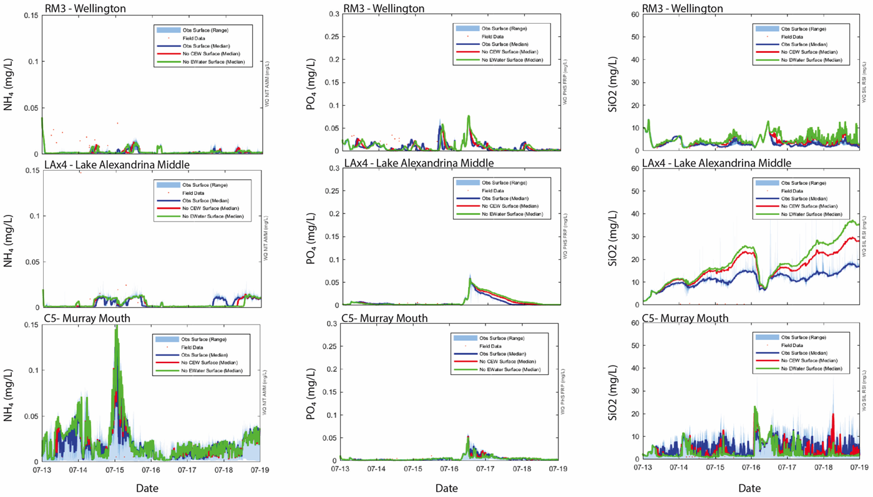

Figure D1. Daily concentrations of dissolved nutrient forms (ammonium, phosphate and silica) at Wellington, Lake Alexandrina and the Murray Mouth under three different flow scenarios from 2013–2019.

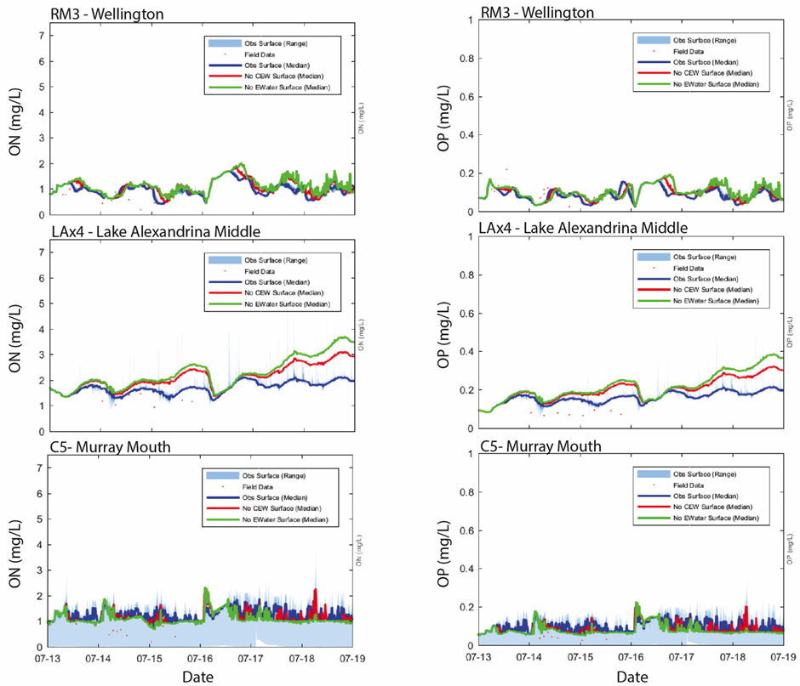

Figure D2. Daily concentrations of particulate organic nitrogen (left), particulate organic phosphorus (middle) and turbidity (right) at Wellington, Lake Alexandrina and the Murray Mouth under three different flow scenarios from 2013–2019.

Table D2. Microinvertebrate classification categories and their definitions for the purpose of this report.

|  |  |
| --- | --- |
| **Classification** | **Definition** |
| Littoral | Organisms that prefer and are adapted to the region of the sublittoral zone up to the shore. |
| Littoral (facultatively pelagic) | Organisms that prefer and are adapted to the region of the sublittoral zone up to the shore however can also aptly survive in open water environments. |
| Pelagic | Organisms that prefer lentic open water environments. |

Table D3. List of all of the rotifer, cladoceran and copepods species identified in 2014-15, 2015-16, 2016-17 and 2017-18 and their classification based on their preferred habitat. NR for Aust. = new record for Australia, NR for SA = new record for South Australia and n. sp. = new species.

| **Species identified** | **Group** | **Classification** |
| --- | --- | --- |
| *Habrotrocha* sp. | Rotifer | Littoral |
| *Philodina alata* **NR for Aust** | Rotifer | Littoral |
| *Philodina* sp. | Rotifer | Littoral |
| *Rotaria neptunia* | Rotifer | Littoral |
| *Rotaria* sp. | Rotifer | Littoral |
| indet. bdelloid [sm] | Rotifer | Littoral |
| indet. bdelloid [lg] | Rotifer | Littoral |
| *Asplanchna* cf. *brightwellii* | Rotifer | Pelagic |
| *Asplanchna priodonta* | Rotifer | Pelagic |
| *Asplanchna* sp. | Rotifer | Pelagic |
| *Asplanchnopus* sp. | Rotifer | Pelagic |
| *Anuraeopsis coelata* | Rotifer | Pelagic |
| *Anuraeopsis fissa* | Rotifer | Pelagic |
| *Brachionus angularis* | Rotifer | Pelagic |
| *Brachionus bennini* | Rotifer | Littoral (facultatively pelagic) |
| *Brachionus* *bidens* | Rotifer | Pelagic |
| *Brachionus bidentatus* | Rotifer | Littoral (facultatively pelagic) |
| *Brachionus budapestinensis* | Rotifer | Pelagic |
| *Brachionus calyciflorus amphiceros* | Rotifer | Pelagic |
| *Brachionus calyciflorus* s.l. | Rotifer | Pelagic |
| *Brachionus caudatus personatus* | Rotifer | Pelagic |
| *Brachionus dichotomus reductus* **NR for SA** | Rotifer | Pelagic |
| *Brachionus diversicornis* | Rotifer | Pelagic |
| *Brachionus durgae* **NR for Aust.** | Rotifer | Pelagic |
| *Brachionus falcatus* | Rotifer | Pelagic |
| *Brachionus keikoa* | Rotifer | Pelagic |
| *Brachionus lyratus* | Rotifer | Pelagic |
| *Brachionus nilsoni* | Rotifer | Pelagic |
| *Brachionus novaezealandiae* | Rotifer | Pelagic |
| *Brachionus quadridentatus cluniorbicularis* | Rotifer | Littoral (facultatively pelagic) |
| *Brachionus quadridentatus* s. str. | Rotifer | Pelagic |
| *Brachionus rubens* | Rotifer | Pelagic |
| *Brachionus urceolaris* | Rotifer | Pelagic |
| *Brachionus* **n. sp. [*angularis-lyratus* group]** | Rotifer | Pelagic |
| *Brachionus* sp. | Rotifer | Pelagic |
| *Keratella americana* **NR for Aust.** | Rotifer | Pelagic |
| *Keratella australis* | Rotifer | Pelagic |
| *Keratella cochlearis* | Rotifer | Pelagic |
| *Keratella* *javana* | Rotifer | Pelagic |
| *Keratella lenzi* **NR for SA** | Rotifer | Pelagic |
| *Keratella procurva* | Rotifer | Pelagic |
| *Keratella quadrata* | Rotifer | Pelagic |
| *Keratella shieli* | Rotifer | Pelagic |
| *Keratella slacki* | Rotifer | Pelagic |
| *Keratella tecta* **NR for SA** | Rotifer | Pelagic |
| *Keratella tropica* | Rotifer | Pelagic |
| *Plationus patulus* | Rotifer | Pelagic |
| *Platyias quadricornis* **NR for SA** | Rotifer | Pelagic |
| *Collotheca pelagica* **NR for SA** | Rotifer | Pelagic |
| *Collotheca* cf. *tenuilobata* | Rotifer | Pelagic |
| *Collotheca* sp. | Rotifer | Littoral |
| *Conochilus dossuarius* | Rotifer | Pelagic |
| *Conochilus natans* | Rotifer | Pelagic |
| cf. *Dicranophoroides* sp. | Rotifer | Littoral |
| cf. *Dicranophorus* sp. | Rotifer | Littoral |
| cf. *Encentrum* spp. | Rotifer | Littoral |
| *Kostea wockei* **NR for SA** | Rotifer | Littoral |
| *Cyrtonia tuba* **NR for SA** | Rotifer | Littoral |
| cf. *Epiphanes* sp. | Rotifer | Pelagic |
| cf. *Microcodides* sp. | Rotifer | Pelagic |
| *Proalides* *tentaculatus* | Rotifer | Pelagic |
| *Proalides* sp. | Rotifer | Pelagic |
| *Beauchampiella eudactylota* **NR for SA** | Rotifer | Littoral |
| *Euchlanis* sp. | Rotifer | Littoral |
| *Ptygura* sp. | Rotifer | Pelagic |
| flosculariid sp. [cf. *Sinanatherina*] | Rotifer | Littoral |
| *Ascomorpha* cf. *ovalis* | Rotifer | Pelagic |
| *Ascomorpha saltans* | Rotifer | Pelagic |
| *Gastropus* *minor* **NR for SA** | Rotifer | Pelagic |
| *Hexarthra* *braziliensis* **NR for Aust.** | Rotifer | Pelagic |
| *Hexarthra* *intermedia* | Rotifer | Pelagic |
| *Hexarthra* sp. | Rotifer | Pelagic |
| *Lecane bulla* | Rotifer | Littoral |
| *Lecane* 'bulloid' **n. sp.** | Rotifer | Littoral |
| *Lecane closterocerca* | Rotifer | Littoral |
| *Lecane crepida* | Rotifer | Littoral |
| *Lecane curvicornis* | Rotifer | Littoral |
| *Lecane* *flexilis* | Rotifer | Littoral |
| *Lecane halsei* **NR for SA** | Rotifer | Littoral |
| *Lecane hamata* | Rotifer | Littoral |
| *Lecane* nr *hamata* **?n. sp.** | Rotifer | Littoral |
| *Lecane ludwigii* | Rotifer | Littoral |
| *Lecane luna* | Rotifer | Littoral |
| *Lecane lunaris* | Rotifer | Littoral |
| *Lecane obtusa* | Rotifer | Littoral |
| *Lecane signifera* | Rotifer | Littoral |
| *Lecane stenroosi* | Rotifer | Littoral |
| *Lecane ungulata* | Rotifer | Littoral |
| *Lecane* (*s. str.*) sp. | Rotifer | Littoral |
| *Lecane* (*M.*) sp. **a** | Rotifer | Littoral |
| *Lecane* (*M*.) sp. **b** | Rotifer | Littoral |
| *Colurella obtusa* | Rotifer | Littoral |
| *Colurella uncinata bicuspidata* | Rotifer | Littoral |
| *Colurella* sp. | Rotifer | Littoral |
| *Lepadella* *acuminata* | Rotifer | Littoral |
| *Lepadella* *patella* | Rotifer | Littoral |
| *Lepadella rhomboides* | Rotifer | Littoral |
| *Lepadella* sp. | Rotifer | Littoral |
| *Squatinella* sp. | Rotifer | Littoral |
| *Lindia* sp. | Rotifer | Littoral |
| *Lophocharis salpina* | Rotifer | Littoral |
| cf. *Proales* sp. | Rotifer | Littoral |
| *Cephalodella catellina* | Rotifer | Littoral |
| *Cephalodella forficula* **NR for SA** | Rotifer | Littoral |
| *Cephalodella gibba* | Rotifer | Littoral |
| *Cephalodella* sp. a [v. sm] | Rotifer | Littoral |
| *Cephalodella* sp. b [med] | Rotifer | Littoral |
| *Cephalodella* sp. c [lg, elongate toes] | Rotifer | Littoral |
| *Eosphora anthadis* **NR for SA** | Rotifer | Littoral |
| *Eosphora* sp. | Rotifer | Littoral |
| *Monommata* sp. | Rotifer | Littoral |
| *Notommata* cf. *prodota* **NR for Aust.** | Rotifer | Littoral |
| *Notommata* spp. | Rotifer | Littoral |
| cf. *Resticula* sp. **[?n. sp.]** | Rotifer | Littoral |
| cf. *Taphrocampa* sp. | Rotifer | Littoral |
| indet. elong. notommatid | Rotifer | Littoral |
| *Scaridium* cf. *longicaudum* | Rotifer | Littoral |
| *Polyarthra* *dolichoptera* | Rotifer | Pelagic |
| *Polyarthra vulgaris* | Rotifer | Pelagic |
| *Synchaeta oblonga* | Rotifer | Pelagic |
| *Synchaeta* *pectinata* [med-lg, >100 µm] | Rotifer | Pelagic |
| *Synchaeta* **n. sp**.[tiny] | Rotifer | Pelagic |
| *Pompholyx complanata* | Rotifer | Pelagic |
| *Testudinella patina* | Rotifer | Pelagic |
| *Trichocerca* *agnatha* **NR for SA** | Rotifer | Littoral |
| *Trichocerca bicristata* | Rotifer | Littoral |
| *Trichocerca bidens* | Rotifer | Littoral |
| *Trichocerca* cf. *insignis* **NR for SA** | Rotifer | Littoral |
| *Trichocerca pusilla* | Rotifer | Littoral (facultatively pelagic) |
| *Trichocerca* *rattus carinata* **NR for SA** [was sp.a] | Rotifer | Littoral |
| *Trichocerca similis* | Rotifer | Littoral (facultatively pelagic) |
| *Trichocerca similis grandis* | Rotifer | Littoral (facultatively pelagic) |
| *Trichocerca* cf. *tigris* | Rotifer | Littoral |
| *Trichocerca* cf.  *weberi* | Rotifer | Littoral |
| *Trichocerca* sp. **b**[tiny] | Rotifer | Littoral |
| *Trichocerca* sp. **c**[long toe, med] | Rotifer | Littoral |
| *Trichocerca* sp. **d**[gracile, med toe(s)] | Rotifer | Littoral |
| *Trichocerca* sp. **e**[sm bulb body, long toe] | Rotifer | Littoral |
| *Trichocerca* sp. **f**[oblate body, short toe] | Rotifer | Littoral |
| *Trichocerca* sp. **g** [small curved gracile, short toe] | Rotifer | Littoral |
| *Trichocerca* sp. **h** [robust, long toe] | Rotifer | Littoral |
| *Macrochaetus* sp. **NR for SA** | Rotifer | Littoral |
| *Trichotria tetractis similis* | Rotifer | Littoral |
| *Filinia australiensis* | Rotifer | Pelagic |
| *Filinia brachiata* | Rotifer | Pelagic |
| *Filinia grandis* | Rotifer | Pelagic |
| *Filinia longiseta* | Rotifer | Pelagic |
| *Filinia opoliensis* | Rotifer | Pelagic |
| *Filinia passa* | Rotifer | Pelagic |
| *Filinia pejleri* | Rotifer | Pelagic |
| *Filinia terminalis* | Rotifer | Pelagic |
| indet. 2-toed rotifer [sm] | Rotifer | Littoral |
| indet. glob. rotifer | Rotifer | Littoral |
| indet. plicate rotifer | Rotifer | Littoral |
| *Bosmina meridionalis* | Cladoceran | Pelagic |
| *Armatalona macrocopa* | Cladoceran | Littoral |
| *Chydorus* cf. *eurynotus* | Cladoceran | Littoral |
| *Leberis diaphanus* | Cladoceran | Littoral |
| *Picripleuroxus quasidenticulatus* | Cladoceran | Littoral |
| *Pseudochydorus globosus* | Cladoceran | Littoral |
| *Pseudomonospilus diporus* | Cladoceran | Littoral |
| indet. chydorid | Cladoceran | Littoral |
| *Ceriodaphnia* *cornuta* | Cladoceran | Pelagic |
| *Ceriodaphnia* sp. [non-*cornuta*] | Cladoceran | Pelagic |
| *Daphnia carinata* s.l. | Cladoceran | Pelagic |
| *Daphnia galeata* **NR for Aust.** | Cladoceran | Pelagic |
| *Daphnia lumholtzi* | Cladoceran | Pelagic |
| *Daphnia* sp. [non-lumh. late embryos] | Cladoceran | Pelagic |
| *Simocephalus* sp. | Cladoceran | Littoral |
| *Ilyocryptus* sp. [juv] | Cladoceran | Littoral |
| *Macrothrix* sp. | Cladoceran | Littoral |
| *Moina* cf. *australiensis* | Cladoceran | Pelagic |
| *Moina micrura* | Cladoceran | Pelagic |
| *Moina* cf. tenuicornis | Cladoceran | Pelagic |
| *Neothrix* sp. | Cladoceran | Littoral |
| *Diaphanosoma excisum* | Cladoceran | Pelagic |
| *Boeckella triarticulata* | Copepod | Pelagic |
| *Calamoecia ampulla* | Copepod | Pelagic |
| *Calamoecia* sp. | Copepod | Pelagic |
| *Gladioferens* sp. [female] | Copepod | Pelagic |
| calanoid copepodite | Copepod | Pelagic |
| calanoid nauplii | Copepod | Pelagic |
| *Acanthocyclops* cf. *vernalis* **NR for SA** | Copepod | Littoral |
| *Australocyclops* *australis* | Copepod | Littoral |
| *Mesocyclops notius* **NR for SA** | Copepod | Littoral |
| *Microcyclops varicans* | Copepod | Littoral |
| *Thermocyclops* sp. | Copepod | Littoral |
| indet subadult cyclopoid | Copepod | Littoral |
| cyclopoid copepodite | Copepod | Littoral |
| cyclopoid nauplii | Copepod | Littoral |
| indet. cyclopoid nauplius | Copepod | Littoral |
| indet. harpac. | Copepod | Littoral |
| harpac. copepodite | Copepod | Littoral |
| indet. copepod nauplius | Copepod | Littoral |
| *Limnocythere* sp. | Ostracod | Littoral |
| indet. ostracod [juv.] | Ostracod | Littoral |

# Acronyms

|  |  |
| --- | --- |
| **AHD** | Australian Height Datum |
| **CEW** | Commonwealth environmental water |
| **CEWO** | Commonwealth Environmental Water Office |
| **CLLMM** | Coorong, Lower Lakes and Murray Mouth |
| **DEW** | Department for Environment and Water |
| **DOC** | Dissolved organic carbon |
| **ENP** | Ecosystem net production |
| **ER** | Ecosystem respiration |
| **GPP** | Gross primary production |
| **LMR** | Lower Murray River (South Australian section of the Murray River). |
| **LTIM** | Long-Term Intervention Monitoring |
| **M&E** | Monitoring and Evaluation |
| **MDB** | Murray–Darling Basin |
| **MDBA** | Murray–Darling Basin Authority |
| **NPL** | Normal pool level |
| **NSW DPIE** | New South Wales Department of Planning, Industry and Environment |
| **PSU** | Practical salinity units |
| **RMIF** | River Murray Increased Flows |
| **TL** | Total length |
| **TLM** | The Living Murray |
| **VEWH** | Victorian Environmental Water Holder |
| **YOY** | Young-of-year |

# Glossary

|  |  |
| --- | --- |
| **Allochthonous** | Refers to foreign or outside sources. For example, organic matter of an allochthonous source is that which has been produced outside of the river channel, e.g. terrestrial or floodplain material. |
| **Autochthonous** | Refers to local sources. For example, organic matter of an autochthonous source is that which has been produced within the river channel. |
| **Base flow** | Flows that are confined to the low flow part of the river channel. |
| **Biofilm** | A collection of microorganisms (e.g. bacteria) attached as a ‘film’ on living (e.g. tree root) and non-living (e.g. wooden pylon) surfaces. |
| **Flood or flooding** | Refers to flows that are overbank. In South Australia, this is deemed to be above bankfull flow (45,000 ML/d). |
| **Freshes (flow)** | Flows greater than base flow but below bank level. |
| **Epibenthic** | Organisms living on the surface of sediment. |
| **Epiphytic** | Organisms that are attached to plants. |
| **Heleoplankton** | Plankton derived from billabongs and other floodplain still, generally-vegetated, waters. |
| ***In situ*** | Used to describe monitoring *in* the field. |
| **Lentic** | Refers to slower water velocities associated with ‘pool water’ habitat in highly regulated systems, typically median velocities of approximately ≤0.3 m/s. |
| **Littoral** | The margin along the bank of the river. |
| **Lotic** | Refers to flowing water, typically with median velocities of approximately >0.3 m/s. |
| **Pulse (flow)** | A description given to the shape of a hydrograph that is characterised by an increase in discharge, followed by a decrease in discharge, often of similar slope. |
| **Recruitment (reproduction)** | Refers to individuals passing the critical stages of early life (e.g. larval) and becoming juveniles in a population, described here as age 0+ years. |
| **Respiration (ecosystem)** | Ecosystem respiration is the measure of oxygen depletion in water by respiring animals. |
| **RMIF** | River Murray Increased Flows: a type of environmental water. Water entitlements recovered under the Snowy Water Initiative (established in 2002) via infrastructure upgrades and water purchase, which receive annual allocations and are used to supply environmental water to the Snowy River (Snowy River Increased Flows, SRIF) and River Murray (RMIF). |
| **Primary productivity** | The rate at which energy is converted to organic substances by autotrophs (e.g. algae and plants) during photosynthesis. |
| **Southern connected Basin** | The southern connected Basin is a network of the Murray River and all tributaries that flow into it between the Hume Dam and the sea. The Lower Darling (below Menindee Lakes) is considered part of the Southern Connected Basin, whilst all rivers upstream of Menindee Lakes are considered as the Northern Basin. |
| **Unregulated flows** | Unregulated flows occur when water in the system exceeds demands and are declared to be unregulated by the appropriate authority (source: <http://www.bom.gov.au/water/awid/id-1026.shtml>). They can be driven by substantial rainfall from upper tributaries, spills from headwork storages and rainfall rejection events. |
| **Weir pool** | Stretch of river between two weirs. |

1. Hydrology (Channel) does not directly address any specific CEWO evaluation question, but provides fundamental information for analysis and evaluation of monitoring outcomes against hydrological conditions and environmental water delivery for all other indicators. Results for this indicator are presented in Section 1.4.
2. Molecules of water, nutrients, and the biological matter transported downstream often move slower than the wave front that is recorded as the change in flow discharge (Chow *et al.* 1988). To account for this, the MDBA has used Bigmod salinity routines as a proxy for transport of biological matter, to estimate the proportion of the flow at the South Australian border that originated at different upstream tributaries. While acknowledging potential difference in travel time between salt and other matter, this approach is preferred over estimating travel times based on observed changes in flow along the main channel.